Cloud setting
- Creat an account in http://www.led-cloud.com/en-US
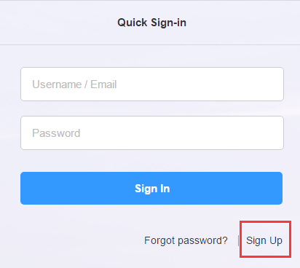
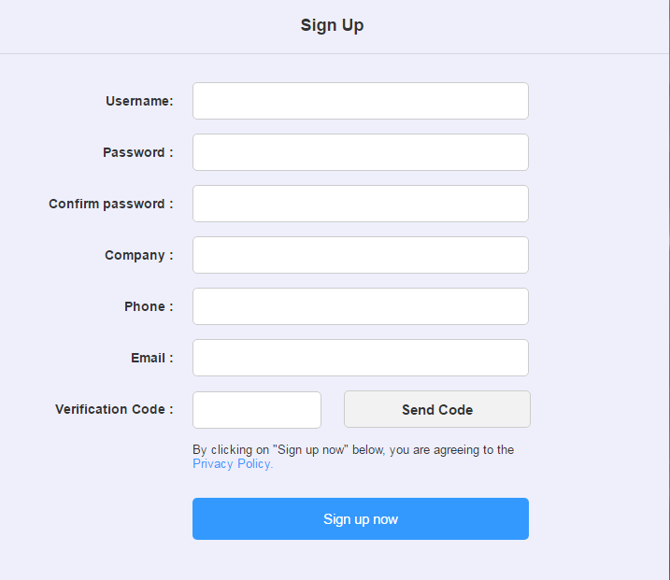
Note : Phone number is not be required!
- the card connect to the PC with net cable, use the HDPlayer to set the screen setting,hardware setting to make the screen display ok. Then set the sever and username to the card.
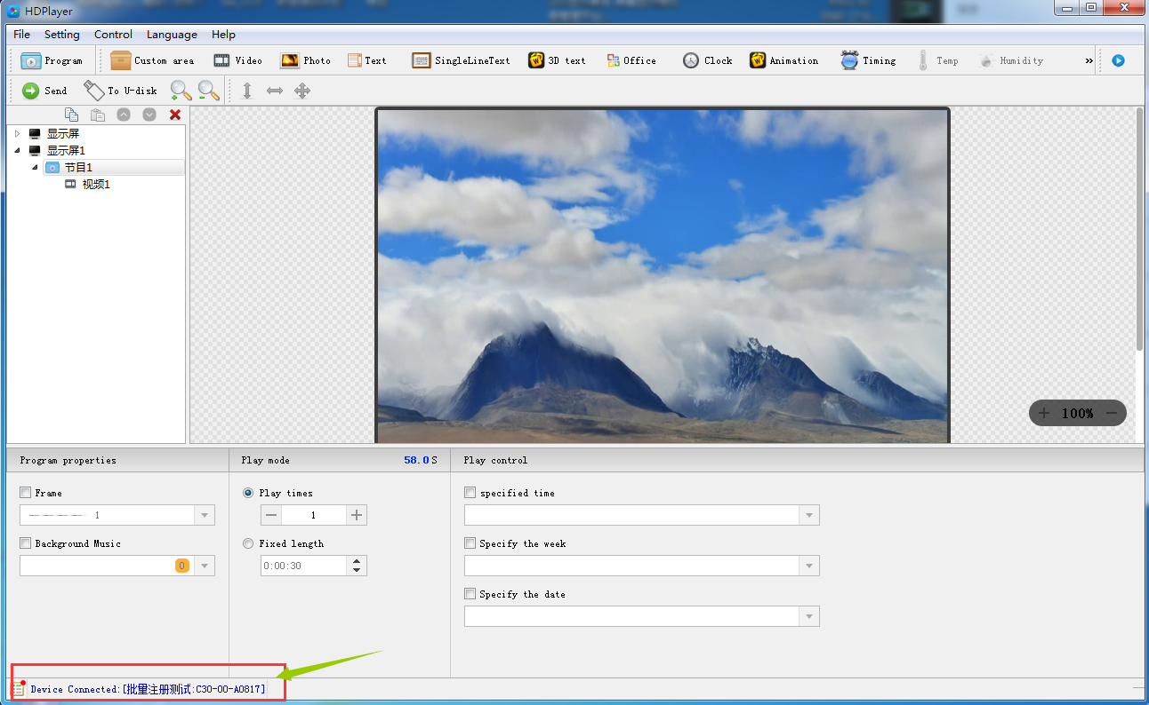
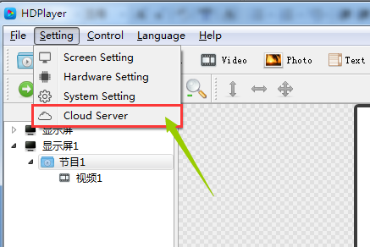
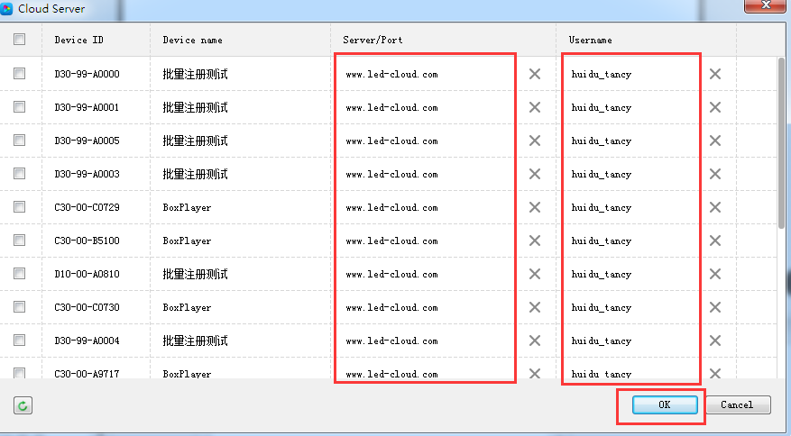

- The net cable connect to the router to the internet,then turn off and on the power of the card. The card will be online in http://www.led-cloud.com/en-US .(if you use the 3G/4G,please insert the SIM card,and remove the net cable)
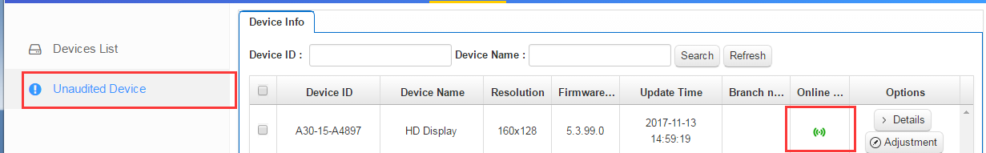
Firstly, online in “Unaudited Device”list, will be audited by huidu sever manager, then will change to in “Devices list”.
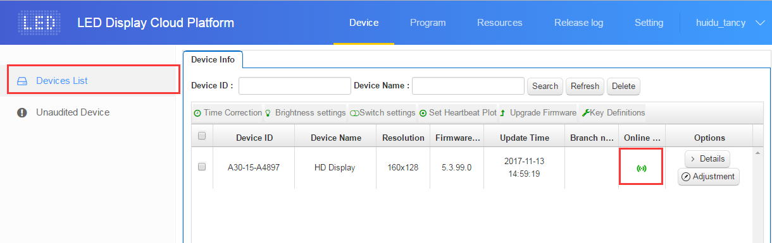
- if the card is not online ,please check the following .
- check the sever and username if correct in ”cloud sever” in HDPlayer.
- Check the router if connect to internet.
- Check the 3G/4G if working. Can connect to PC with net cable ,then click“Device information”, check the 3G/4G information.
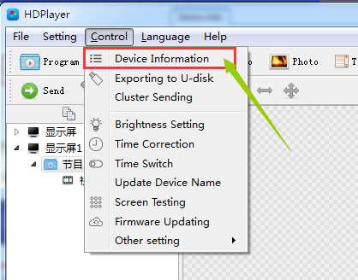
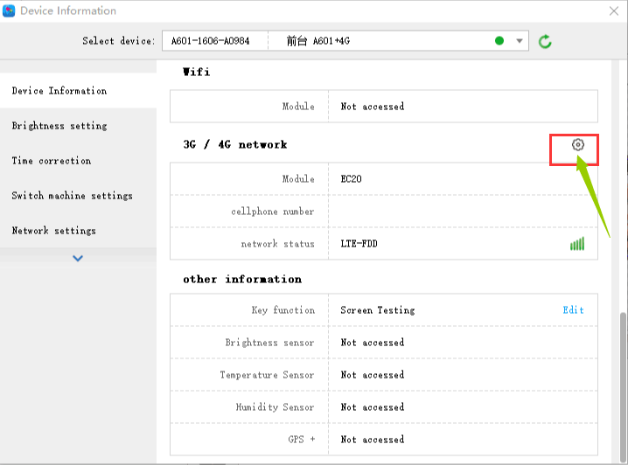
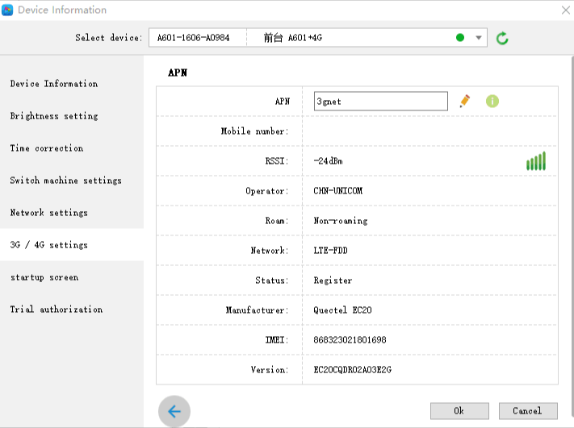

Note: some SIM card need to set the APN, can ask the SIM card operator.

