CONTENTS
目录
Chapter one, Overview 2
1. System requirements 2
2. Communication mode 2
Chapter two, Installation and Uninstall 3
1. Installation 3
2. Uninstall 4
Chapter three, Editing Programs 4
1. New display 4
2. Display Management 7
3. Programs, broadcast control, regional management 8
3.1 Program management 8
3.2 Broadcast Control Management 9
3.3 Regional Management 10
4. Text Editor 11
4.1 Font attributes 11
4.2 Border settings 12
4.3 Effect settings 13
4.4 Background settings 14
5. Clock editing 16
6. Picture editing 17
7. Send a show 18
Chapter four, Other Functions 18
1. Help menu 18
2. Search equipment 20
3. Equipment online 21
4. Switch settings 21
5. Brightness setting 22
6. Time correction 23
7. Hardware settings 24
8. remote control 35
9. Wi-Fi settings 36

Chapter one, Overview

At present, the LED display control system industry uses computer-based control software to control, and each project site requires another computer to debug, which is very inconvenient. The smart phone has become the electronic product that all people carry with them. The mobile phone-based LED screen control software has become an urgent need for the industry.
After the user installs this APP on a mobile phone or a tablet computer, it can control the full color and single dual color LED display controlled by Wi-Fi.

System requirements
Mobile phone installation requirements
（The system is any mobile phone above Android 4.0）

Communication mode
Scheme 1 Onboard Wi-Fi
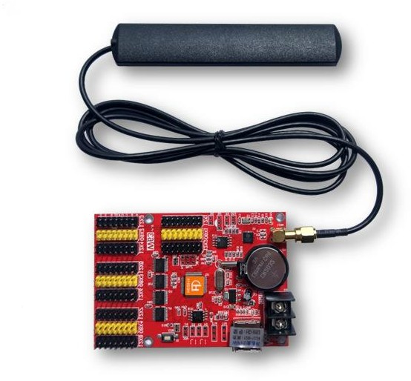
Scheme 2 Wi-Fi router（Six generations of network ports are connected to wireless routers）

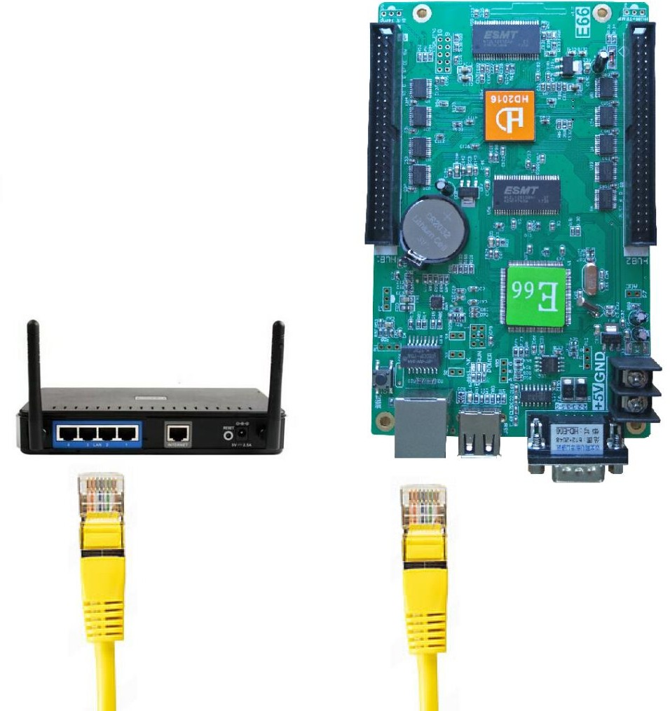

Chapter two, Installation and Uninstall

Installation
Method one ：Users can download on website.

Method two：Users can use the mobile phone or computer browser to scan the QR code download software, and then send it to the mobile phone through the data line or chat software to install. After downloading APP
to mobile phone, it can be installed by default.


Method three：Search "LEDART" installation on the mobile phone's own software store, app store, and app market.

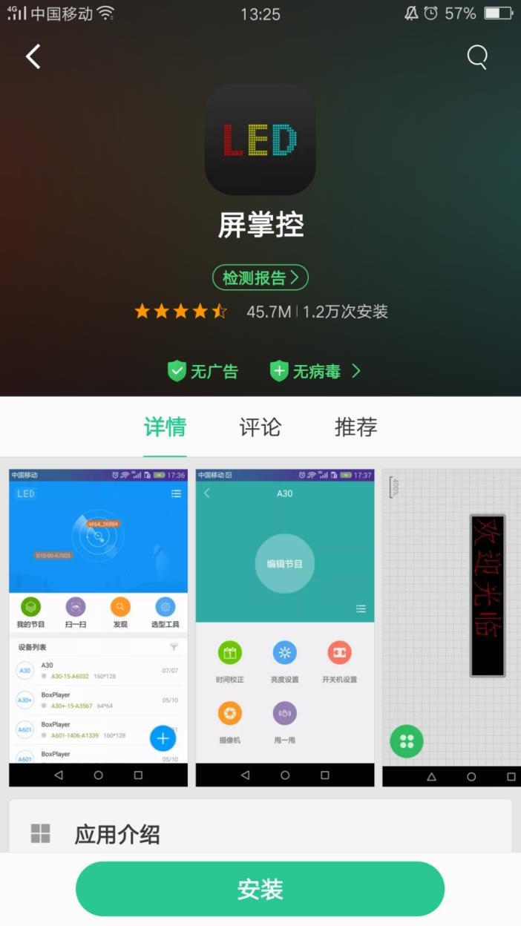

Uninstall
Long press the "LEDART" icon on the mobile phone interface until the "delete" icon appears and drag directly to "delete".

Chapter three, Editing Programs

New display

Open the software, click on the program's icon, click on "New single-color screen," prompt "read back screen parameters" dialog box, click "confirm" to create a new display, which contains the display name

(you can modify the display name), Display size, color, grayscale. Click OK after setting,And will come out a text area interface, as shown.
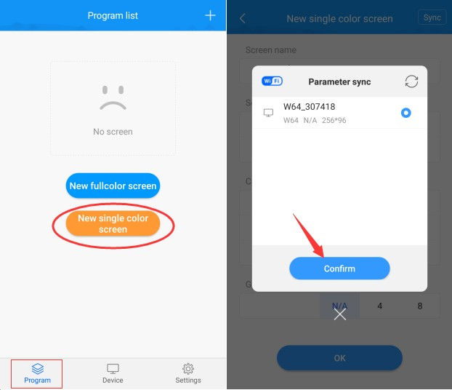

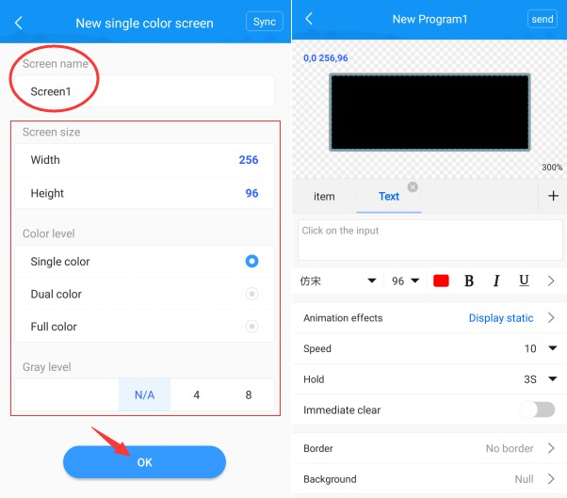

Display Management
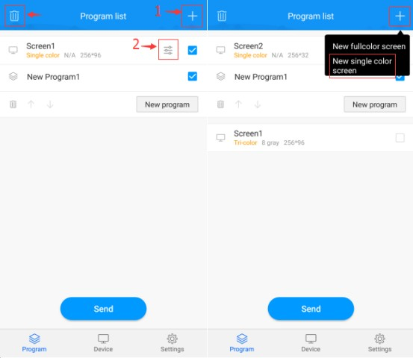

1） New display (new single-color screen).

2) Display editing (display name, display width, height, color, grayscale).

3） Delete the display (check the display, click the delete icon, the display can be deleted).

Programs, broadcast control, regional management

Program management
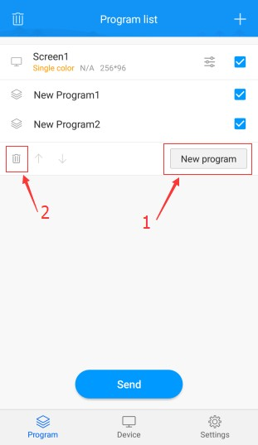

- New program.

- Delete a show (check the show, click the delete icon, the show can be deleted).

Note: For multiple programs, programs that do not need to be played are not checked, and then click “send program”

Broadcast Control Management

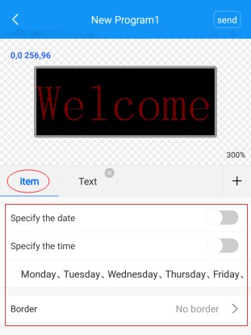

Click "Programs" to see the play time (play on the specified date, play at the specified time, play on the specified day) and the program frame”.

Regional Management
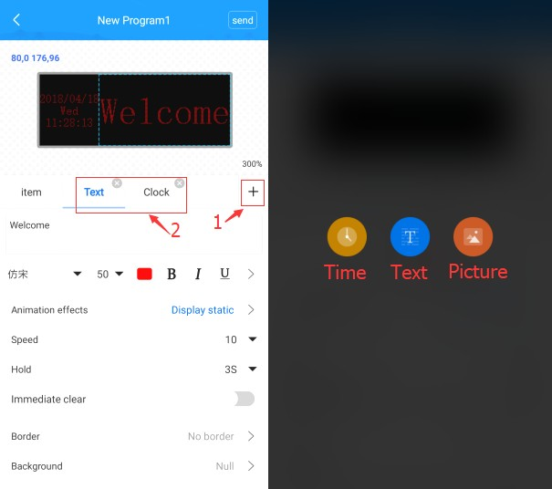

- Add area (time, text, picture)

- Area (show all areas), there is a cross icon at the top right of the area, click this icon to delete the area.

Text Editor
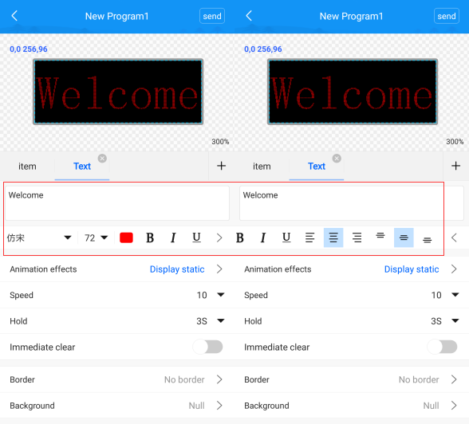
  - Font attributes

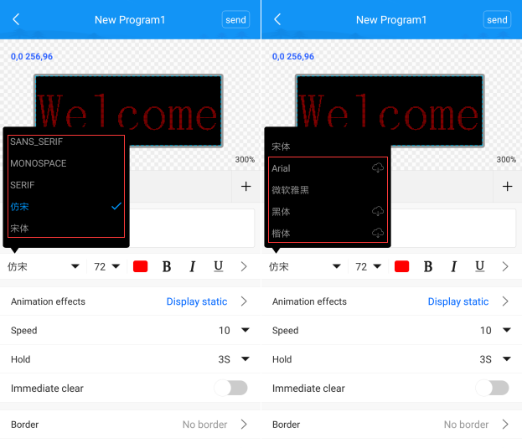
The default font is imitation Song, other fonts are Arial, SANS_SERIF, MONOSPACE; fonts that need to be downloaded and installed are Arial, Microsoft Yahei, Bold, Carcass.

  - Border settings

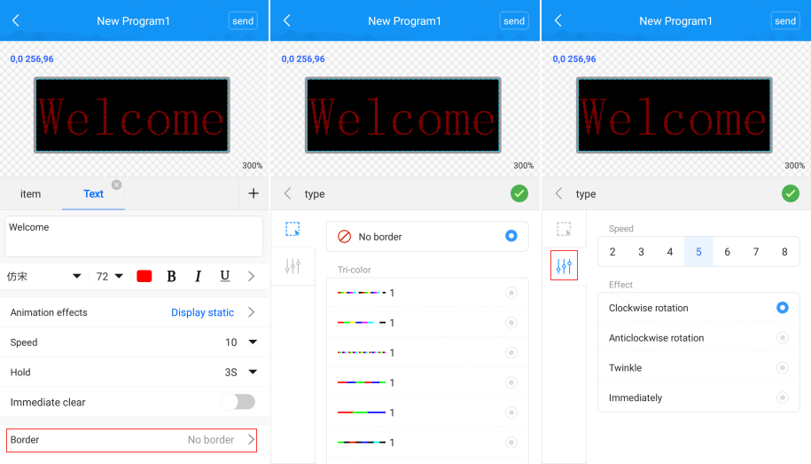

- Border selection, text border can choose no border, you can also choose solid color border, color border, tri-color border, according to your needs to choose.

- The text border can adjust the border speed and border effects, the speed is 1-9, of which 1 is the fastest and 9 is the slowest. Border effects include clockwise rotation, counterclockwise rotation, flashing, and static four special effects.

  - Effect settings

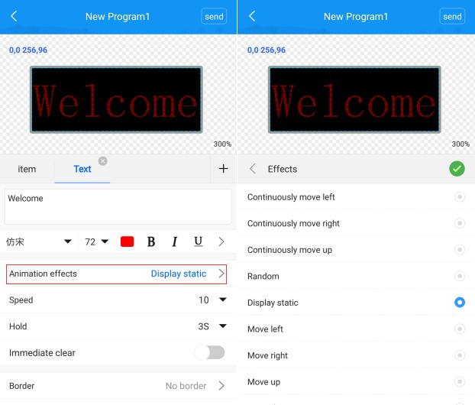

- Text effects are by default static, other effects include continuous left, continuous right, continuous up, random, left over, right over, up over, down over and other effects.

- The default text movement speed is 10, with the fastest value of 1 and the slowest value of 2000.

  - Background settings

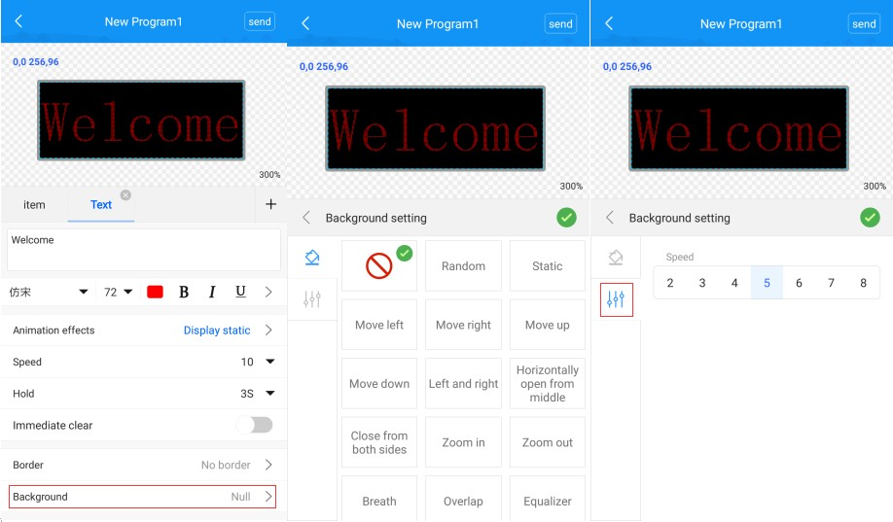

- Can choose background effects, random, static, left, right, up, down, left and right movement, left and right, left and right closed, zoom in, zoom out, breathing, diamond extensions and other effects.

- Select the background speed, there are 1-20 options, of which the value 1 is the fastest and the value 20 is the slowest.

Clock editing
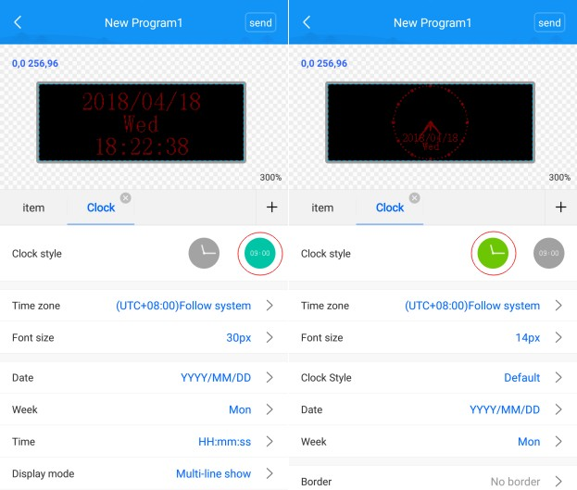

Click xx this icon to add the clock area.
- Clock style can be selected, digital clock, dial clock, time zone can also be selected.

- You can adjust the interval between date, week, and time. The mode of clock display can be single-line display, multi-line display, two-line display, or separate display of date or week or time.

Picture editing
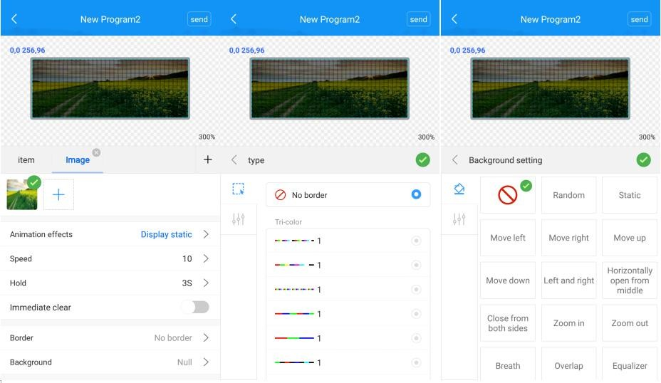
Click this icon to add the clock area.

- In the following will come out a“ ” xx icon, click on the select the phone inside the picture, you can add in.
- Special effects options, such as still display, pan left, pan right,pan up and other effects.

- Speed of effects, one of the fastest, the slowest of 2000, can also adjust the time of stay.

- The border speed is 1-9, among which 1 is the fastest and 9 is the slowest. You can also choose the border effect, clockwise rotation, counterclockwise rotation, flashing, and static four special effects.

- Background effects, static, diamond extension and other special effects,choose according to your needs.

- Background effects speed, 1-20, of which 1 is fastest, 20 is slowest.

Send a show
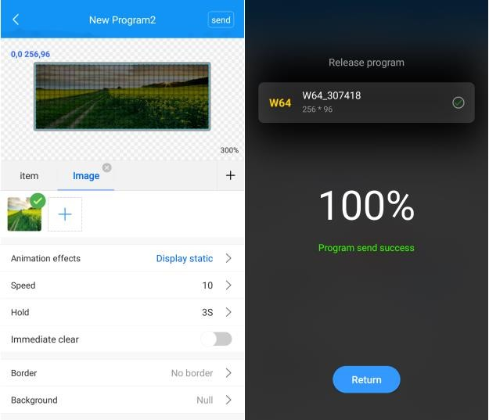
Click the "Send" icon in the upper right corner. After successful sending, 100% will be displayed. The following shows that the program has been sent successfully.

Chapter four, Other Functions

Help menu
The software help interface mainly includes interface language, selection tools, font management, clearing cache, using system Wi-Fi connection, software version.

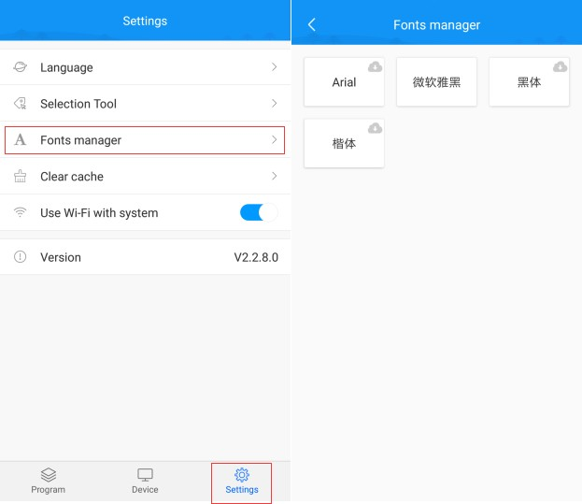

1) Languages are Chinese Simplified, Chinese Traditional, English, Turkish, German, Spanish, Persian, Japanese, Korean, Russian, Polish, Greek, French, Malaysian, Portuguese, Serbian, Thai, Vietnamese, Italian , Hindi and other 20 languages.

- "Selection tool" is the type of control card we recommend for users according to the screen type and other information. Without technical support, you can also easily and securely purchase control cards.

- "Font Management" with Arial, Microsoft Elegant, Blackbody, Carcass.

- Click "Clear Cache" to clear the cache file.

- "Use system Wi-Fi connection" point "seeking machine" switch to phone settings to connect to Wi-Fi.

- Software version V2.2.8.0.

Search equipment
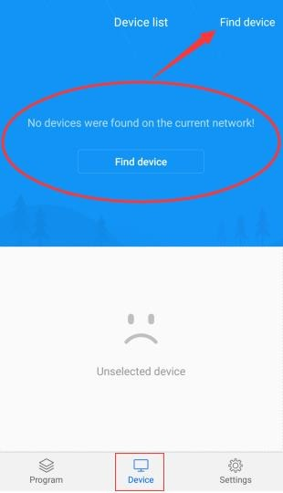

- Equipment online
Device list, you can view the current online device.
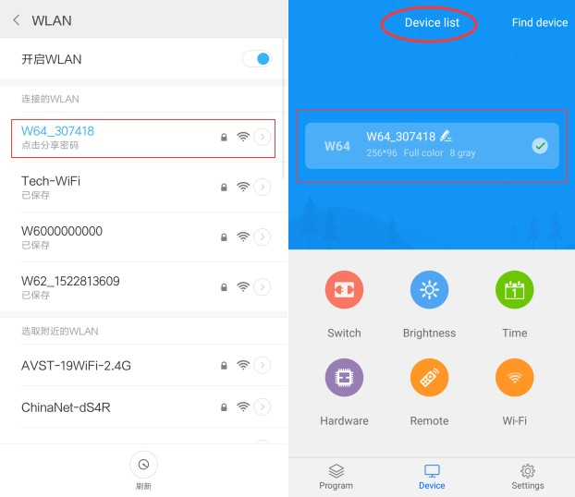

Switch settings
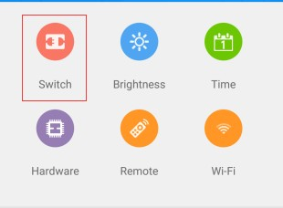
Switch settings, open the "enable", set the boot time and shutdown time, after the set time, the screen will be black, in fact there is no power, the

power in the display is still on.
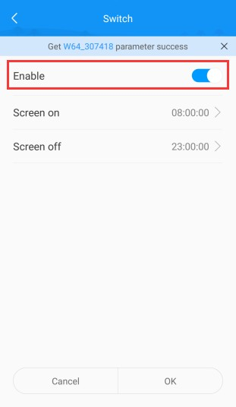

Brightness setting
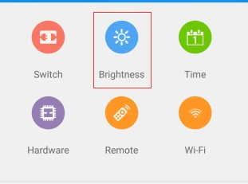

Brightness settings, slide the phone screen left and right to switch, there are default, according to the time and automatic adjustment of these three settings, automatic adjustment requires an external brightness sensor.
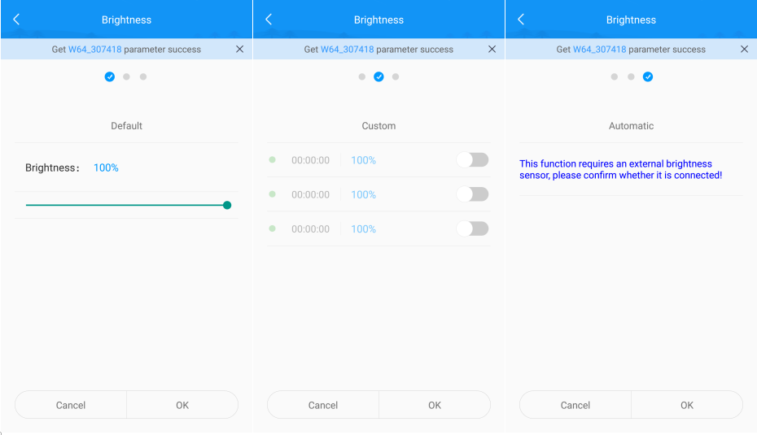

Time correction
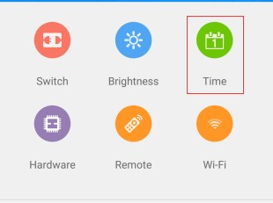
Time correction, can directly synchronize the time of the mobile phone, you can also turn off the "automatic settings", manually set the time

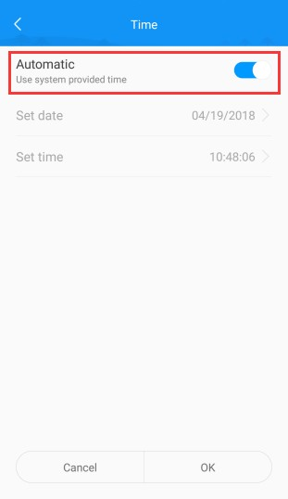

Hardware settings
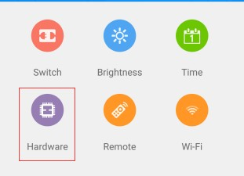
Hardware settings login password 888, hardware settings, including scan parameters and basic parameters (data polarity, OE polarity, priority mode, clock frequency and other parameters), there are commonly used smart

settings file, you can also do smart settings.
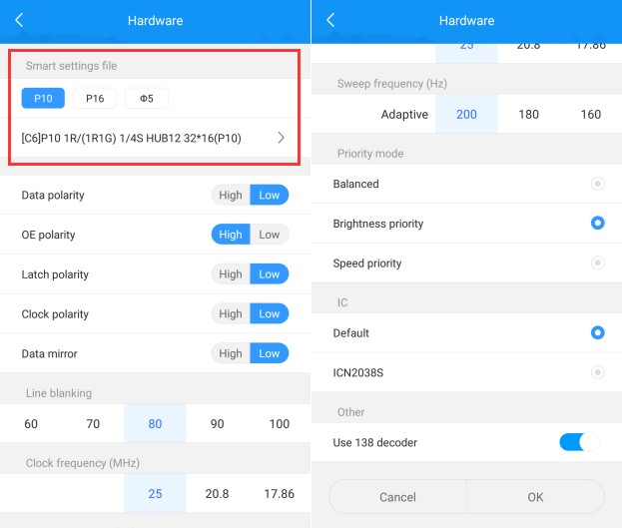
The scan mode is set incorrectly, some garbled characters appear on the screen.

The data polarity is set incorrectly, the text is usually displayed in a "reverse" manner, ie the word is black and the background is fully lit.

OE polarity setting is wrong, display brightness is very dark, text has ghosting

If you do not know which parameter to choose, you can set it intelligently. Now for example, an indoor P5 full-color module is 64 x 32 points. The

universal IC, the cable on the module must receive the first 75 interface.

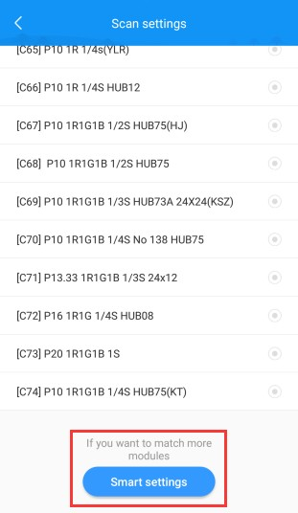

Step one: Enter a module width point number, you can also manually enter the number, and then click Next.

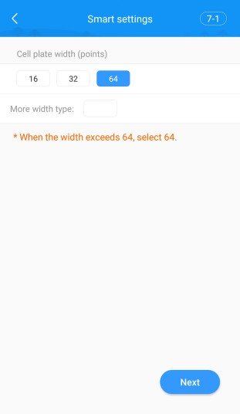

Step two: determine the polarity of the data, according to the actual situation of the screen to choose, select the state B, if the module is full bright state, choose B light, A off, B light off when the data polarity is High effective, A light B off when the data polarity is low。

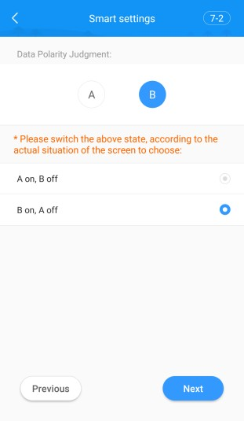

Step three: OE polarity determination, according to the actual situation of the screen to choose, select the state A, if the state A is brighter than the state B, select A than B light, select the state B, if the state B is brighter than the state A , Select B is brighter than A, B is more effective than A when OE polarity is high, A is brighter than B when it means OE polarity is low, and when there is no change, there is no 138 decoder.

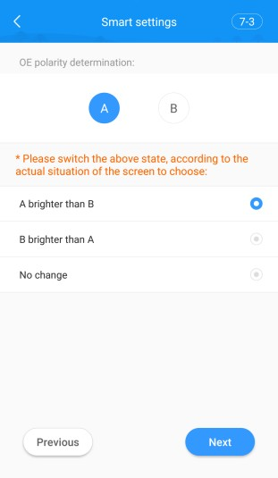

Step four: the determination of the color channel, switching 4 kinds of states, according to the actual situation of the screen to choose, single color without this option, dual-color only state A and B.

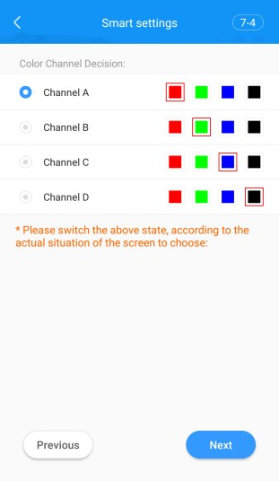

Step five: the determination of the load height, see how many lines are on the display at this time, how many rows are selected.

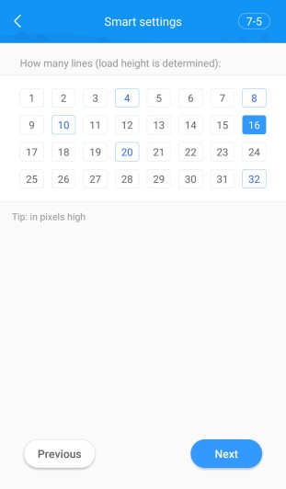

Step six: Determine the scanning method, observe the module, select the number of rows (a few lines on the single board, select a few lines).

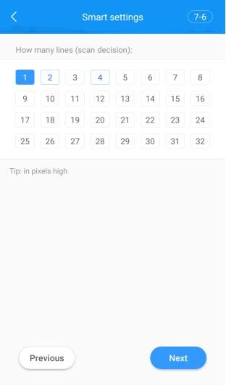

Step seven: Enter the stroke point. Observe that the first bright spot on the module is the first cell in the first row. Click the first cell in the first row in the stroke point interface table. The blue arrow above To control the orientation of the sketch, if you are wrong in the middle, you can take a step back or click the reset icon below. When all the squares are filled, you can click to finish.

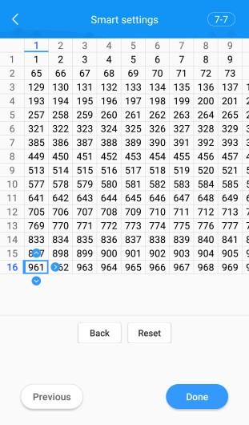

You can name your own configuration file or delete it (Left slide-out delete button).

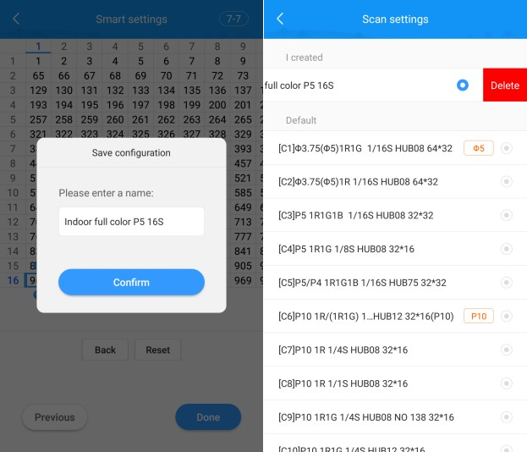

remote control

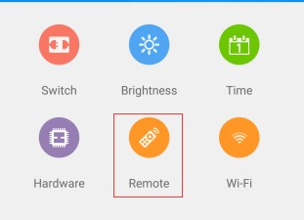
Remote control, including on/off screen, up/down program, brightness adjustment and program switching.
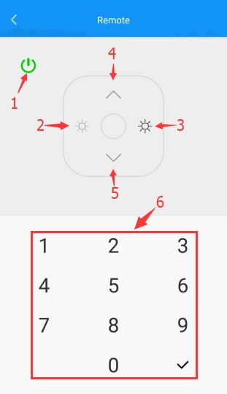

1） Open screen and close screen 2） Turn down the brightness
- Increase brightness
- Switch to previous show 5） Switch to the next program
6） Play programs by selecting number keys

Wi-Fi settings
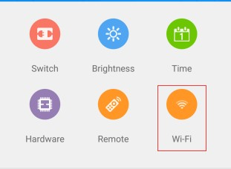
The Wi-Fi settings must be connected to the control card's Wi-Fi to operate, and the non-control card's Wi-Fi cannot find the device. In the Wi-Fi settings, you can change the SSID and password of the Wi-Fi card, or you can connect the Wi-Fi card to the wireless router.

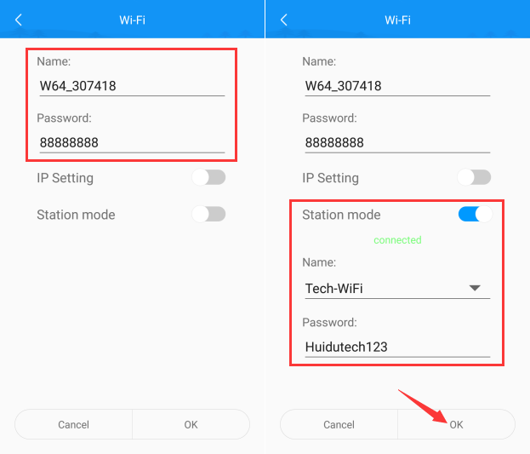

Wi-Fi password and name cannot be empty, only numbers (0 to 9), letters (A to Z, a to z), and underscore (_) can be entered.
The AP mode is suitable for single-card connection. The Station mode is suitable for multiple Wi-Fi cards connected to the wireless router. You can manually enter the Wi-Fi name of the wireless router, or you can directly select the drop-down list and enter the Wi-Fi of the wireless router. Connect the password and click OK. Station mode option is off by default and needs to be turned on.

