Contents
目录
Chapter one, Overview 2
1. System requirements 2
2. Communication mode 2
Chapter two, Load and unload 3
1. load of LEDART 3
2. Unload of LEDART 4
2. Main interface 5
3. Program editor 6
4. Video editor 7
5. Picture edtior 8
6. Text editor 10
7. Animation editor 12
8. Clock editor 14
9. Temperature editor 15
10. Humidity editor 16
11. Timer editor 17
12. Border and program setting 18
1） Area border 18
2） Program setting 19
13. Regional management 21
14. Program management 21
15. Update the program 23
Chapter four, Function setting 24
1. starting up and power off 24
2. Brightness 24
3. Time correction 25
4. Shakes 26
6. selection tools 28
7. Other setting 29

Chapter one, Overview

At present, the industry of LED display control system is controlled by computer based application software. Every project site needs to be equipped with computer debugging, which is very inconvenient. And smartphones have become the electronic products that all people carry, and the LED screen control software based on mobile phones has become an urgent demand for the industry.
If you install this APP to a mobile phone or a tablet, you can control Full color and Single-dual color LED displays controlled by Wi-Fi.

- System requirements

Mobile phone system supported：
Android 4.0 and above；iOS 7.0 and above

- Communication mode
Scheme one Communication through the Wi-Fi module
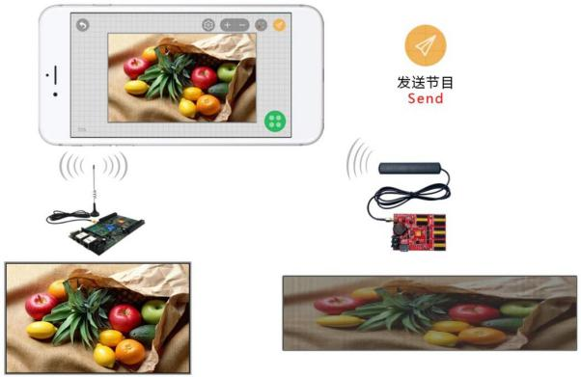

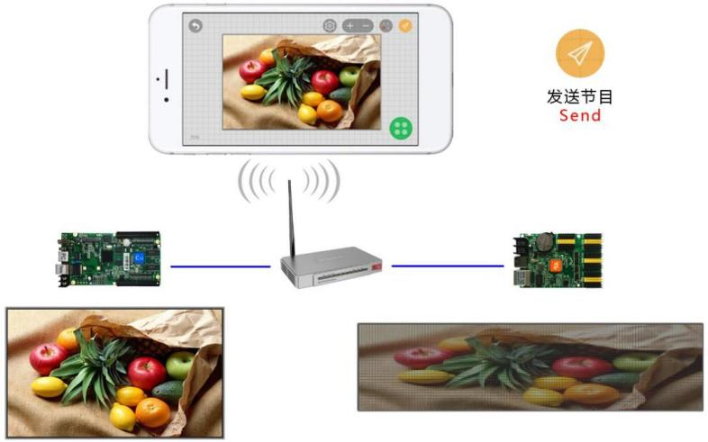
Scheme two Communication through the via wireless router

Chapter two, Load and unload

- load of LEDART
Users can download the software by website:
Notes: first download and install the package to the computer, then send it to the phone by data line or communication tool.
You can also search in every major application store, such as HUAWEI,

Xiaomi, OPPO, VIVO, application treasure, 360, pea pods, APP Store, download " 屏 掌 控 " or "LedArt". You can also scan the following two- dimensional code to download APP through browser scanning function.。
When you download APP to your phone, you can install it by default.

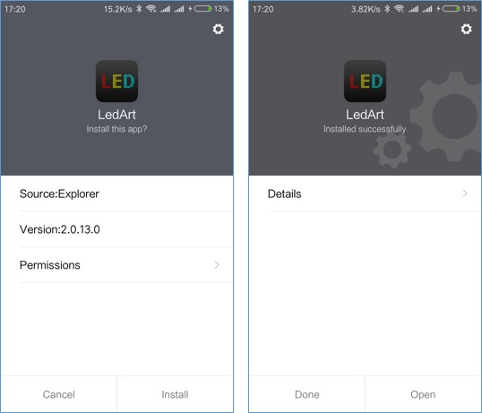

- Unload of LEDART
On the phone interface, press the "LEDART" icon until the "delete" icon appears, and drag directly to "delete".

Chapter three, The editing and sending of the program

- Wi-Fi connection
  - Open the settings on the phone -- wireless settings (or WLAN/Wi-Fi), find the wireless signal of the control card (such as A30-15-A2316), click and enter the password (default: 88888888) after the connection.

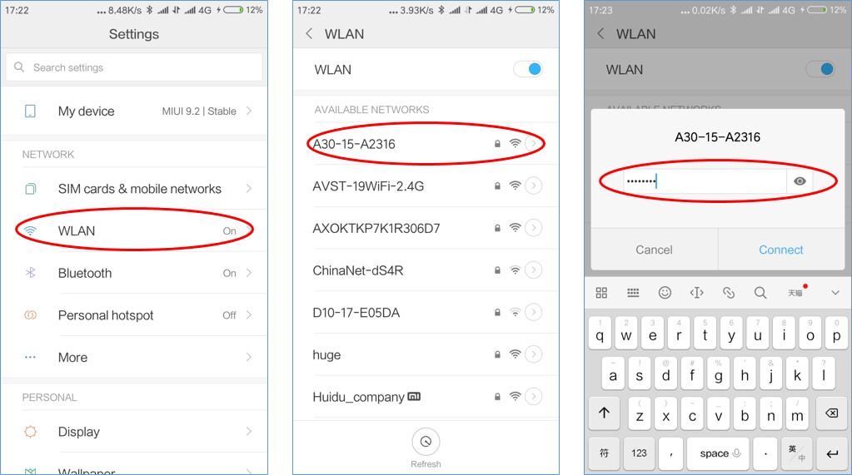

  - Connect the WLAN function on the phone "Find device" APP, and select the wireless Wi-Fi signal connection for the corresponding control card
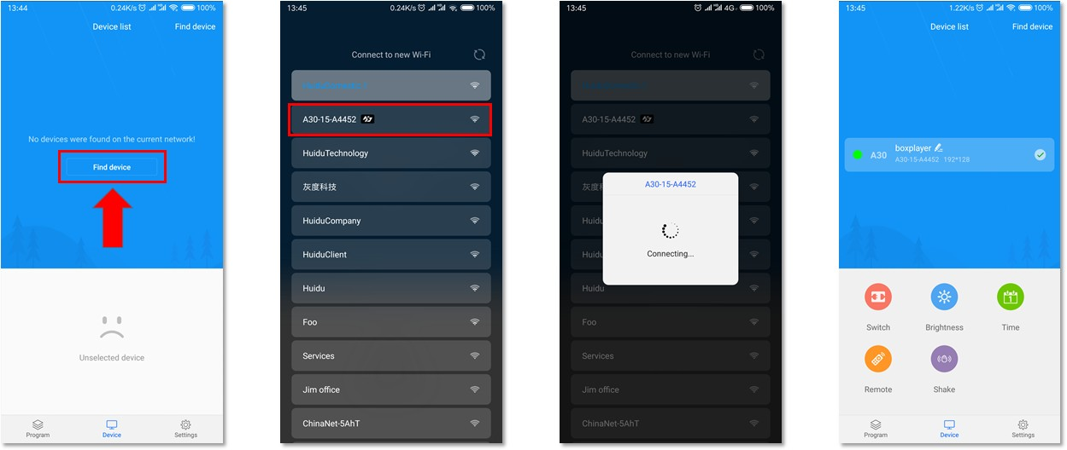

- Main interface
The software interface contains the device list and the function setting area
The function settings include the switching machine setting, the brightness setting, the time correction,the remote control, and shakes etc.

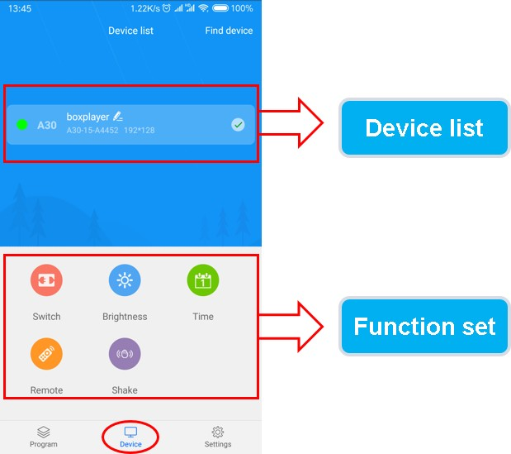

- Program editor
Click the edit program button in the click function area to edit the last edited screen again, or slide the screen into the "screen edit history list" to select a display screen for editing. You can also click the "new screen" button in the lower right corner to create a new display screen, enter the name of the display screen and the resolution of the display.
（Notes: the resolution of the display must be in accordance with the resolution of the program currently set by the control card）。

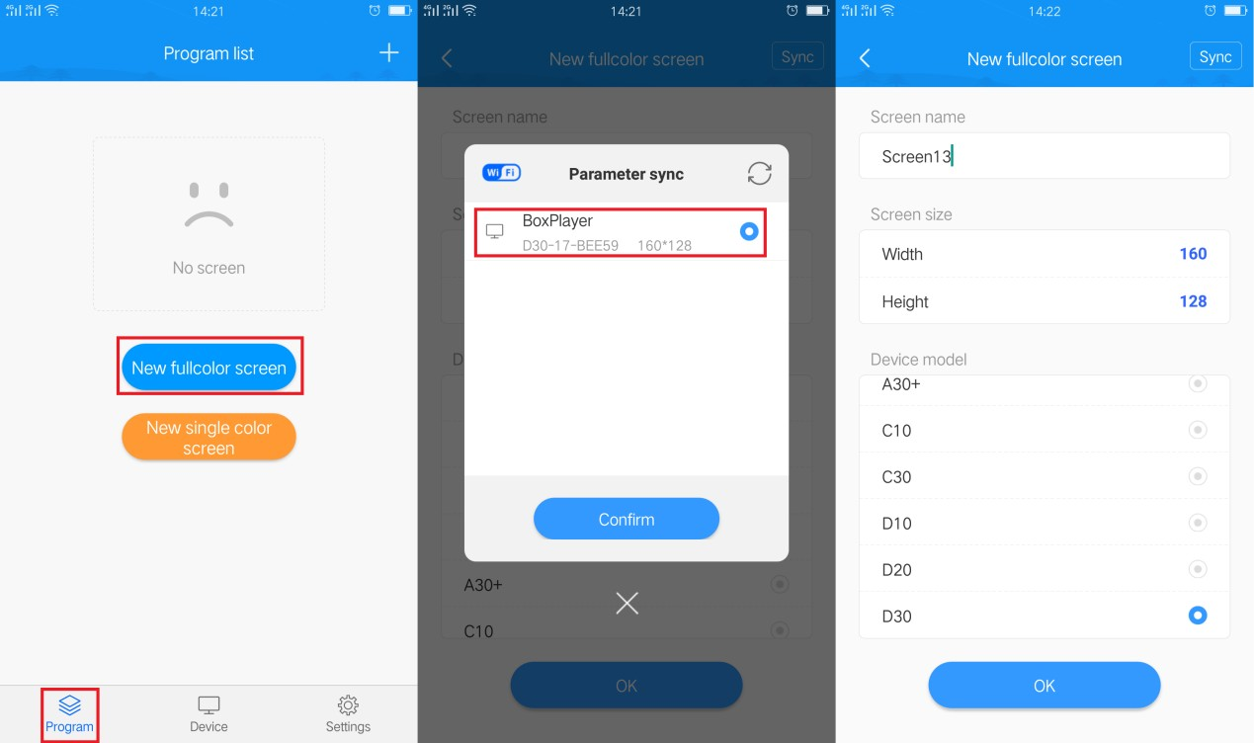

- Video editor
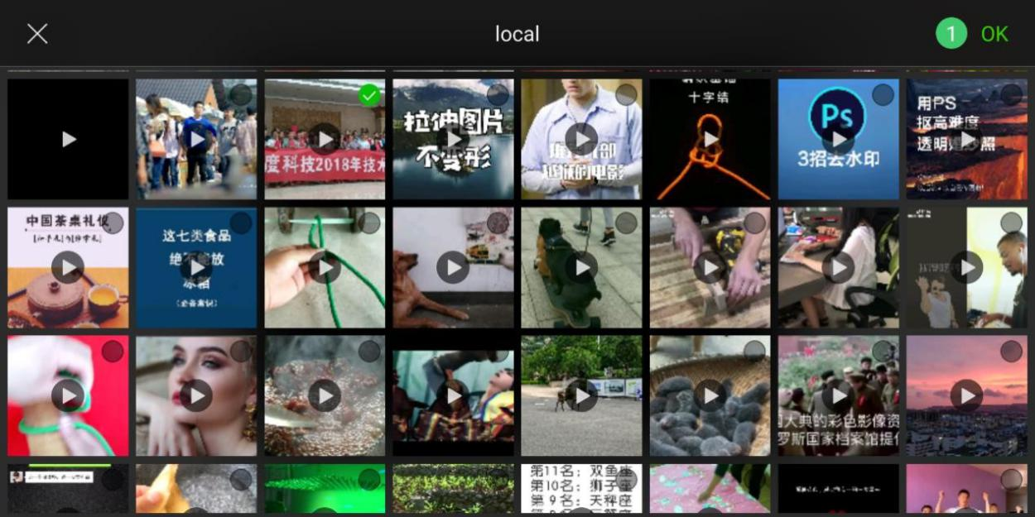
- Click the lower right corner on the screen program edit interface，and click Select the add video，Enter the local video list, select the video to add.

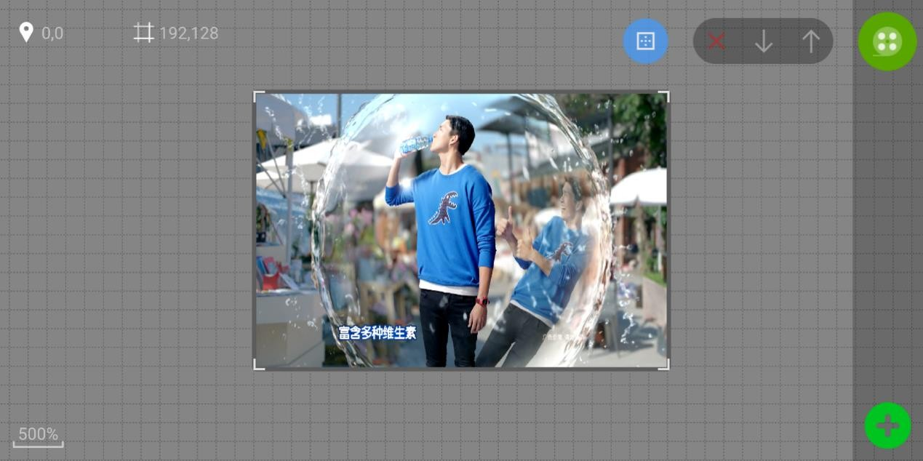


- Select the display area, click the upper right corner access to the video
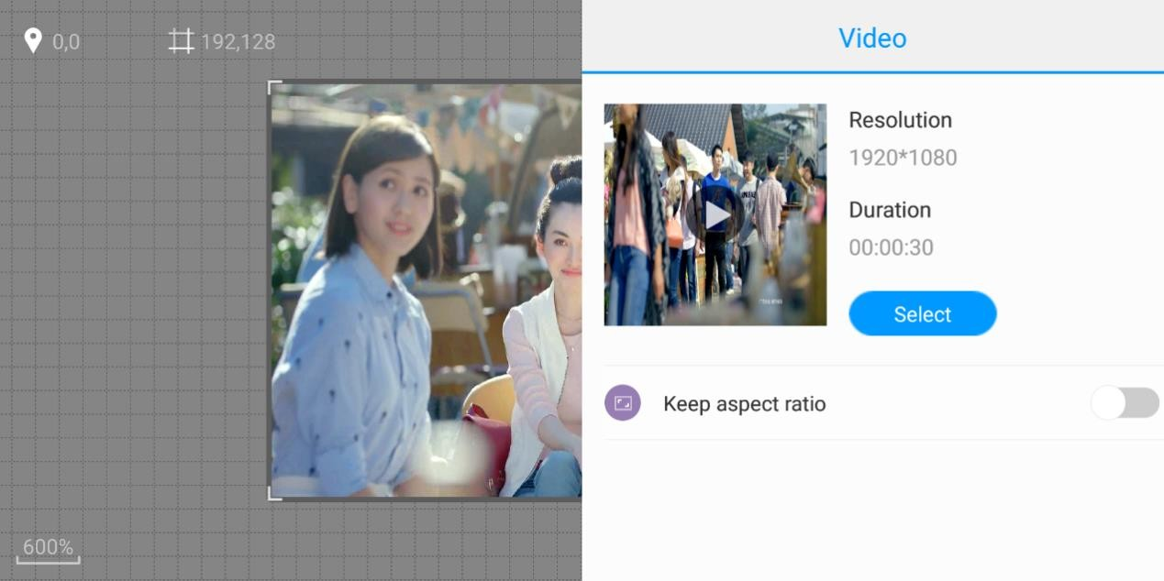
property interface. You can see the size and time of the video, and you can also reselect the video settings to keep the width to height ratio。

- Picture edtior
- Click the lower right corner on the screen program edit interface , and click Choose to add pictures, enter the local picture list, select the picture to add.

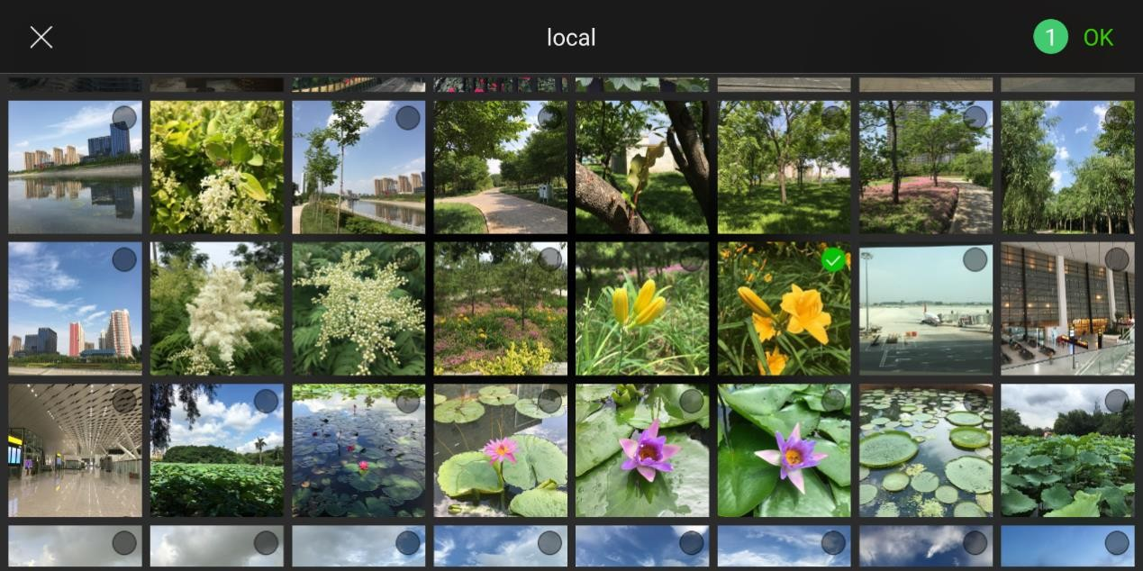
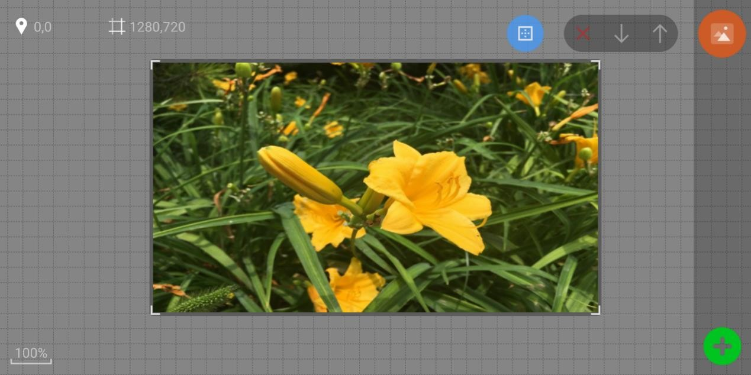


- Select the picture area, click the upper right corner access to the picture
properties interface, can view the picture information, set the picture display special effects and other operations.

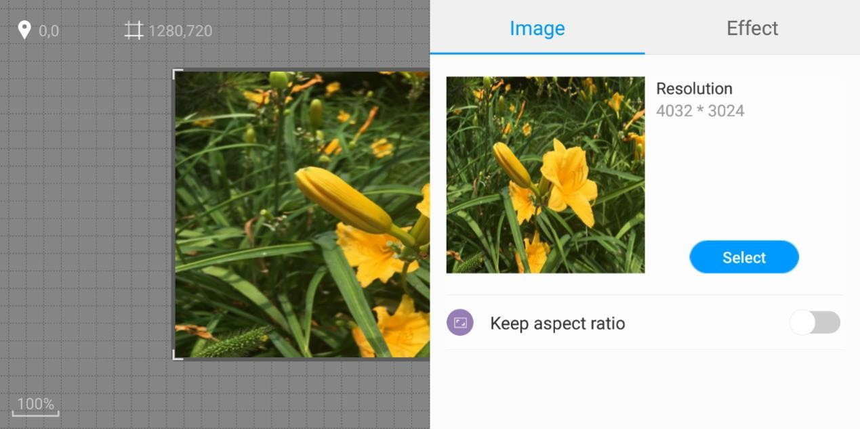
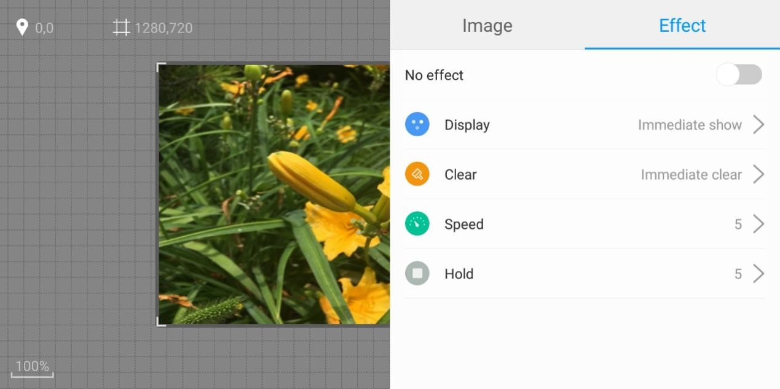

- Text editor


- Click on the lower right corner of the APP program editing interface, then
click to select Add Text, enter the text editing interface, input the text content to be displayed, and set the text color, background color, alignment, font, bold, italic, underline effect.

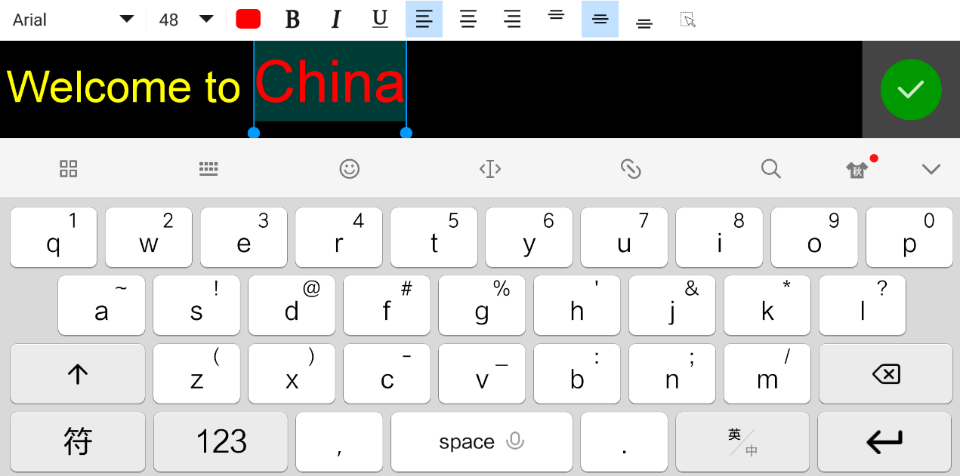
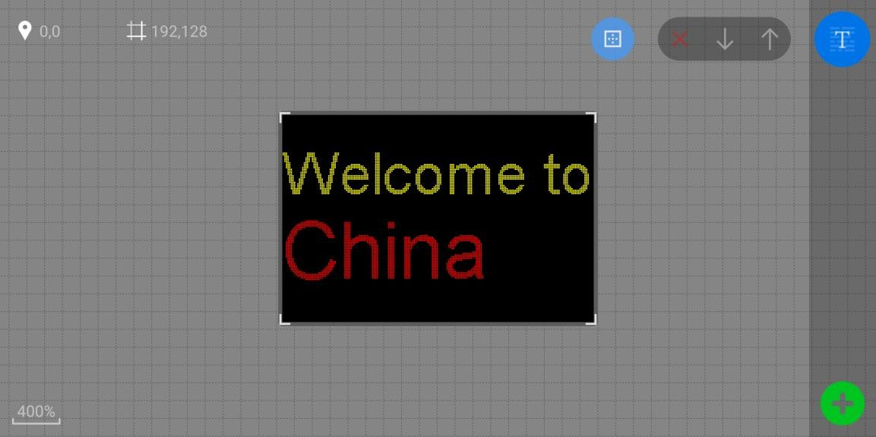


- Select the text area, click on the upper right corner to enter the text
property interface, and set the single-line display, multi-line display, and move effects of the text.

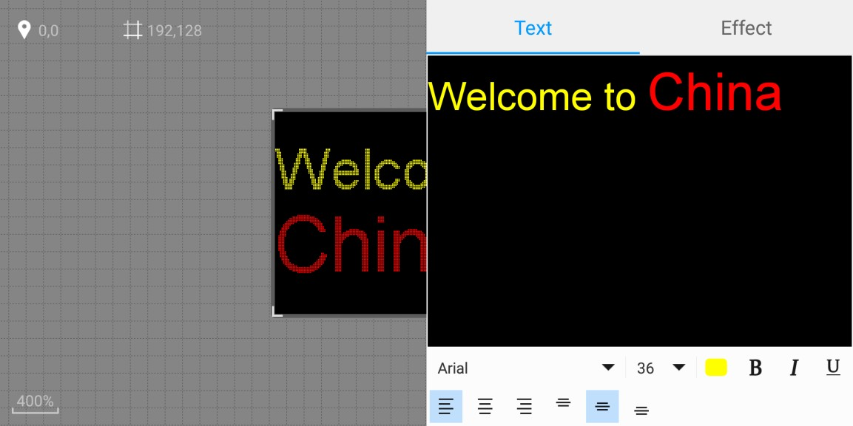
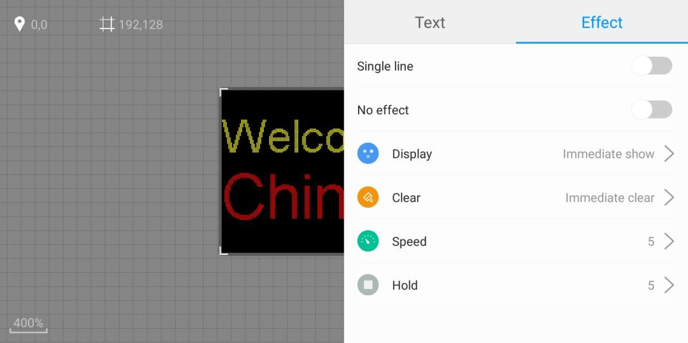

- Animation editor

- Click the lower right corner of the APP program editing interface, then
click to select the add animation , enter the animation word editing interface, input the text content to be displayed, and set the font and font size of the text.

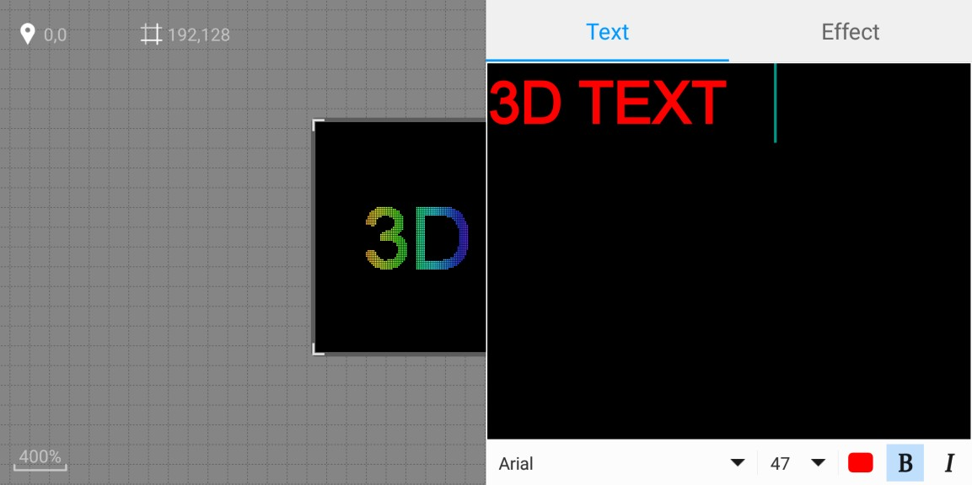
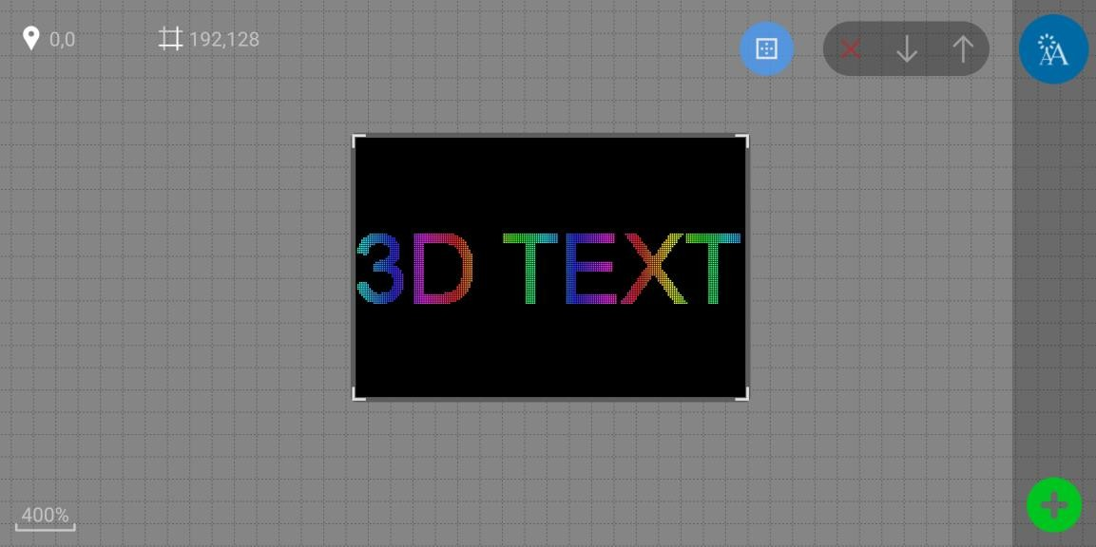


- Select the animation word area, click on the upper right corner to enter
the animation word property interface, and set the animated style, neon background, speed, etc. under the special effect interface.
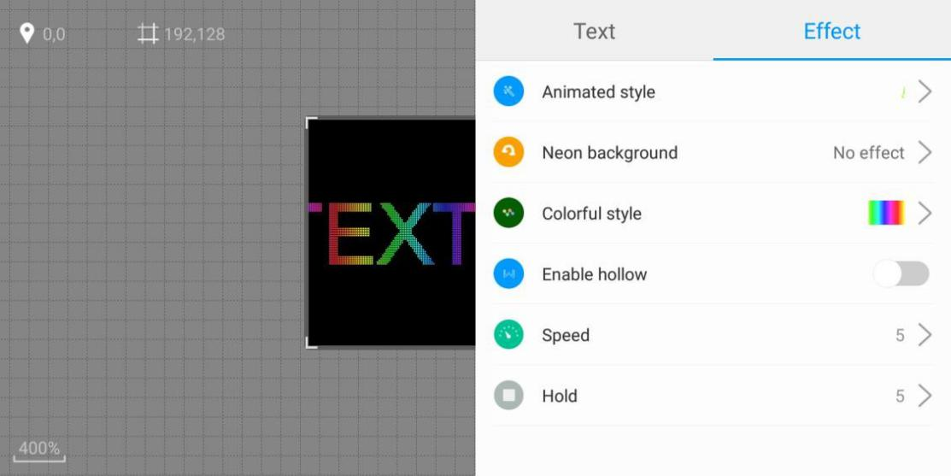

- Clock editor

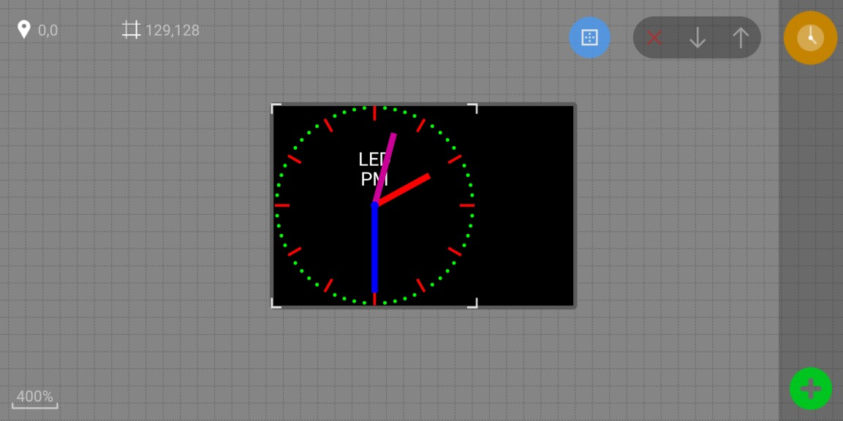
- Click the lower right corner on the screen program edit interface, and click to Select add clock values。
- Select the clock area, click the upper right corner Entering the clock property interface, the clock style (analog clock style, digital clock style two) and style properties can be set.
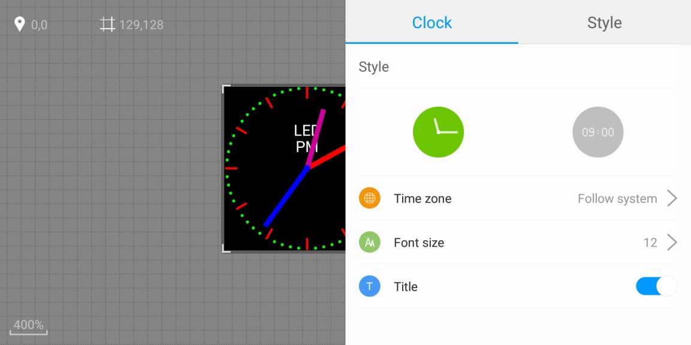

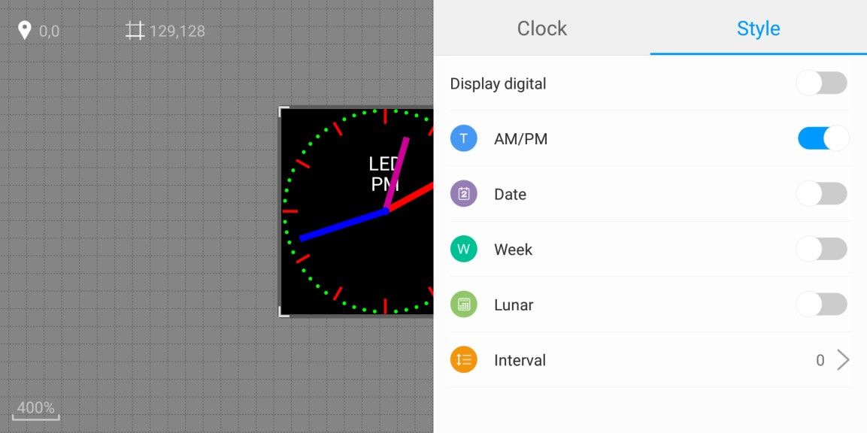

- Temperature editor

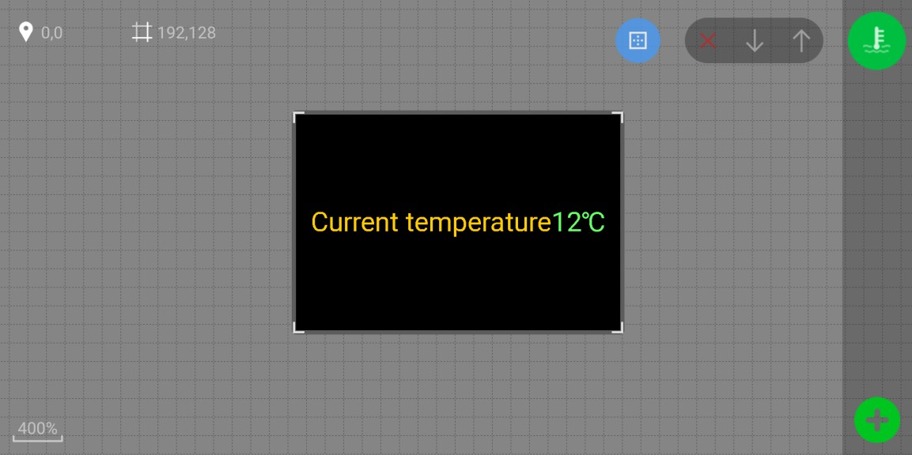
- Click the lower right corner on the screen program edit interface, and click to Select add Temperature values。
- Select the temperature area, click the upper right corner Enter the temperature property interface, can set the temperature style, the fixed text display, and so on。

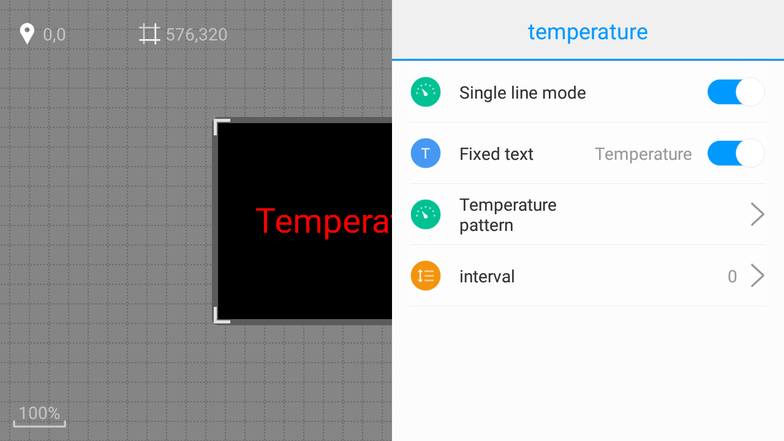

- Humidity editor

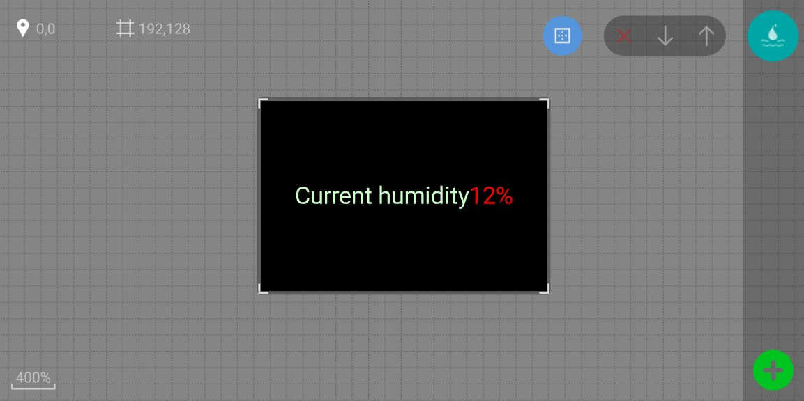
- Click the lower right corner on the screen program edit interface, and click to select add humidity values。
- Select the humidity area, click the upper right cornerenter humidity property interface, can set humidity style, fixed text display, etc.

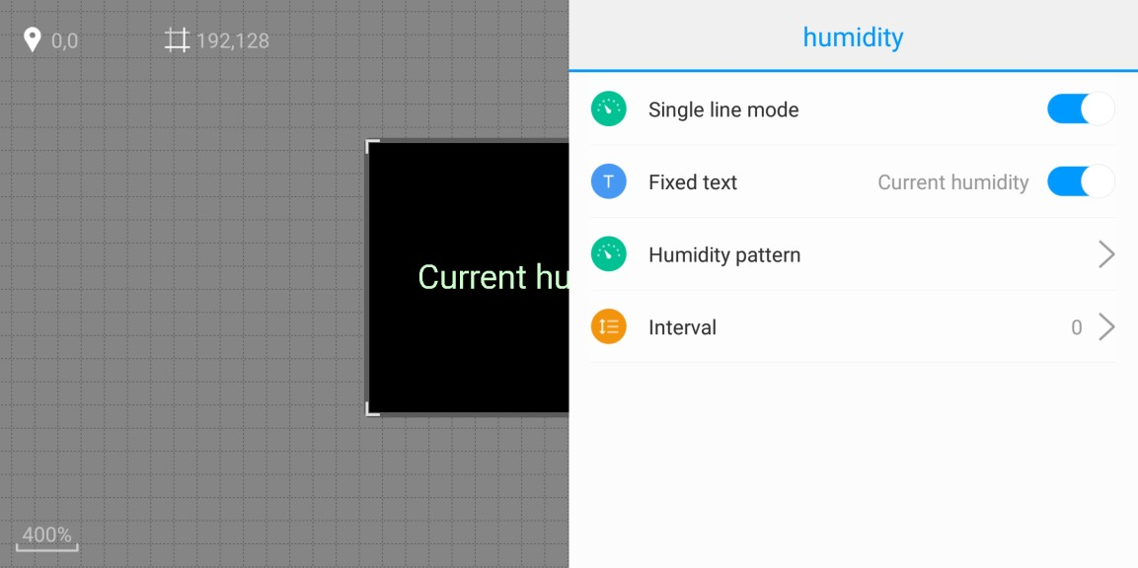

- Timer editor

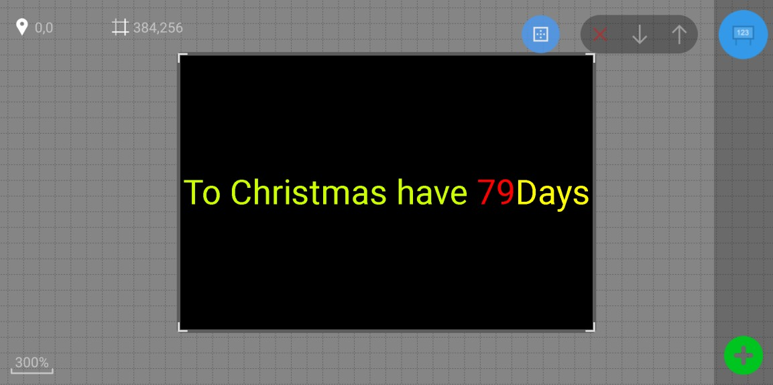
- Click the lower right corner on the screen program edit interface, and click to select add timer values。
- Select the timing area, click the upper right corner Enter the timing property interface to set up a fixed display of text title, target time, style, and so on.

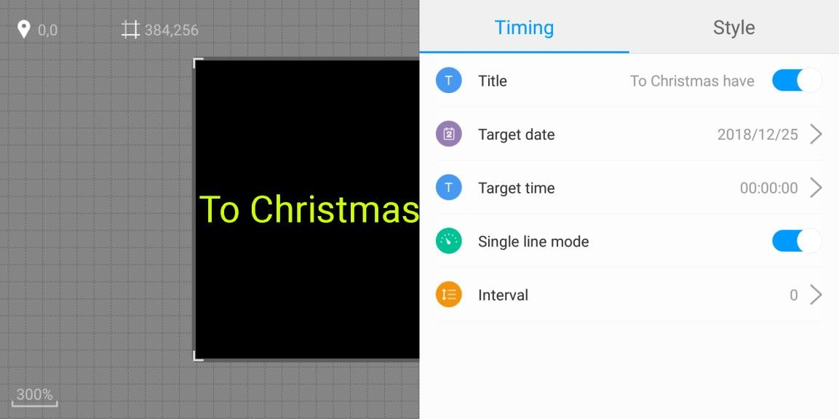
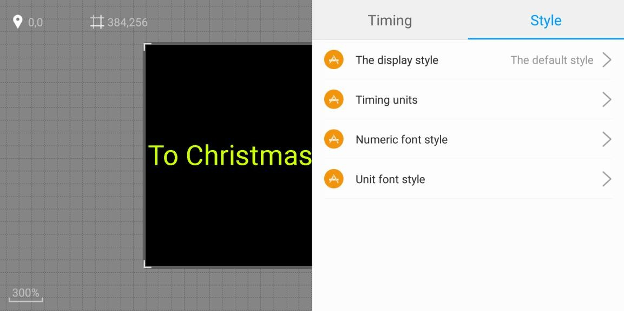

- Border and program setting
- Area border

After selecting the video, picture, text or clock in the APP editing interface, click  to enter the border setting interface to set the border type and its special effects and speed.

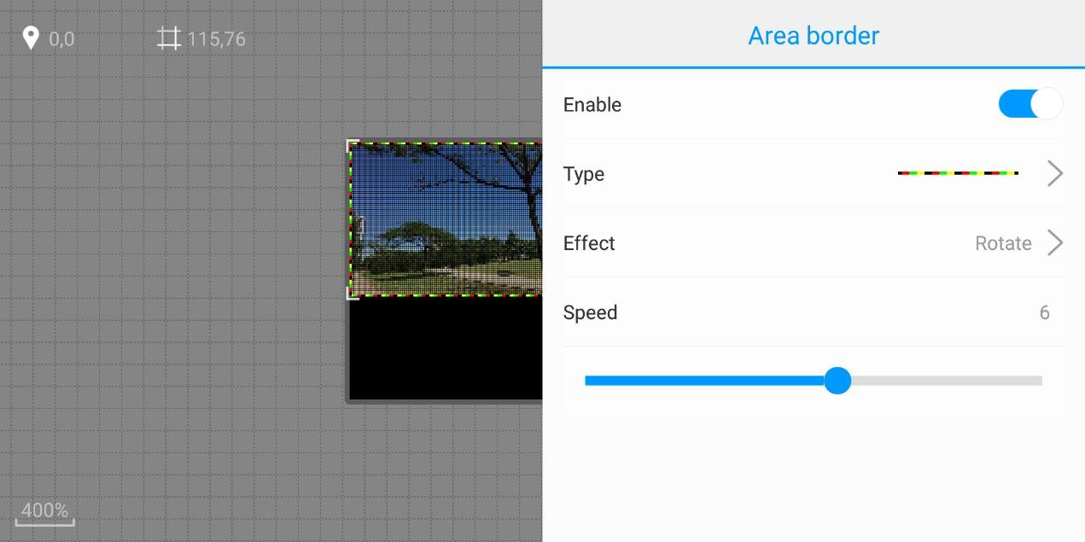
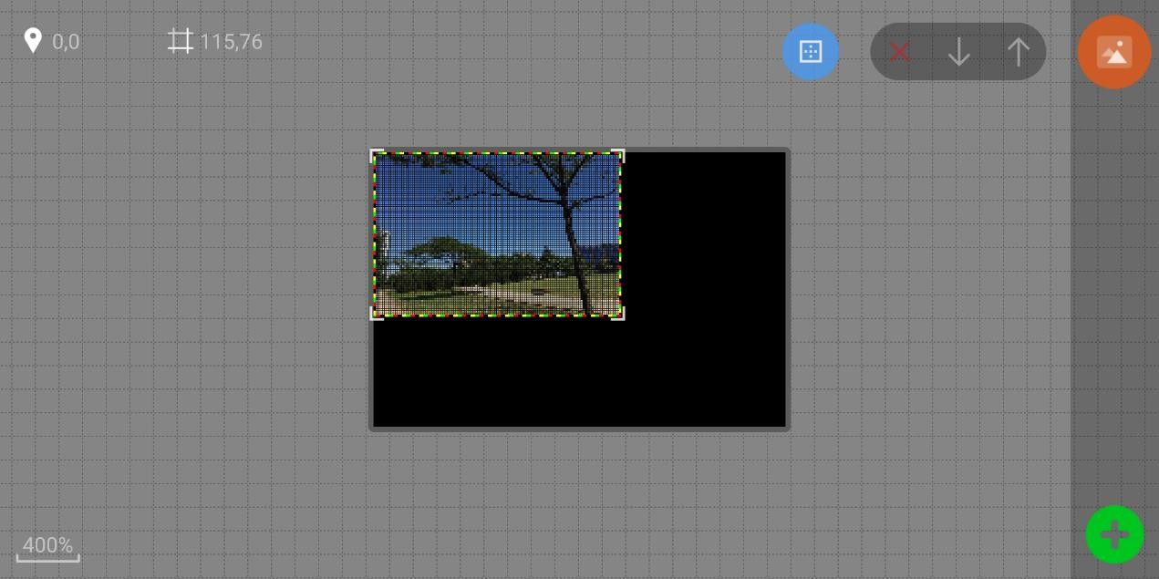
- Program setting


In the APP editing interface (cannot select the program area), click on the lower right

corner to enter the program setting interface . The "Program Border" option can set the border type and its special effects and speed.

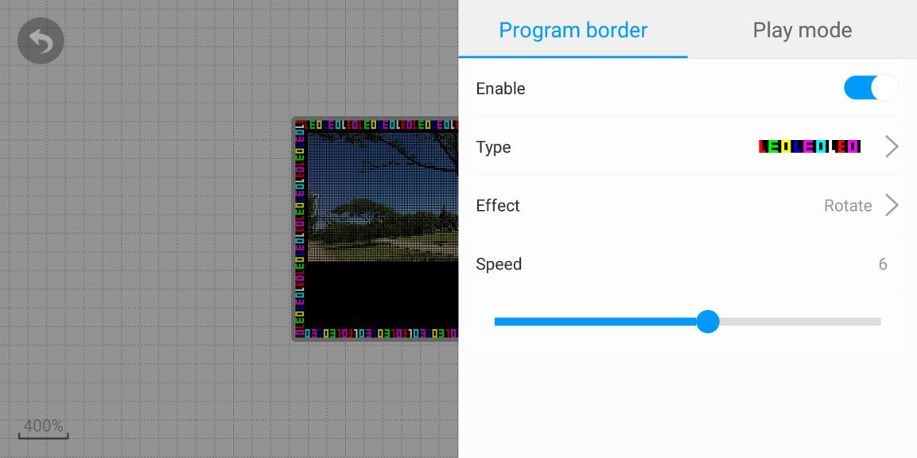
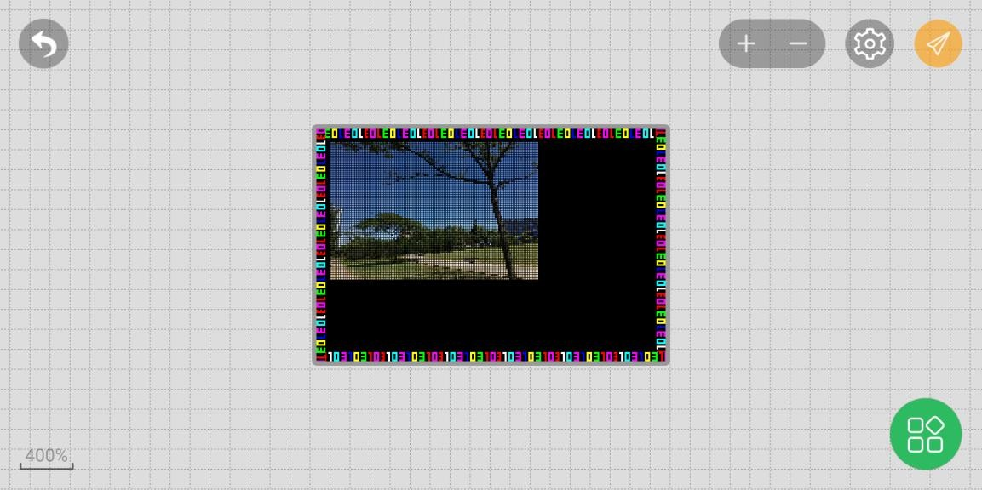
The Play Mode option sets the number of times the show is played and the duration of the show.
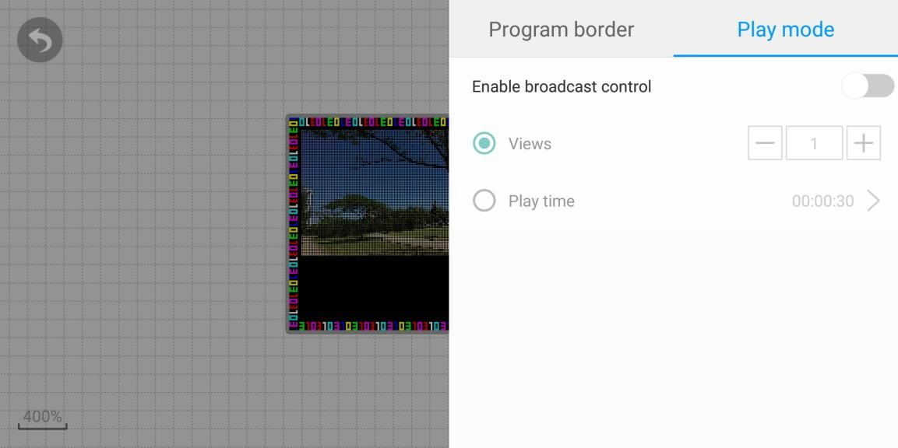

- Regional management
A program can add multiple areas, and at the same time, multiple contents can be added to a region, such as video, picture, text and so on. After that, the added area is at the top level, which is located at the top of the regional list.
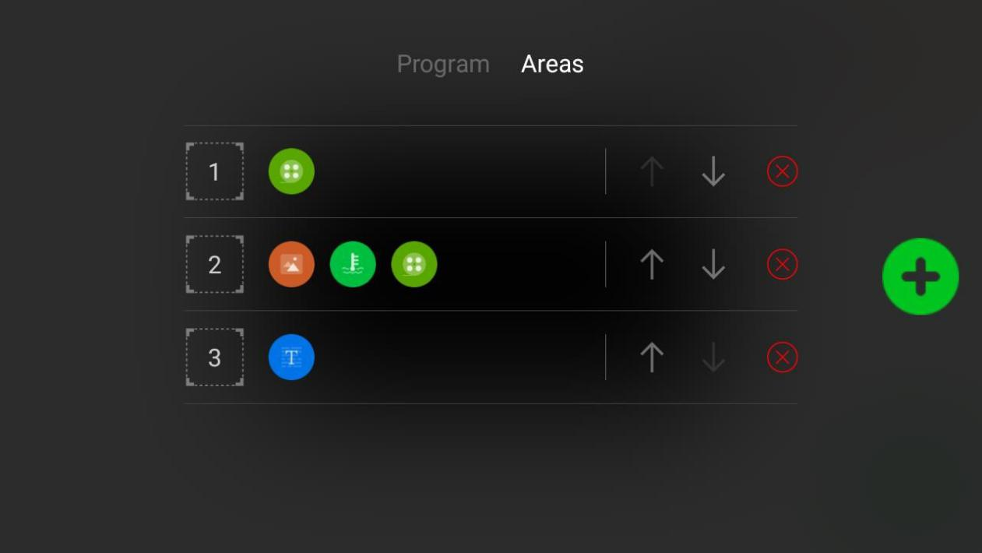
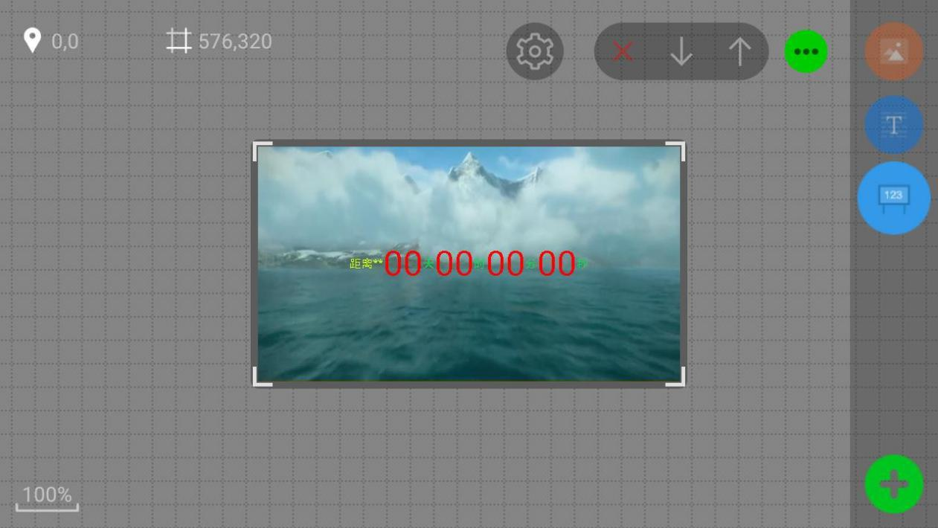

- Program management

In the main interface of the app, click  on the bottom right corner to

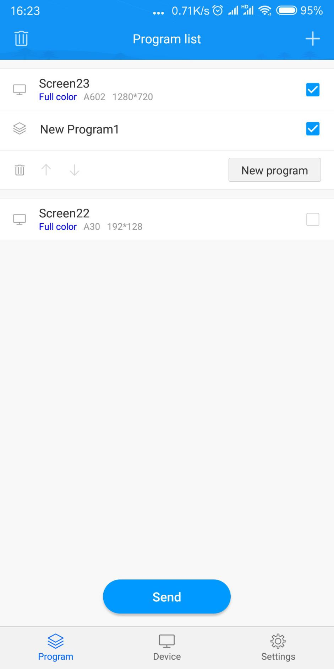
enter the program management. In the program management interface, you can see the program list, you can add programs or add display programs.

- Update the program
After editing the program, click on the  send button on the phone screen, enter the sending list, select the corresponding device and send it.
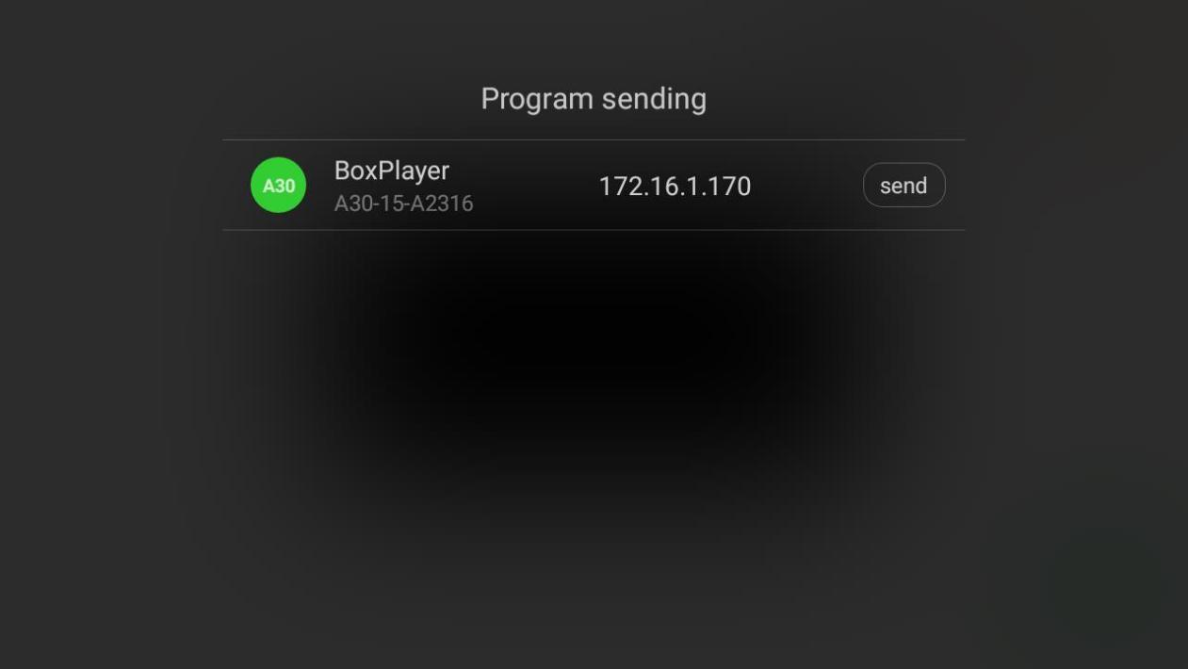
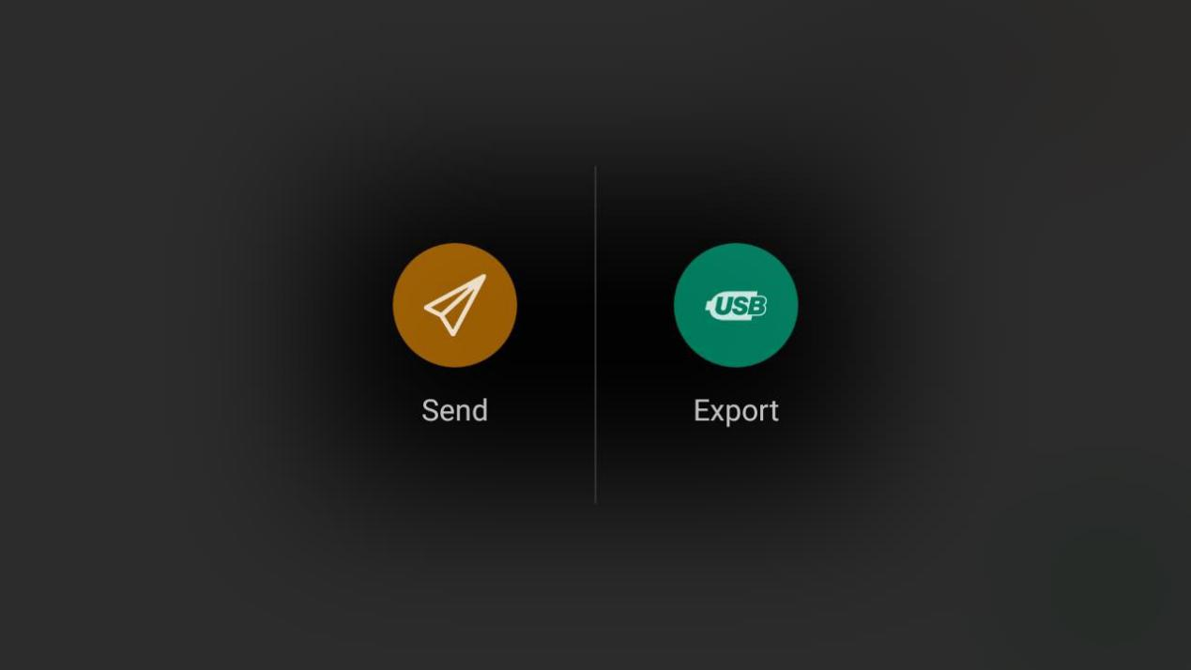
You can also click the send button for the first time, select the export program buttonand connect the cell phone to the control card through data line, so as to realize program update（only Android mobile phone ）.

Chapter four, Function setting

- starting up and power off

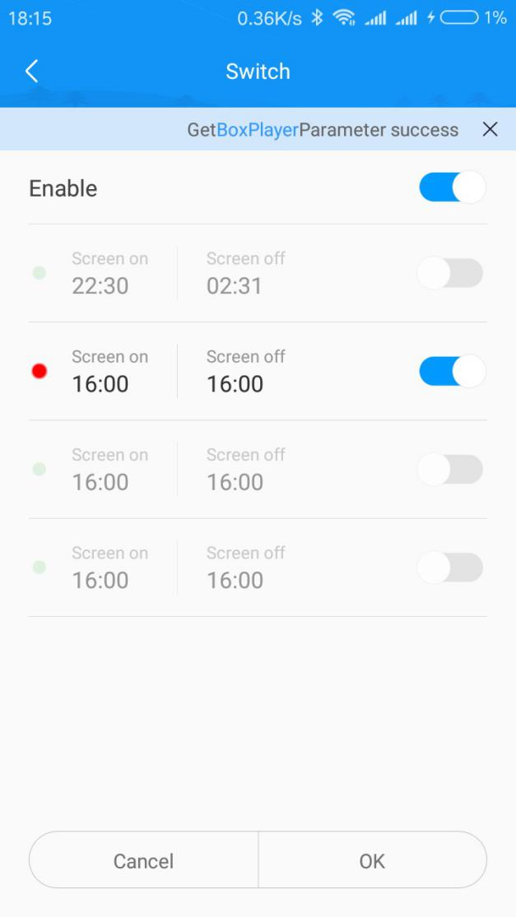
In the main interface of the software, click on the switch to set the button , and enter the switch setting interface. At the same time, it can set the switch function of 4 time periods. Shutdown just cut off the signal to make the screen black screen, in fact no power off.

- Brightness
In the software main interface, click the brightness setting button to enter the brightness setting interface. The right and left sliding phones can be switched to default, adjust the three settings automatically according to time and automatically adjust the need to control the card to connect the brightness sensor.

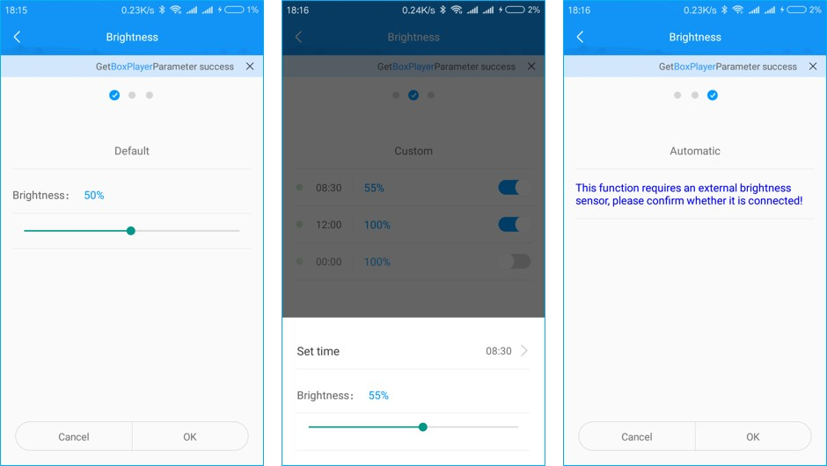

- Time correction
In the software main interface, click the time correction setting button  to enter the time correction interface, which can directly synchronize the cell phone time, and also can turn off the "automatic setting" and manually set the time.

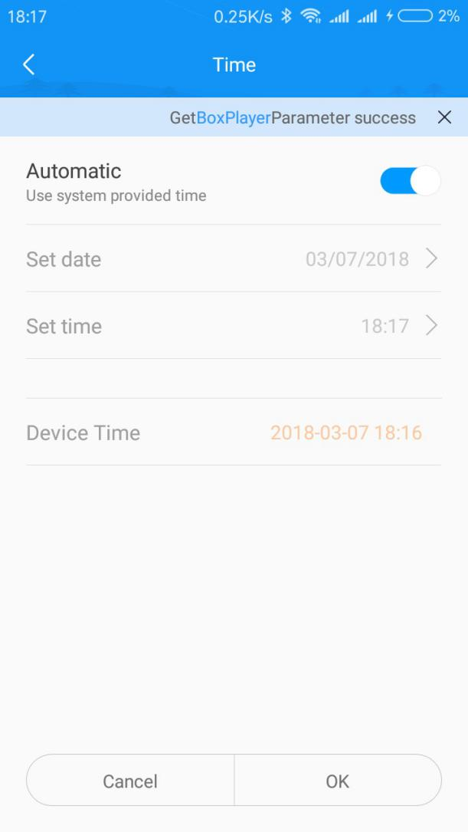

- Shakes
In the software main interface click  button to swing into the swing interface, sliding around the screen to switch the picture or video, select a picture or a video shake mobile phone (mobile phone can feel the vibration) or sliding upward on the mobile phone screen, pictures or video can be sent to the control card and will not delete the original content.

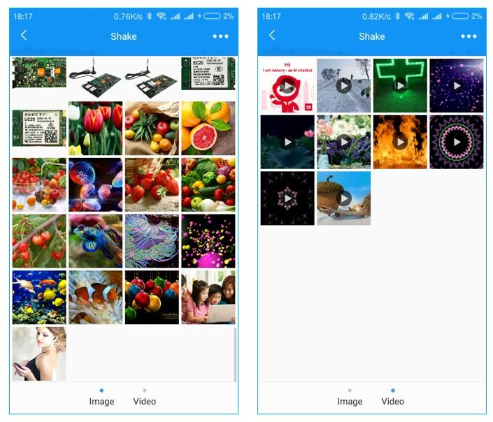

- Remote-control
On the software main interface, click the remote control button  to enter the remote control interface. It can set the brightness of the display screen, play a serial number program and switch screen.

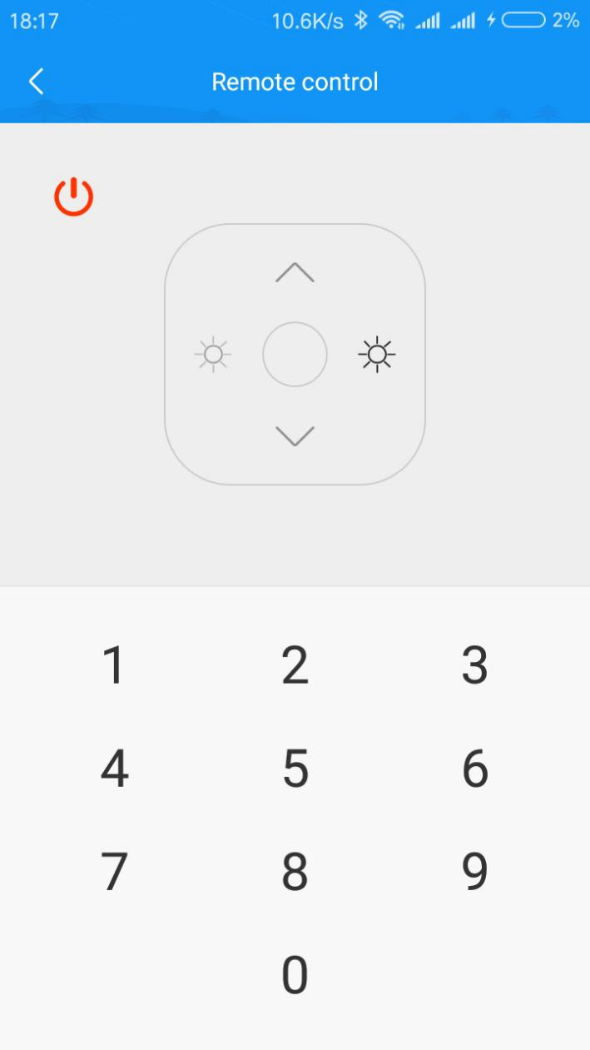

- selection tools
Click the 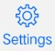 icon on the left upper corner at the main software interface, select the selection tool to enter the full color product selection, input the display information automatically according to the actual needs, and automatically calculate the basic parameters of the display screen, and provide the optional control card type and quantity.

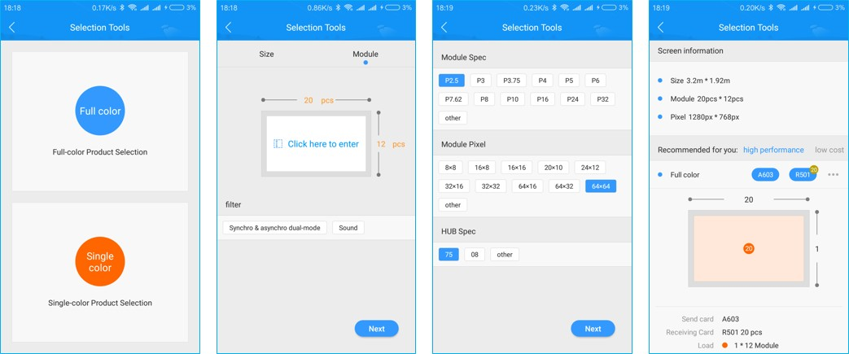

- Other setting
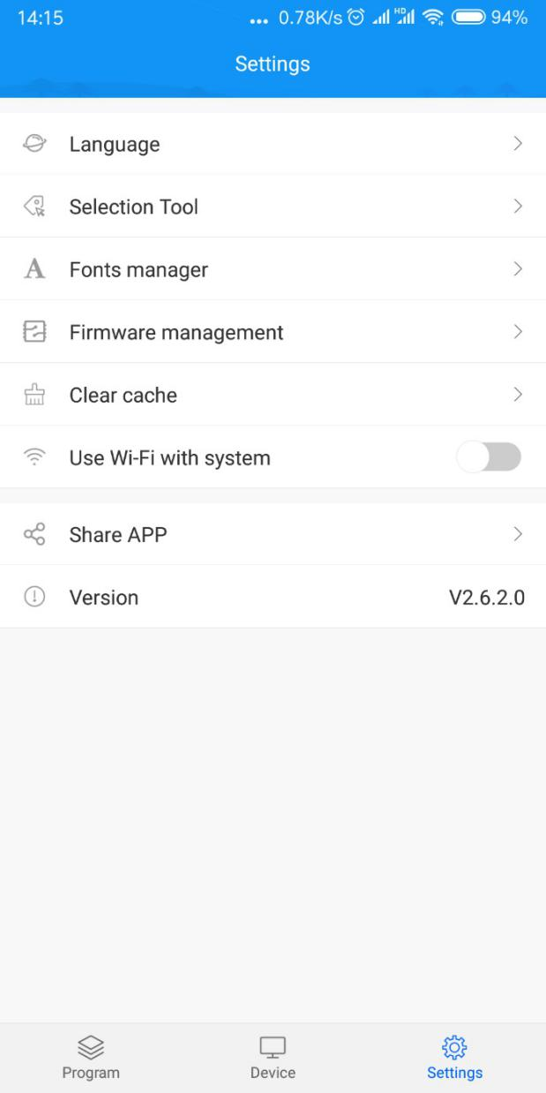
In the setting interface of the main interface of the APP, you can manage fonts, set the language, share the QR code of the app, and clear the cache.

