LED display information management platform instruction manual

Catalog
LED display information management platform instruction manual 1
Chapter 1 Overview 1
1. System module 2
Chapter 2 Module function introduction 2
- Login interface 2
  - Account login 2
  - Sign up 3
- Device management 3
- Device List 3
- Equipment details 4
- Delete program 5
- Program management 6
- program list 6
- New program 6
- Editing program 7
- Release program 11
- Resource management 13
- Publish logs 15
- publish task list 15
- unchecked task list 15

Chapter 1 Overview

- System module
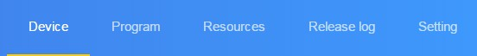
LED display information management platform using B / S system architecture, including equipment, programs, material, release log and set the module.

  - System module

- Login interface：User registration, login, change password, switch language.
- Equipment: equipment up / down status, time correction, brightness adjustment, firmware upgrade and other operations, equipment "details" can see the equipment running status information.
- Programs: including new programs, program editing, program preview, program release and other operations. Program list can view the program "history", and preview program content.
- Materials: upload video, pictures, GIF animation, pending material.
- Release log: program release record, program task release status and un-audited program record
- Settings: background management. Including user management and network management; new outlets, the equipment assigned to outlets, and then create new sub-users, the outlets will be given to users, in order to achieve user rating management equipment.

Chapter 2 Module function introduction

- Login interface

- Account login
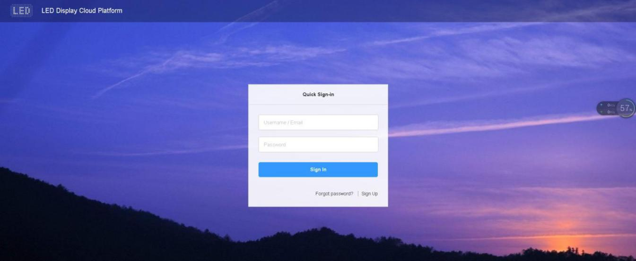
Users can choose the user name / email / phone number landing，Figure2-1 .

2-1 window of login

- Sign up
Click in the login window “sign up”，Figure 2-2 .
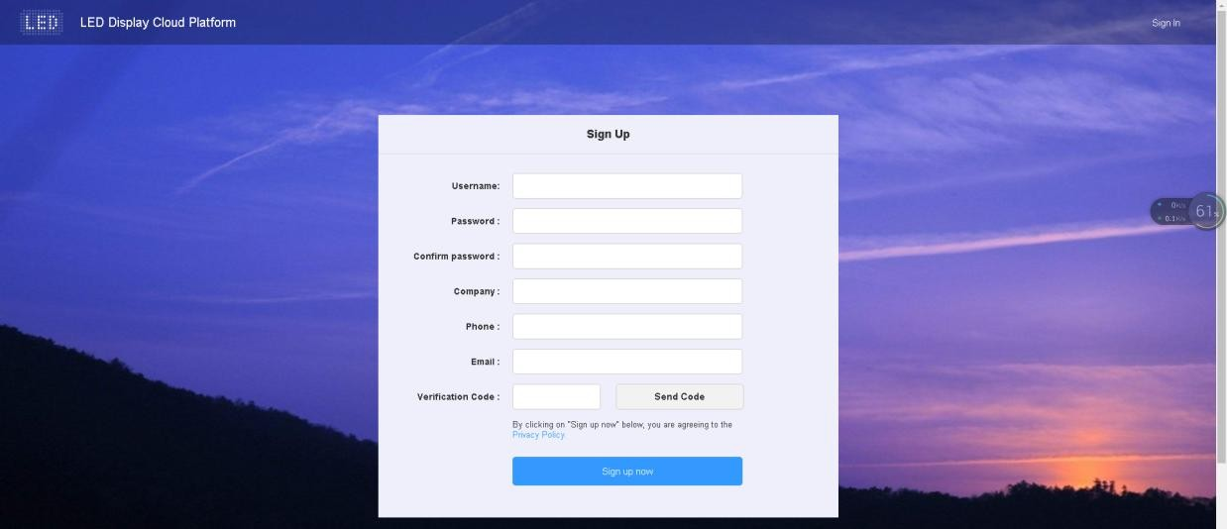

2-2 Register account interface

Note: A. The verification code can be obtained via text message or email.

B. Must fill in the correct company name, phone number, email, so that smooth platform administrator audit.
- Device management
Device management is divided into two parts: a brief list of information and equipment details.
- Device List

Each on-line device needs to be audited by the platform administrator or it can not be managed through the platform .

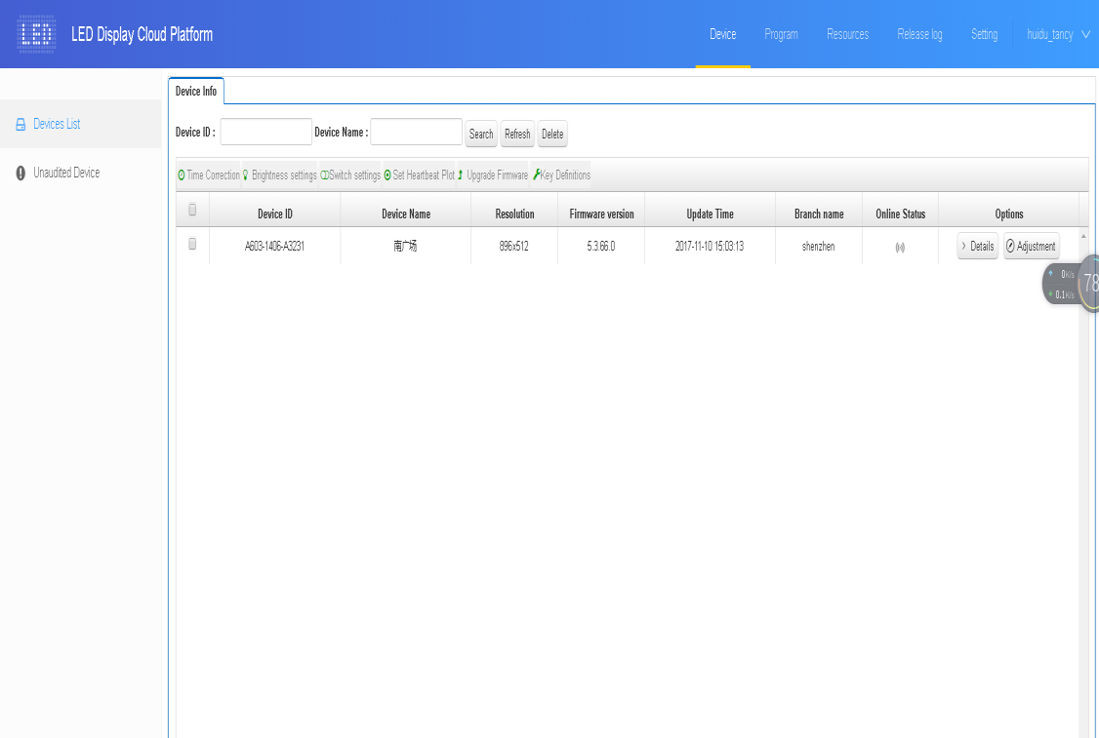
2-6 Device list
The list contains Device ID, Device Name, Resolution, Firmware Version, Up / Down Time, Up / Down Status and Network Node Name. The "Time Correction", "Brightness Setting", "On / Off Setting", "Firmware Upgrade".
- Equipment details
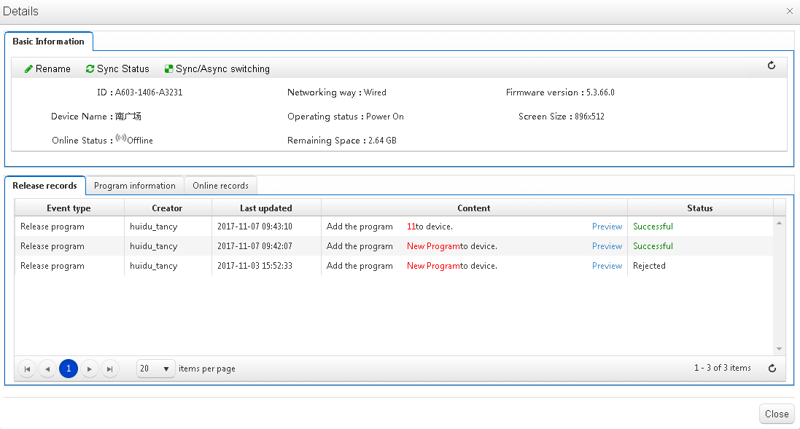
Click the "Details" button to enter the selected device details interface, where you can view the basic information of the device, including the networking mode, firmware version, running status, remaining space, etc. Figure 2-7.

图 2-7 Equipment details

Device ID: ID of the currently selected device;

Device name: the name of the currently selected device;

On-line status: The online device is connected, the offline device is disconnected,

Operating status: open screen for the LED screen boot status, off the screen for the LED screen off state;
Firmware version: the current device firmware version number;

Screen Size: The size of the screen stored in the device (the screen size can only be changed by HDPlayer software);
Remaining space: the space left in the device;

School hours: the service time as a benchmark for the school equipment;

Brightness Settings: Set the brightness of the LED screen;

Rename: modify the device name;

Switch settings: timer switch LED display;

Firmware upgrade: upgrade device firmware;

Synchronization status: synchronously read the device program, networking mode, remaining space and other status; (The default will automatically read back, when the automatic read-back can not use this function, manual read back.)
Release record: can view the device's task release record;

Program information: You can view the number of programs in the device, program name, space occupied by the program, "delete" and "preview" programs;；
Logs up and down: You can view the logs of devices on and off the line.

- Delete program
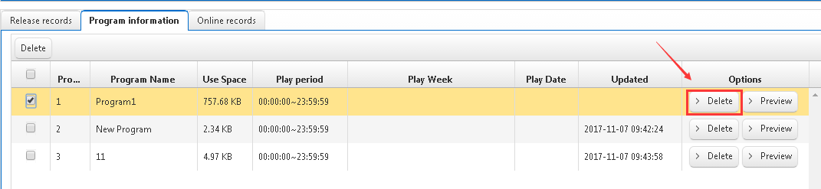
Click on the "Device" list in the "details", and then select "program information", select the corresponding program to delete.

2-8 Delete program

- Program management

- program list
Click [Program management] to enter the program list, you can rename, preview, edit, copy, release, history, program creator, modify time and other operations. If there are more programs, you can select the text box Enter keywords, click the "Query" button, Figure 2-9.
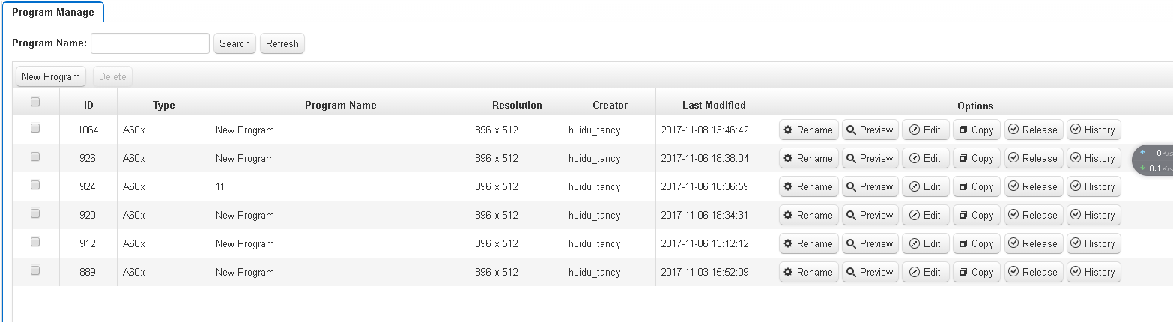

  - program list

Program Type: The device type selected when creating a program, the product family for DX0 / AX0 / A60X, respectively.

Program Name: the name of the program created

Control range: The size of the analog display that created the show；

Created by: the user name of the created program

Modify the time: the last editing program time;

Operation items: The program can be renamed, preview, copy, edit, publish and other operations.

- New program
Click [Program management], then select "New Program", in the New Program dialog box, define the program name, and then select the corresponding device, OK, Figure 2-10.

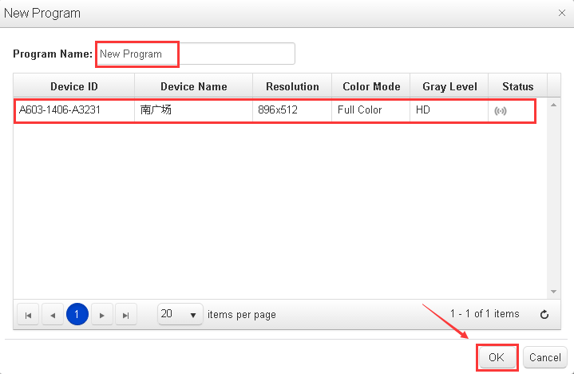

  - new program
NOTE: screen resolution can not be modified, according to the actual screen size, the provided software HDPlayer.
- Editing program
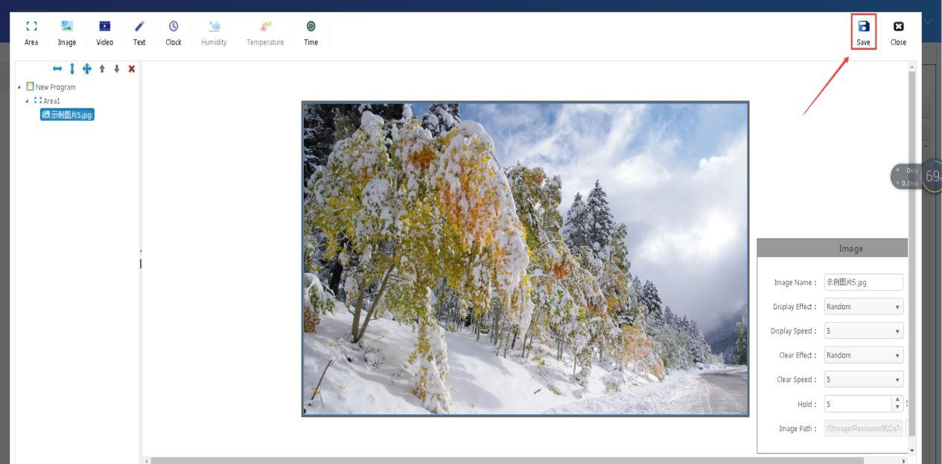
Edit the program page, you can add multiple regions, pictures, videos, text, etc., after editing, click "Save", Figure 2-11.

  - Program editing window

- In the tree area select "program", you can modify the program name and so on.

- Click the "Add Area" button， Stretching around the area, up and down, maximize, delete, move the order and other operations.
In the area properties window, you can modify the area name, position and size, or drag the area or stretch the area on the analog display.
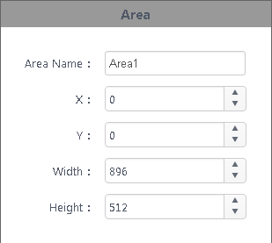

2-13 Area properties Note: Content must be added in the area.
- Select a region, click "" button to enter the picture list interface, select the picture to be added and click OK, Figure 2-14.

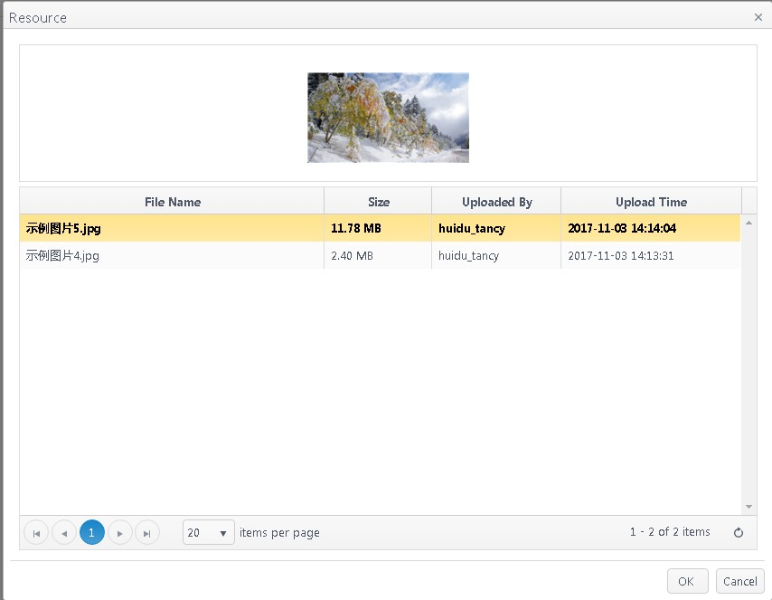

2-14 Add a picture window

Support*.gif、*.jpg、*.jpeg、*.png、*.bmp、*.tiff、*.pbm、*.pgm、*.ppm、*.xbm、*.xpm etc. format images.
- In the area under the selected picture， you can delete, move the order and other operations, in the picture attribute area can rename the image, display effects, display speed, dwell time and other operations, as shown in Figure 2-15.
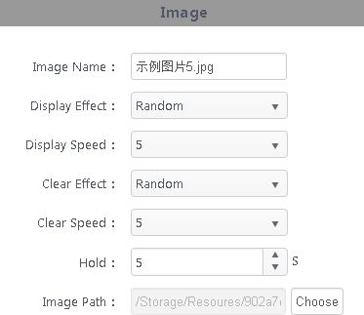

2-15

- Select one area, click on the top left corner of the video “” button to enter the video resource box, Figure 2-16, select the video you want to add and click "OK”.
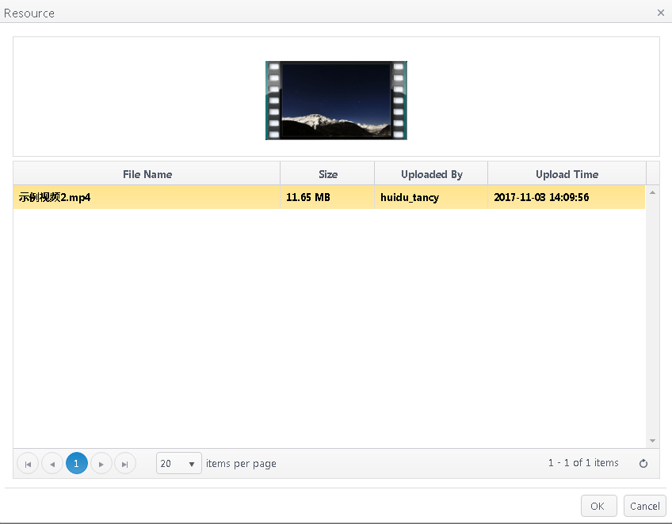

图 2-16 Add video window

Support*.gif、*.jpg、*.jpeg、*.png、*.bmp、*.tiff、*.pbm、*.pgm、*.ppm、*.xbm、
*.xpm etc. format video.

- Check the video below the area, you can delete, move the order and other operations, in the video properties dialog box can set the number of video playback, Figure 2-17.
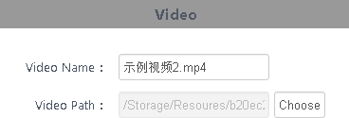

2-17

G. Select a region, click “ ” button to add text， you can delete, move the area up and down and other operations.
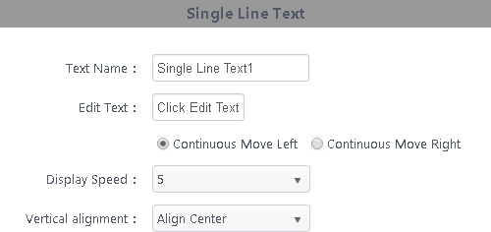
In the text properties dialog text may be renamed, and the display speed of the display effect, the screen is cleared and the screen is cleared effects speed, dwell time between the display and clear the screen of Figure 2-18；

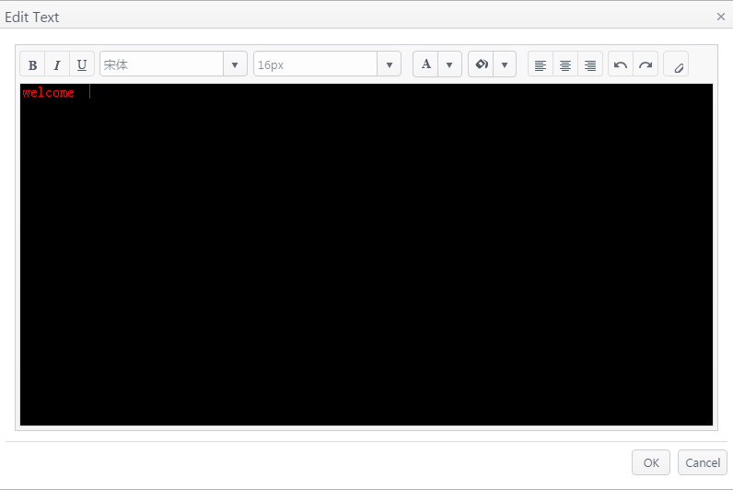
2-18 Text attribute Click the "Edit Text" button to edit the text, Figure 2-19.

2-19 text editing window

- Release program

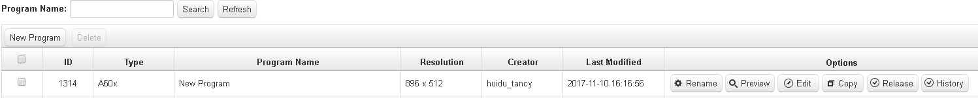
A. After editing the program click on the upper right corner of the " " Save button. Return to the program list, find the program to be released (program name or program ID), click the "Publish" button, and Figure 2-20.

2-20

B. In the dialog box can be set to release regularly sent, specified time, day, date playback. Figure 2-21.
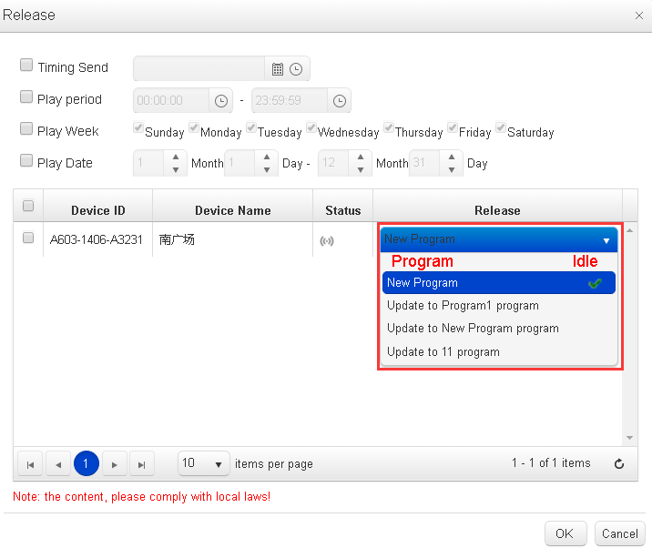

2-21

New programs - based on the original program to increase the program, the original program reservations;

--- Update to X program --- Replace X program.

C. After issuing the determination, automatically jump to publish a detailed program task window, you can view the sending state. In the case of programs for review, the status bar shows awaiting approval, Figure 2-22. (You can also go to the device list or release record click on the details to view the task release record)
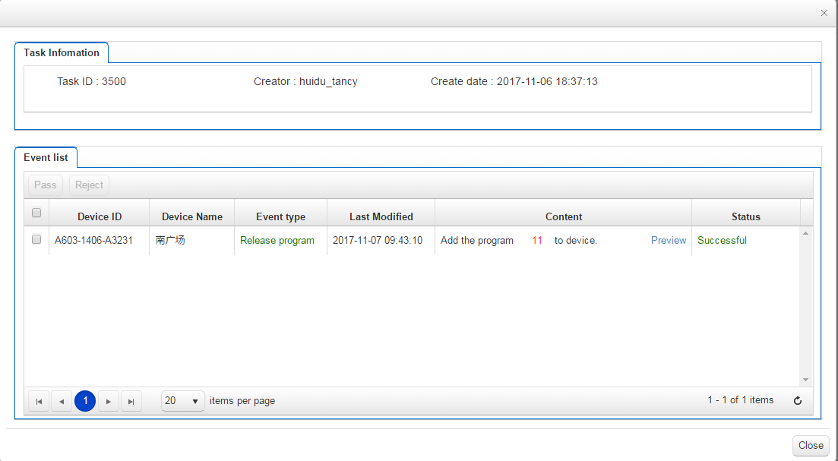

2-22 Task release details

- Resource management
By default, all resource information can be previewed in the resource list, or previewed by image and video. Figure 2-24. Click on a picture or video to enlarge the preview. View unmanaged material for uploaded, unverified material.

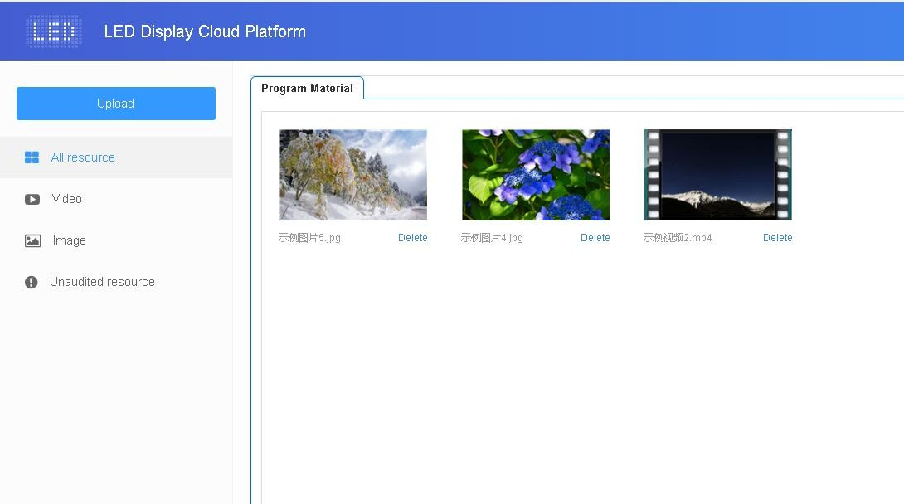

2-24 Resource Management List

To save time, you can advance to the resources (images, videos) to play uploaded to the server, call the resource on the server directly in the process of editing program to reduce the waiting time, effectively improve the efficiency.

Click on the " " button in the top left corner of the material list, click the "Select" button in the pop-up dialog box to select the material to upload, Figure 2-25.
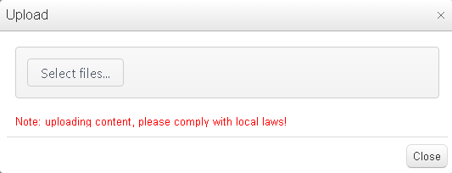

2-25 Upload resources

Select the file you want to upload, Click "Open" to start uploading and display the upload progress bar.

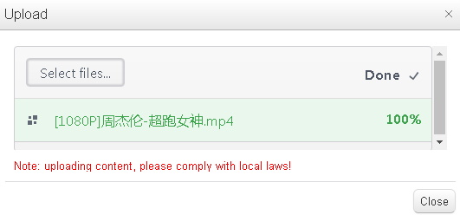

2-27 Upload the result

- Publish logs
View the list of tasks and unapproved programs in Release Management.

1）publish task list
In the list of released tasks, you can view program creator, creation time and task status, Figure 2-30 .
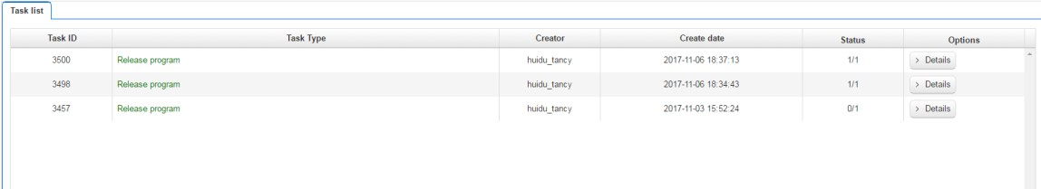

2-30

Task Status: A / B, A represents the number of the program successfully posted; B represents the program destined B devices. For example, 2/3 indicates that the program is sent to three devices, and two devices have been successfully released and one failed. Click "Details", you can see the release status.
2）unchecked task list
When a sub-user does not have the permission of the program management module, the published program needs to be audited, audited by a registered user or a user who has the permission of the device, and then submitted to the platform administrator for review. Figure 2-31.

