document content | HD2020 LED Control System Operation Manual
version | V1.0

HD2020 LED
Control system operation manual

Table of Contents

目录
Chapter 1 Overview 4
1.1 Features 4
1.2 Operating environment 4
Chapter 2 Installation and Uninstallation 4
2.1 Installation 4
2.2 Uninstallation 5
Chapter 3 Detailed Use of Tools 6
3.1 Software main interface 6
3.2 title bar 6
3.3 Menu Bar 6
3.3.1 File menu 6
3.3.2 Setting menu 7
3.3.3 Language menu: 14
3.3.4 Help menu: 14
3.4 Tool bar 14
3.5 Preview display 15
3.6 Display property bar 16
3.7 Using the remote control 16
3.8 Setting method of smart setting 17
3.9 Setting method of cross screen 22
Chapter 4 Display Program Creation Process 23
4.1 New display and program files (first level content) 23
4.3 Program production completed 24
Chapter 5 How to Display Different Contents 25
5.1 Text display 25
5.2 Graphic display 25
5.3 Animated word display 26
5.4 Excel display 27
5.5 Time display 28
5.6 Forward / countdown display 29
5.7 Count display 30
5.8 Temperature or temperature and humidity or PM2.5 display (sensor is required separately) 31
5.9 Lunar calendar 33
5.10 prayer 33
5.11 weather 34
Chapter 6 Communication Settings 36
6.1 The practice of serial line 36
6.2.1 232 communication 36
6.2.2 485 communication 37
6.3 The practice of network cable 38
6.4 Communication settings (network port) 39
6.4.1 LAN single network card (HD-E63) communication 39
6.4.2 LAN network card communication 39
6.5 Communication settings (Wi-Fi card) 42
6.5.1 Wi-Fi Card connection 42
6.5.2 Change the SSID and password of the Wi-Fi card 45
6.6 How to use a USB flash drive 46
Appendix 2 Common settings during use 48
Appendix 2.1 How to upgrade the control card 48
Appendix 2.2 How to restore control card to factory settings 49
Appendix 2.3 How the Control Card Tests the Display 49
Appendix 2.4 Display timing switch 50
Appendix 2.5 How to set the text to stand still 50
Appendix 2.6 Text moves continuously without interruption 52
一、 PM2.5 operat Instructions 54

Chapter 1 Overview

Features

"HD2020" control system is a new round of huge adjustments made by Hudu Technology Co., Ltd. in 2020. In order to facilitate customers' selection, some duplicated controllers are integrated, the control range is updated more flexibly, and the price is more moderate, which is enough to cope with the current trend of taller, longer and more diverse screens.

The overall interface of the software continues the style of simple operation, powerful functions, easy to learn and use, and supports graphics (JGP, BMP, GIF, text, etc.), text, animated characters, Excel, time, timing, counting, lunar calendar, temperature and humidity, prayer , Weather, can support serial (including 232 and 485), network port, Wi-Fi, U disk and other control, can meet the application of different occasions.

Operating environment

operating system:
Chinese and English (Operation interface supports Chinese, Traditional Chinese, English, Arabic, Bulgarian, French, German, Indonesian, Hindi, Iranian, Italian, Japanese, Korean, Mongolian, Polish, Portuguese, Romanian, Russian, Serbian, Spanish, Thai, Turkish, Vietnamese 23 languages) Windows XP SP3 / Win7 / Win8 / Win10, etc.

Chapter 2 Installation and Uninstallation

Installation

"HD2020" software installation is very easy, the operation is as follows:
Find the file HD2020 V1.0.8.0.exe in your CD, double-click HD2020 V1.0.8.0.exe. The software installation wizard will enter, as shown below

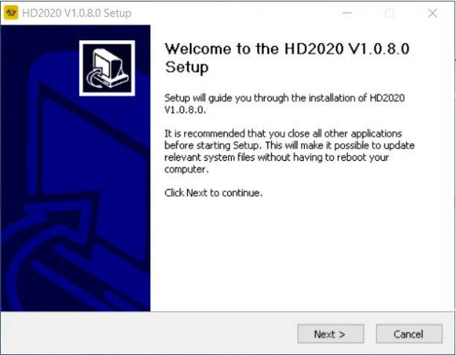
Follow the on-screen prompts (Next) to complete the installation to complete the installation

After the installation of the "HD2020" software is completed successfully, the "HD2020" program group will appear in [Start] / [Programs]. Click HD2020 to run HD2020. You can also click the desktop HD2020 shortcut to open the software.

Uninstallation

"HD2020" software package provides a complete uninstall function, users can easily delete all documents, program groups and shortcuts in "HD2020". Users can choose to uninstall HD2020 in the [Start]
/ [Programs] / HD2020 program group to complete the software uninstall operation.

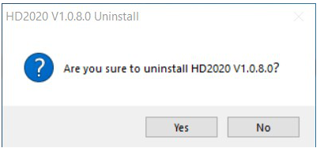

Chapter 3 Detailed Use of Tools

Software main interface

Open the main interface of the `` HD2020 '' software as shown below:
The toolbar can be divided into two columns or displayed as one column;
The information window can prompt whether the current command is sent successfully, or display the current online device.

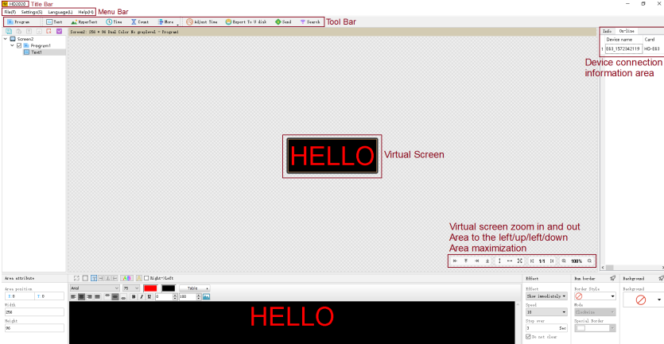

title bar

Used to display the software name;

Menu Bar

Include File-Settings-Language-Help and more

File menu

Contains new display, new cross screen, open, save, save as, exit, log out options, as shown in the figure:

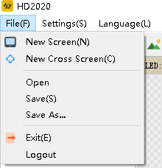
New display: It is used to create a new display. There are no restrictions on the HD2020 manageable screen.
New cross screen: used to create a new cross screen;
Open: used to open the saved display file;
Save as: used to save the current display file with a custom path;
Exit: Close HD2020 software;
Cancel: Used to cancel the current account.

Setting menu

Including screen parameter settings, system settings, communication settings, cloud server settings, device management, cluster sending, timing switch on and off, time settings, brightness settings, firmware updates, more settings (boot screen, boot prompt, button settings, screen control) As shown below:

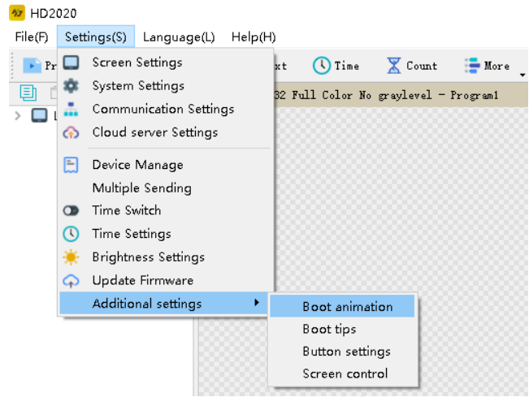
Screen parameter setting: used to bind the device and set the basic parameters of the display, as shown in the figure;

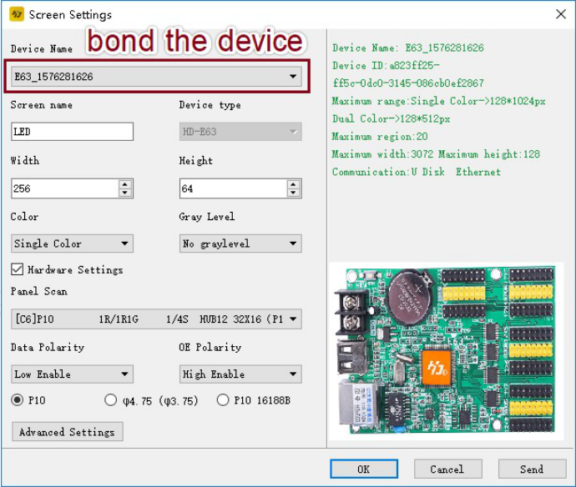

In the first step, if the control card has been displayed normally, you only need to change the screen widescreen height, color and gray level;If the screen does not display normally, you need to set the hardware.

The second step is hardware settings. For regular screens, please select common smart settings. For non-conventional screens, please perform smart settings (smart settings must be performed when a device is found, and U disk cards cannot be used for smart settings).

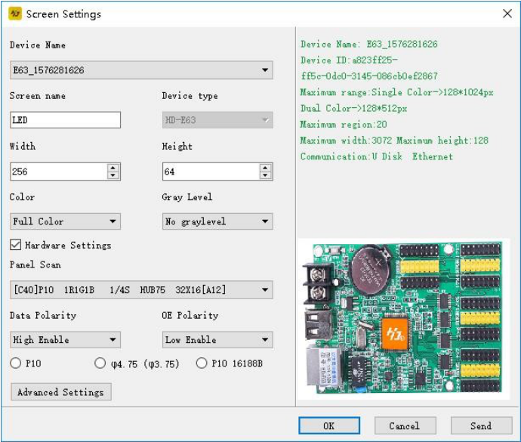
The button settings are in the Settings → More Settings → Button Settings interface, which is used to adjust the
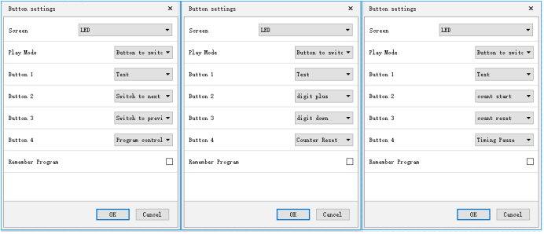

Communication settings: Used to modify the communication settings when multiple cards are connected.
- The default Ethernet is the single-machine direct connection mode, that is, when there is only one card connected to the computer, there is no need to change any settings, as long as the network cable is connected properly, the device can be found.

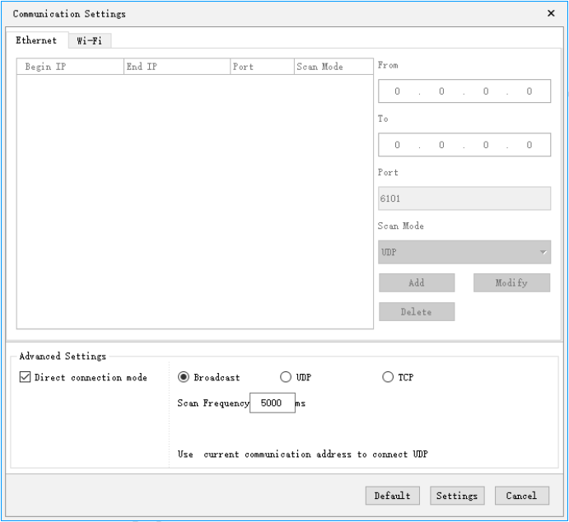

- When you do not check the single-machine direct connection mode, it is applicable to the control card and the main control computer are not in direct connection mode, and the control card and the main control computer are not in the same network segment, you need to add the IP address of the network segment where the control card is located to the software The operation is shown in the figure. After adding, you can find the card on the 192.168.3. * Network segment.

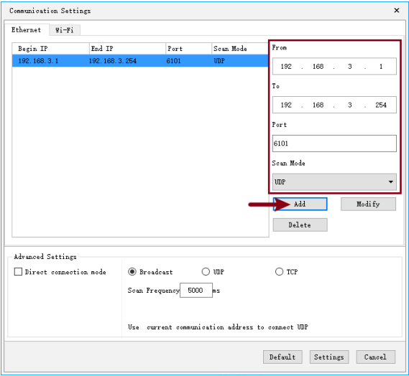
4. The Wi-Fi card interface is used to connect the Wi-Fi signal of the control card. Enter the default connection password 88888888 as shown below:

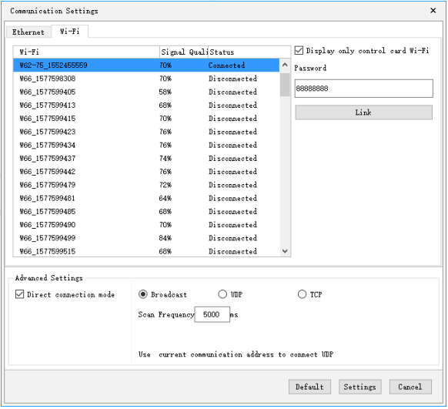

System Settings: Used to set system parameters (not recommended to change). as the picture shows:

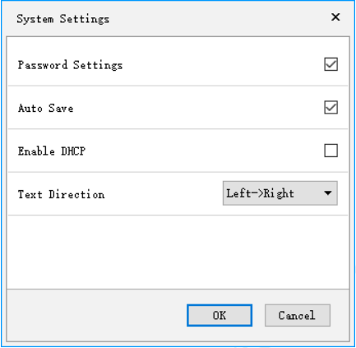
Cloud server settings: Used to bind the network port card to the cloud platform, enter the registered user name and server address, as shown in the following figure:

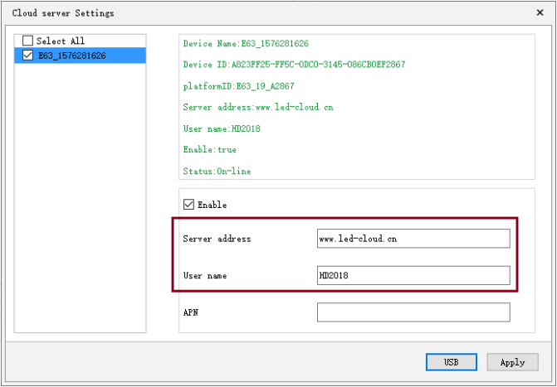

Device management: Used to modify the names of all devices that can be found, modify the IP address of the network port card, and also manage the current device's clear display data, time settings, brightness

settings, timer switch, display test, open screen, restart Display, Wi-Fi settings.

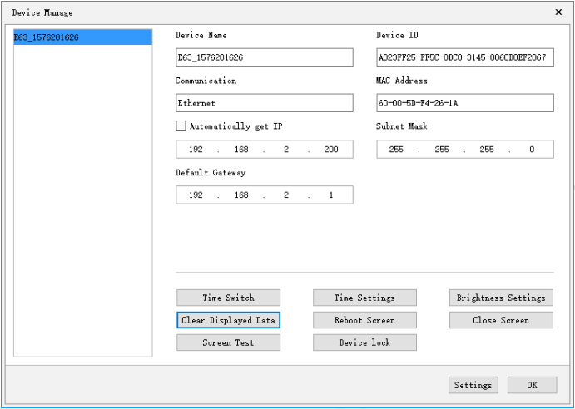
Cluster sending: used to send multiple display files; there are two types of multi-screen mode and copy mode.
- Multi-screen mode: It is required that the device name is selected in the screen parameter setting, and one device is bound to each screen.
- Copy mode: Select the display to send and send the display to all found devices.

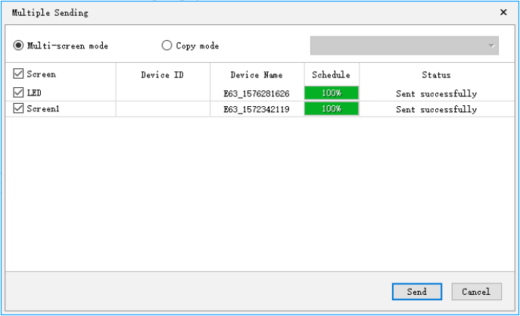

Time setting: Set the time on the control card, which can be the current time of the system, or it can be the elapsed or future time.
Brightness setting: divided into manual, automatic adjustment (requires additional sensor), three types of adjustment by time.
Timer power on / off: Set the startup time and shutdown time of the control card.
Startup screen: Enable the startup screen, click OK after loading the file, or export the file to a USB flash drive.
Firmware update: used to upgrade the control card.
Power-on prompt: Used to remove the power-on prompt of the control card, you can set not to display or show all / firmware version / control card + memory size
Screen control: used to control the on / off / play / pause of the display

Language menu:

Includes Simplified Chinese, Traditional Chinese, English, Arabic, Bulgarian, French, German, Indonesian, Hindi, Iranian, Italian, Japanese, Korean, Mongolian, Polish, Portuguese, Romanian, Russian, Serbian, Spanish 23 languages: Chinese, Thai, Turkish, Vietnamese, for switching the user interface without language.

Help menu:

Toolbar for viewing the version number of the HD2020 software.

Tool bar

Contains programs, text, graphics, time, timing, counting, animated characters, temperature and humidity, Excel, Chinese calendar, prayer, weather, time, U disk export, send, search for machines and other tools, as shown in the figure:
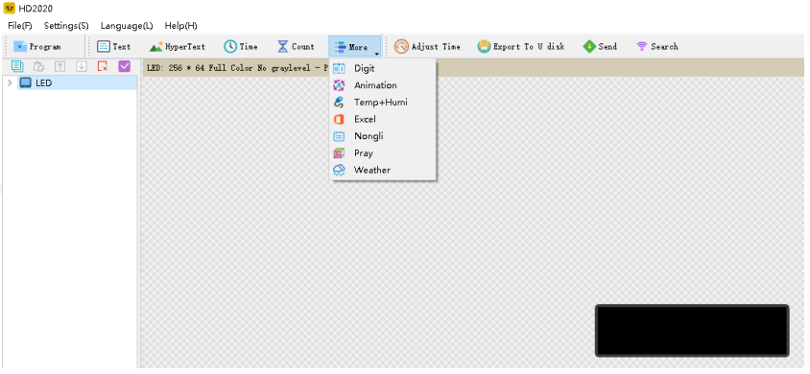

Program: used to create a new program (the program is the next-level directory of the display screen); Global program: only for cross screen;
Graphic: for creating a new graphic area, you can add pictures, GIF, text;
Text: The text can support 90 °, 180 °, 270 ° rotation, and supports regional background;
Animated characters: used to create new animated characters areas, hollow characters, font strokes can be built, and classic backgrounds and image backgrounds are supported;
Excel: Add Excel area, support horizontal screenshot and vertical screenshot, support area background; Time: Support digital clock and dial clock, add AM / PM display in dial, support regional background; Timing: support four modes: countdown, countdown, button countdown, button countdown, cycle counting by button, and region background;
Counting: can count from small to large, count from large to small, support regional background;
Temperature and humidity: temperature, temperature and humidity, PM2.5 need different sensors for displaying the current ambient temperature or temperature and humidity or PM2.5 (need to add a temperature sensor or temperature and humidity sensor or PM2.5 sensor);
Lunar calendar: can display the day of the dry, the lunar calendar, solar terms, festivals, support regional background.
Prayer: Displays the prayer time.
Weather: display weather (temperature, wind speed, wind direction, PM2.5, weather)
Time calibration: correct the time of the control card (adjust the clock of the control card to synchronize with the computer);
U disk export: for U disk card, current display file and time are saved to U disk (U disk update);
Send: used to send the current display file;
Seeking machine: used to find the control card.

Preview display

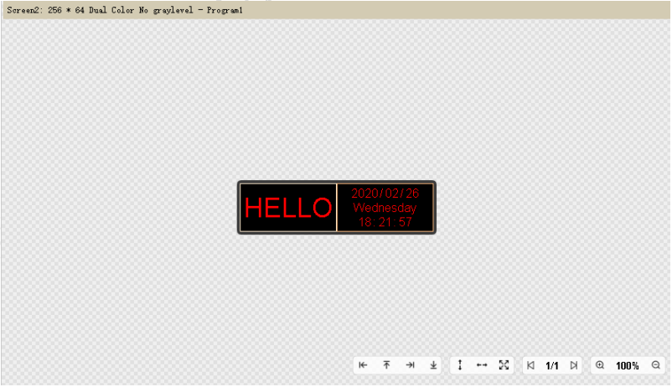

Please note: There is a line of toolbar below the analog display. Reasonable use can help you edit the display file more conveniently (including: zooming in / out the simulation window, moving the current area to the left and right, maximizing the area, turning the display content, etc. tool)

Display property bar

This column can display the current display information → device type → screen parameters →
communication method → display file size

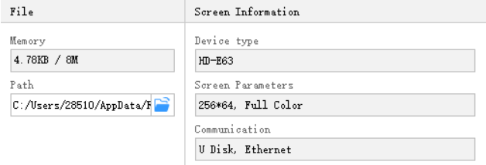

Using the remote control

Need to weld an infrared remote control sensor, the use of the remote control is shown below:

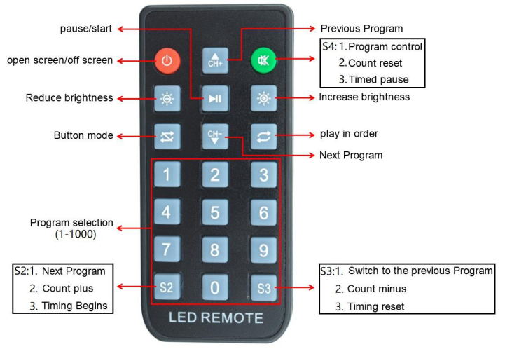

Setting method of smart setting

a.Select the device in the screen parameter settings and set the color of the module

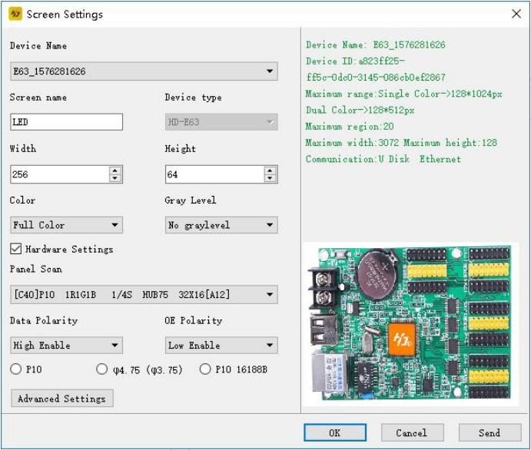
b．Perform smart settings. In the commonly used smart settings, if there are parameters for the unit board you are currently using, you can directly select them, and then click Send, as shown in the figure below:

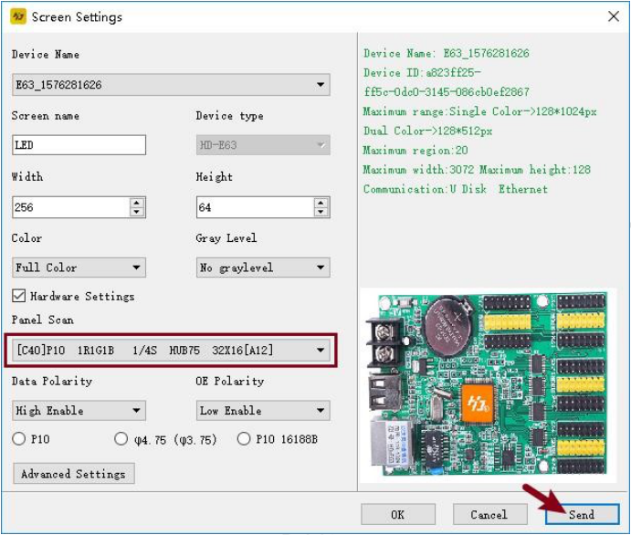
If you cannot find the unit board you are currently using in the common smart settings, you can refer to the following methods for smart settings.
⑴Set the width of a unit board

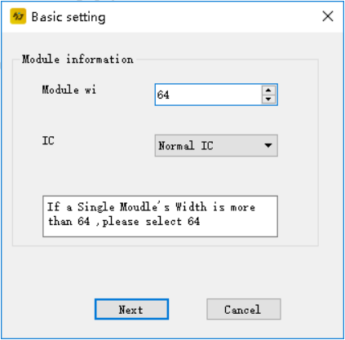
⑵Select the data polarity and OE polarity of the cell board.

When A is on and B is off, it indicates that the data polarity is low and valid.；
When A is brighter than B, it means that the OE polarity is low and effective. When B is brighter than A, the OE polarity is high and effective. When it is not changed, there is no 138 decoder.

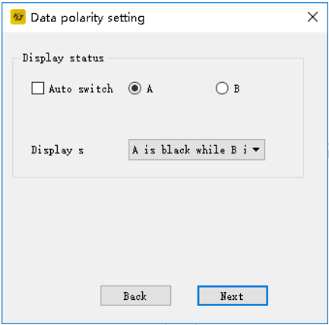

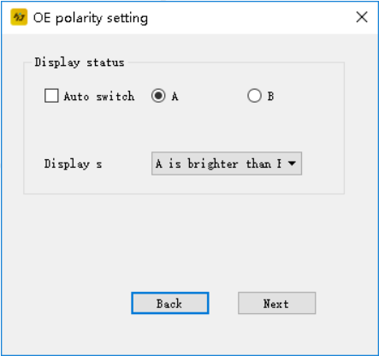

(3) The color channel is selected according to the actual situation of the display screen. There is no option for single-primary colors, and only two states are available for states A and B.

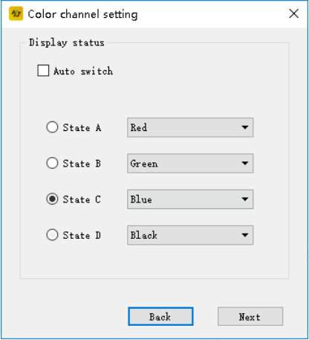

⑷. Determine the scanning method of the unit board. As shown in the figure, 16/1 = 16, we know that the current unit board is 16 scans.

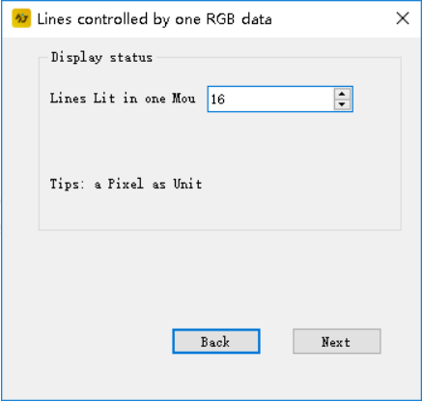
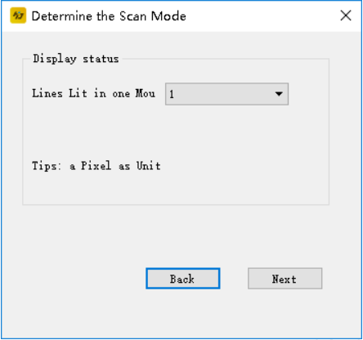
⑸. Determine the lighting method according to the lighting condition of the unit board.
Draw the point according to the position of the first light on the screen. If you draw a wrong step, you can click "Back" to redraw the point, or you can reset all points and restart the point. After the trace point is completed, name the file set by the smart, and then click OK.

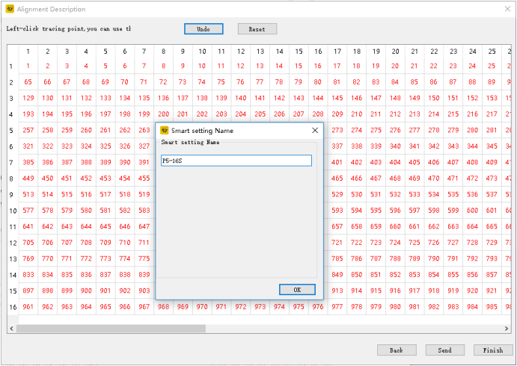

Setting method of cross screen

Create a new cross screen, as shown in the figure:

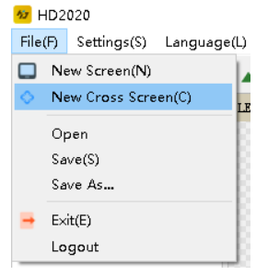
The module selection and basic settings of the cross screen refer to the screen parameter settings above. The size of the cross screen is divided into three parts: top, middle, and bottom.

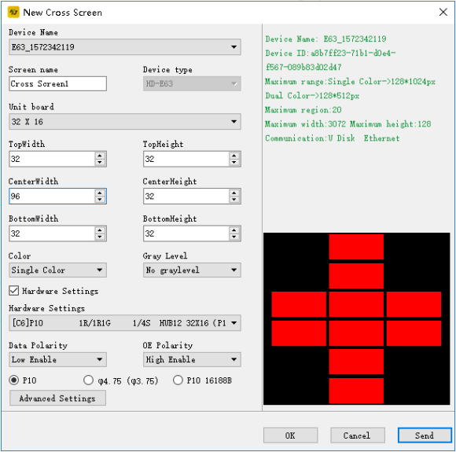
The cross screen can establish global programs and general programs. Global programs are programs that display one area at the top, middle, and bottom as a whole. Creating ordinary programs can display programs in multiple areas.

Chapter 4 Display Program Creation Process

New display and program files (first level content)

Method: Click File-New Display (password is 168), and the setting page pops up as follows:

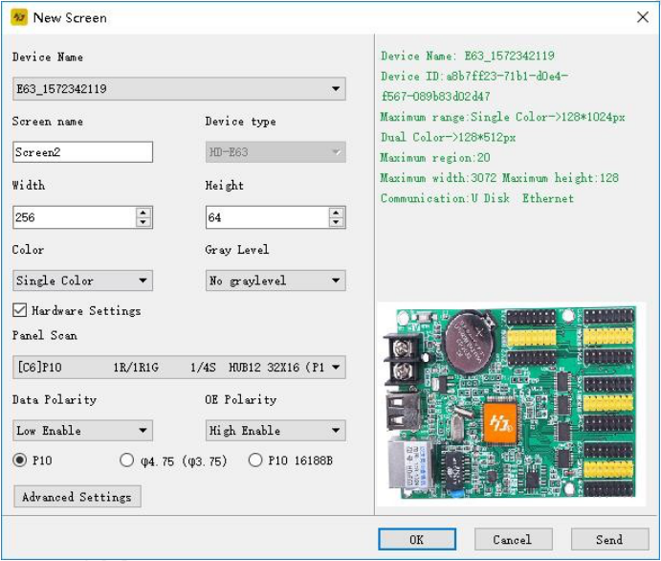

The control card already has the correct parameters (normal display text), create a new display screen, click OK, and complete the establishment of a display screen and a program.
If the control card does not have the correct parameters (the text is not displayed normally), select the device, select the color, set the width, height, and gray level; then click to enter the hardware setting interface and set the display point method of the display, that is, commonly used smart settings. Network cable, serial cable or Wi-Fi for intelligent settings.

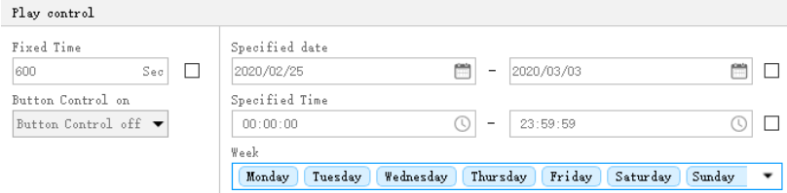

Note: Each of the 1000 programs can set different properties. These properties include playback time,
fixed-length playback, and border settings.

  - New partition (second-level content, each program can be set up with 20 partitions)
Method: After selecting the program, click on the graphic, text, time, timing, counting, temperature and humidity, animated characters, Chinese calendar, etc. to create different types of partitions, as shown below:

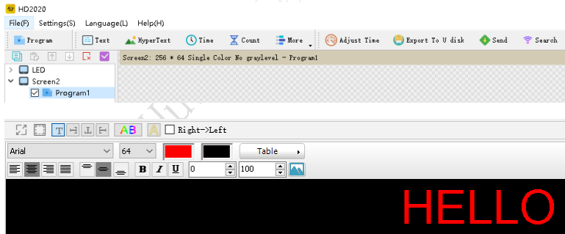

Program production completed

After the first two steps above, we have completed the creation of a display file. If you need to control multiple display screens with one software, you need to create multiple display screen files, and repeat steps 1, 2 and 2;

The simulation screen can view the dynamic picture of each program in real time, and set the display mode. If you are satisfied, you can send the content to the display screen through the send button.

Chapter 5 How to Display Different Contents

Text display

For text-only content display, we can use text area to meet the requirements. The text supports left rotation, right rotation, and reverse. You can customize the table, you can add borders, and add background.
Steps: Create a display screen by referring to 4.1.
Click the text, the text area appears (coordinates, width, and height can be set freely)

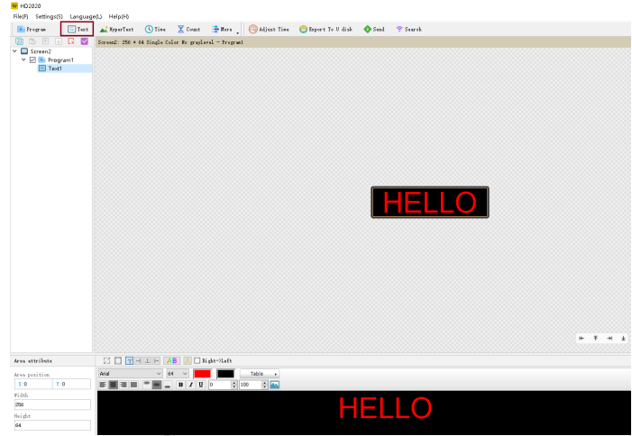
HD2020's software editor is powerful and can change the font size of a single text.

Graphic display

If I want to display a logo or picture on the display (only JPG, BMP, PNG, GIF, etc.), how should I set it? Proceed as follows:

Steps: Create a display screen by referring to 4.1.
Click the picture and text, the picture and text area (coordinates, width, and height can be set freely), add the picture to be displayed in the blue icon position below, as shown below:

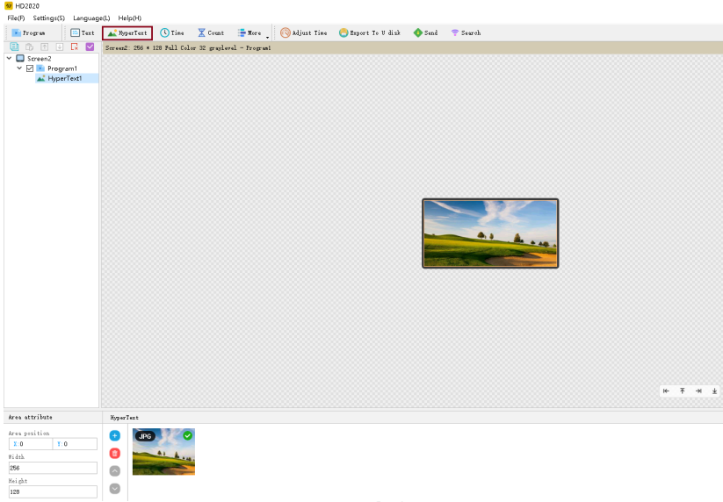

Animated word display

Steps: Create a display screen by referring to 4.1.
Click the animated word, the animated word area appears, and you can enter text content in the editor position below,
As shown below:
Animated words can display image backgrounds, and can also support classic background displays.

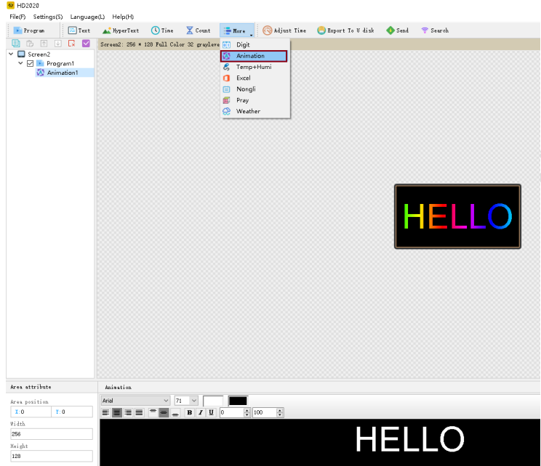

Excel display

To display an Excel sheet on the display, follow these steps Steps: Create a display screen by referring to 4.1.
Click Excel, the Excel area appears, and you can add the Excel file to be displayed in the path position below, as shown below:
Excel shows that Excel needs to install the full version of Microsoft software to load properly. Screenshots can be taken horizontally or vertically.

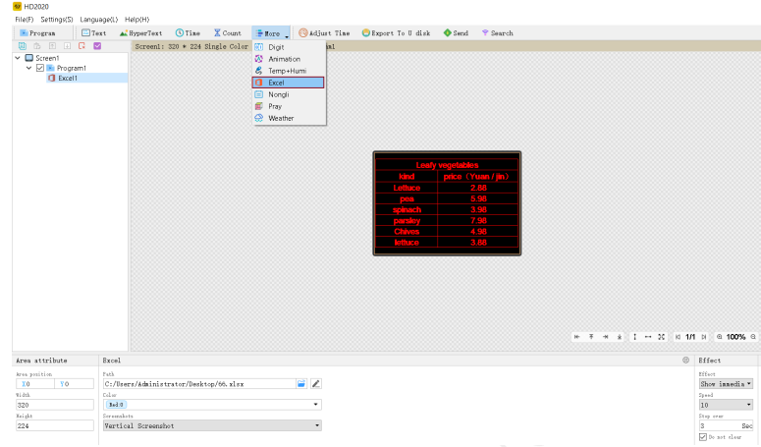

Time display

The time display on the display is similar to text, graphics, and click on the time zone. The steps are as follows
Steps: Create a display screen by referring to 4.1.
Click the time, the time zone appears, the setting is relatively simple, and the location can be set, as shown in the figure below:

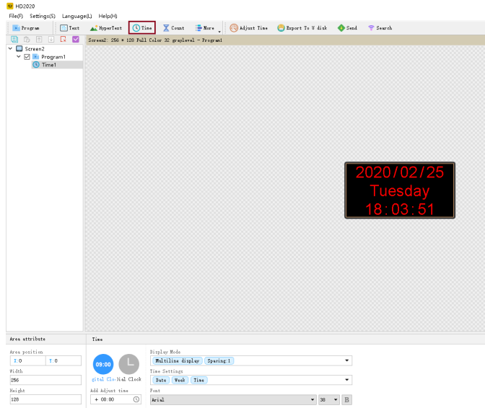

Forward / countdown display

Display shows countdown / countdown, button countdown / countdown Steps: Create a display screen by referring to 4.1.
Click the timing to display the timing area (coordinates, width, and height can be set freely) as shown in the figure:
Supports cycle timing, that is, automatic reset and countdown after the countdown is completed.

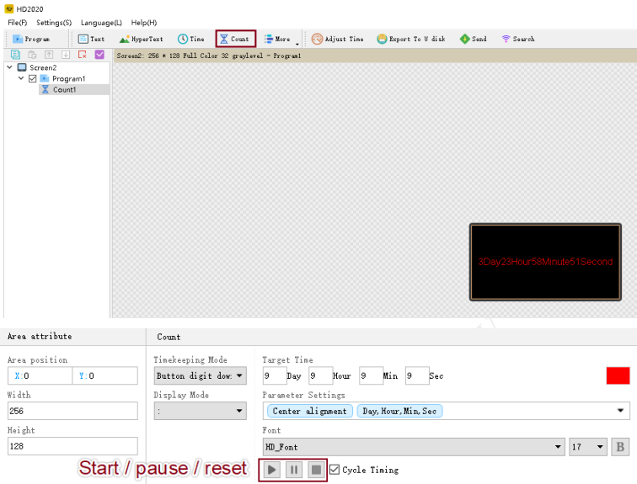

Count display

The display shows the count as follows:
Steps: Create a display screen by referring to 4.1.
Click count to appear count area (coordinates, width and height can be set freely) as shown in figure：

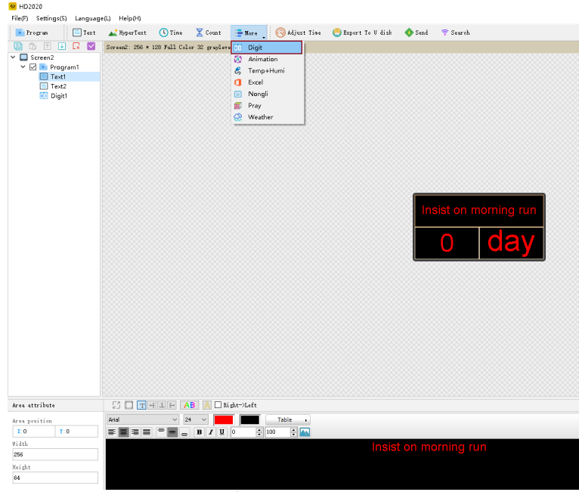
The initial state is to choose from large to small or small to large. How much the jump threshold is increased or decreased, you can add the minimum and maximum pictures. The maximum value that can be set is 9999999.

Temperature or temperature and humidity or PM2.5 display (sensor is required separately)
Display shows current ambient temperature or temperature or humidity or PM2.5 Steps: Create a display screen by referring to 4.1.
- Click the temperature and humidity to display the temperature and humidity area (coordinates, width, and height can be set freely). The temperature and humidity are different from the sensors used, as shown in the figure:

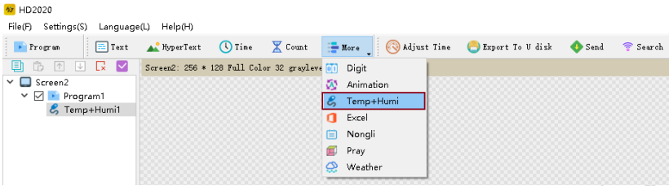

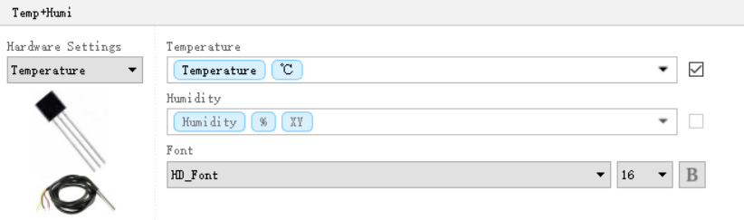

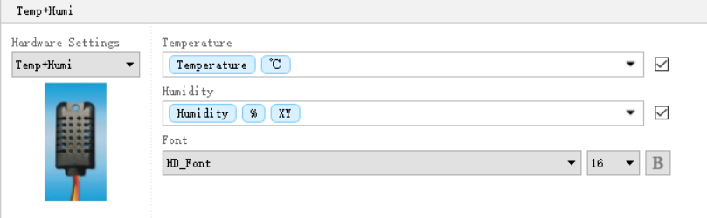
- PM2.5 sensor is shown below：

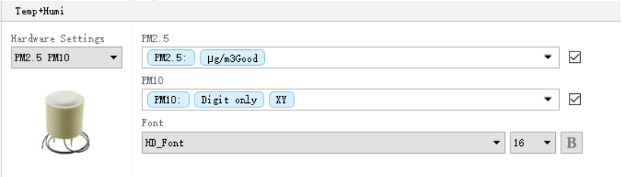

Lunar calendar

Steps: Create a display screen by referring to 4.1.
Click on the lunar calendar to display the lunar calendar area. The lunar calendar can choose to display days, lunar calendar, solar terms, festivals：

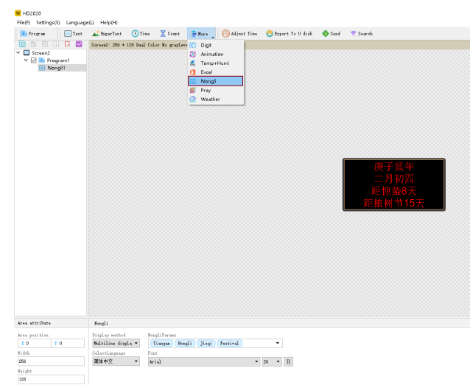

prayer

Steps: Create a display screen by referring to 4.1.
Click on the prayer to display the prayer area, select the country and city prayer time to be displayed below, as shown in the figure:：

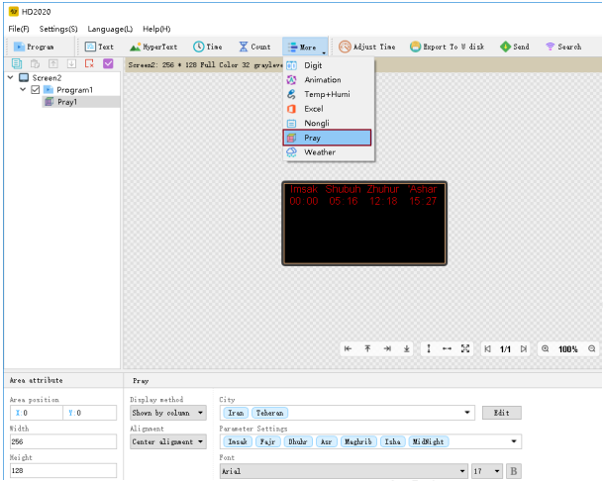

weather

Steps: Create a display screen by referring to 4.1.
Stand-alone weather appears in the weather area, select the country and city weather to be displayed below, as shown in the figure:

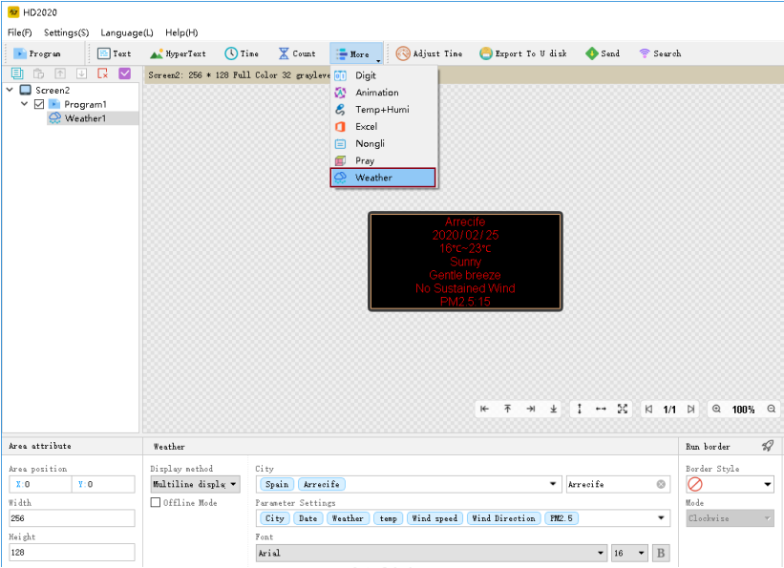

- Software version: HD2018 or HD2020

- Currently the online mode only supports network interface cards, and requires 4.15 firmware and above;

- The network port card is connected to a router that can access the Internet. The weather data acquisition time of the lower computer is once every one hour.

Through the above 5.1-5.11, we can understand that our software can set multi-function and multi-region content, which is enough to meet the application of the display in various scenarios.

Chapter 6 Communication Settings

6.1 The practice of serial line

Our system uses a straight RS232 communication line. The finished product line is shown in the figure：
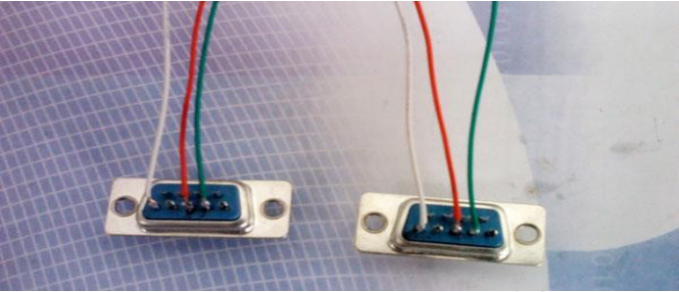

232 communication

232 communication serial port connection. After the driver is successfully installed, the current device can be found. A computer can only connect one 232 communication serial card.
After the information window prompts to find the device, select the current device name in the screen parameter setting interface to send parameters and programs to the current control card. As shown: When the device is found, the information window displays information.
When the device is not found in the information window, please click the search button, the location is as shown below:：

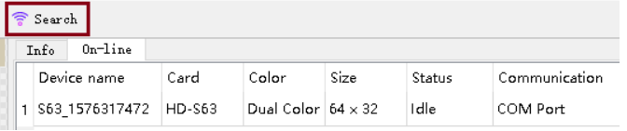

If still not found, check the serial cable.
If the current message window prompts "The device is not bound to the selected screen", please go to

Settings → Screen Parameter Settings and select the device name, as shown in the figure:

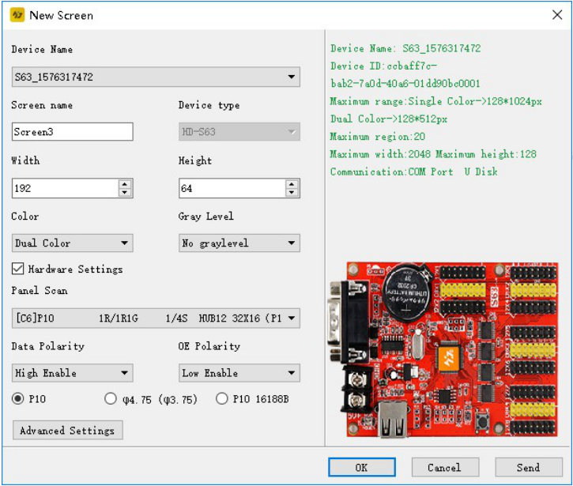

485 communication

Method two: 485 communication serial port connection. A 485 converter is required. A computer supports only one 485 communication serial card. The connection method is as follows:
The positive pole on the converter is connected to the square hole on the control card, and the negative pole on the converter is connected to the middle hole on the 485 interface on the control card.
The device management interface shows the ID number of the control card, indicating that the device has been found as shown in the figure:

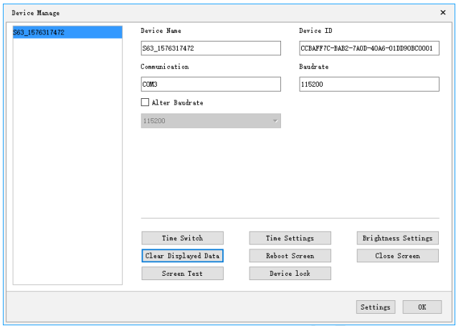

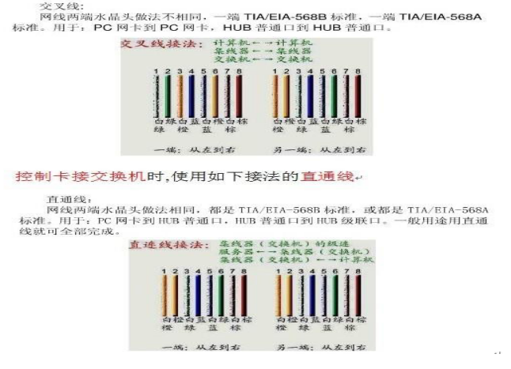

The practice of network cable

There are two kinds of network cables: cross cables (used when the control card is connected to the computer) and straight-through wires (used when the control card is connected to the router)

Communication settings (network port)

LAN single network card (HD-E63) communication

Method: No settings are required. After a single device is directly connected to the control card, the information window → the online bar will show the connected devices, as shown in the figure:

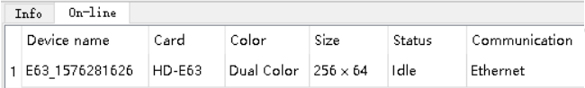

If the current message window prompts "The device is not bound to the selected screen", please enter the settings screen and select the device name as shown：

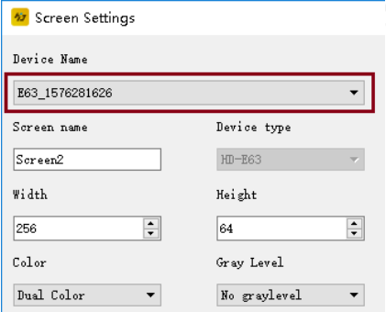

LAN network card communication

Method: 1. When there are multiple network port cards, change the IP address of the control card to the same network segment as the current LAN. As shown in the figure, change the IP address and device name of the control card in the device management interface and modify the point settings.

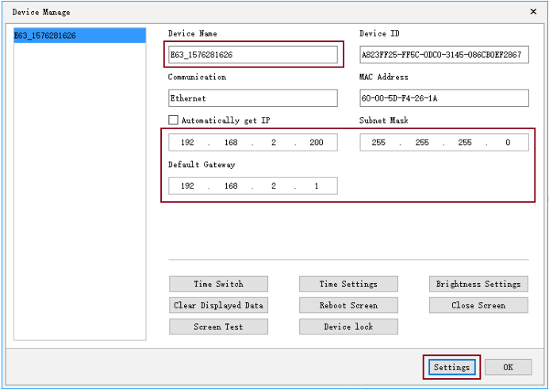

- After the IP address is modified, a new display is created in the software, and the device name is bound when the screen parameters are set.

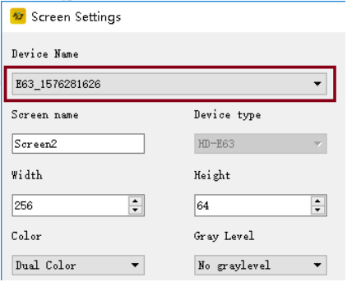

- Use cluster sending to send the program, tick all the displays, and then click Send. As shown in the figure:

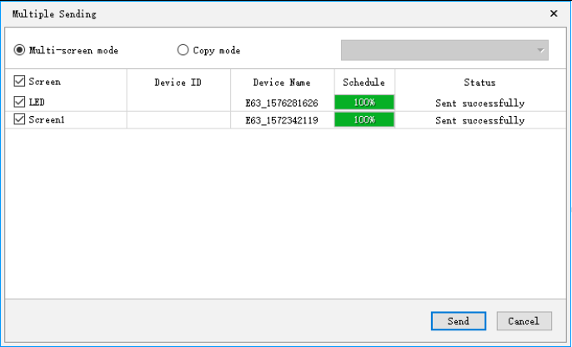
4.If the control card is on the same network segment, refer to 1, 2, and 3 to complete the setting and send it. If the current control card's network segment and the main control computer are not on the same network segment, please add the network segment where the control card is located in the communication settings interface For example, the control card is connected to the 192.168.3. * Network segment, the current master computer is on the 192.168.5. * Network segment, and the communication setting interface in the 2020 software needs to add the control card IP 192.168.3. *, Or directly add IP segment 192.168.3.1-192.168.3.254, as shown in the figure:

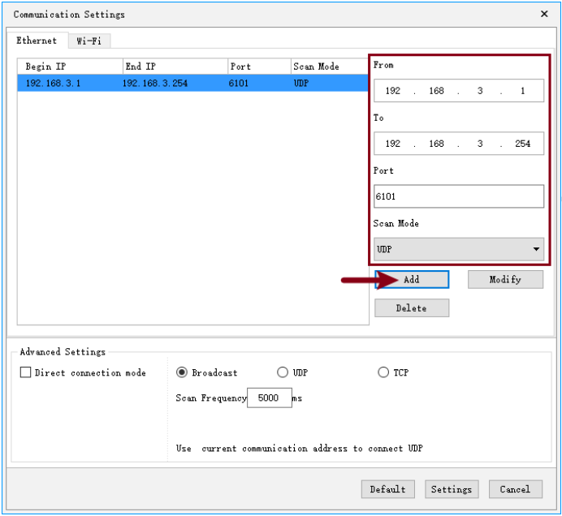

Communication settings (Wi-Fi card)

Wi-Fi Card connection

When the Wi-Fi card is connected, first connect the Wi-Fi signal sent by the control card (requires a current computer with a wireless network card, if using a desktop computer, be sure to purchase a wireless network card, and generally use a laptop with a wireless network card) as shown Note: 1 Wi-Fi card has been connected to the current network.
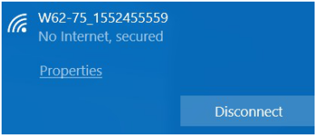

When connecting to Wi-Fi signal, the default password is "88888888". If you connect in 2020 software, you need to enter the password of "88888888", as shown in the figure: Click Connect, and the default password can also be modified.

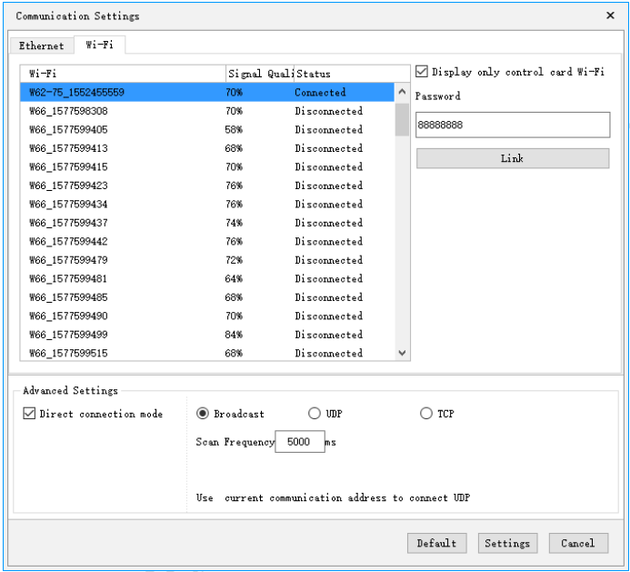

Once Wi-Fi is connected, the device can be found in the software. As shown in the figure: the information window will appear on the online bar of the control card and other information.
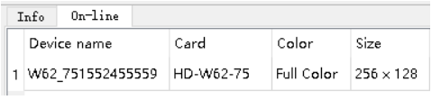

Select the current device in the screen parameter settings, and you can send the content to the control card, as shown in the figure：

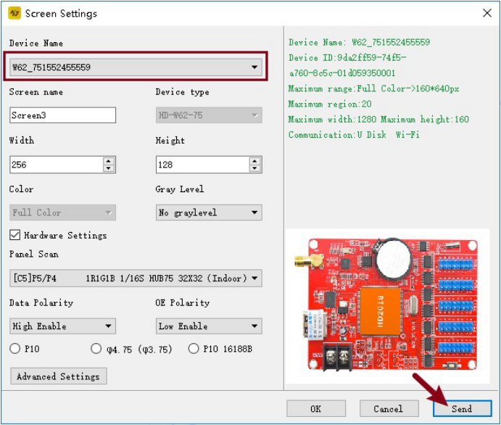

If the current display is abnormal, set the intelligent setting parameters in the advanced settings of the hardware setting interface. If the current display is normal, you do not need to enter the hardware setting interface. (Regular screen only needs to select common smart settings, non-routine can perform smart settings)
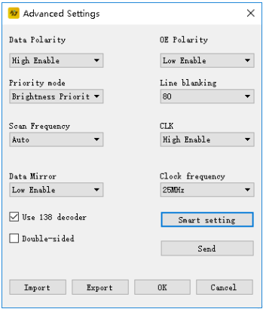

Change the SSID and password of the Wi-Fi card

In the menu bar of the main interface of the software, click Settings → Device Management → Wi-Fi settings to enter and you can start to change the card's SSID and password.
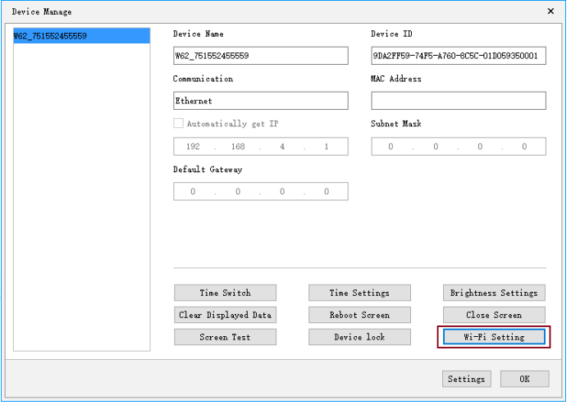

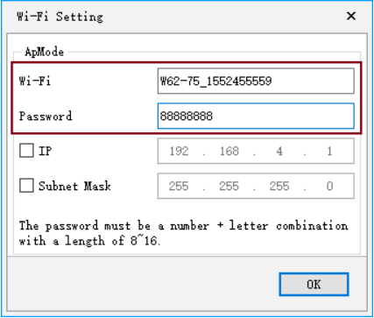

How to use a USB flash drive

U disk card is free of wiring and easy to use. Take the conventional P10 monochrome module as an example:
- 1. Set the screen parameters of the display, select the model of the control card, and hardware parameters. Enter the screen parameter setting interface, and set the display color, screen width, screen height, gray level and other paramete
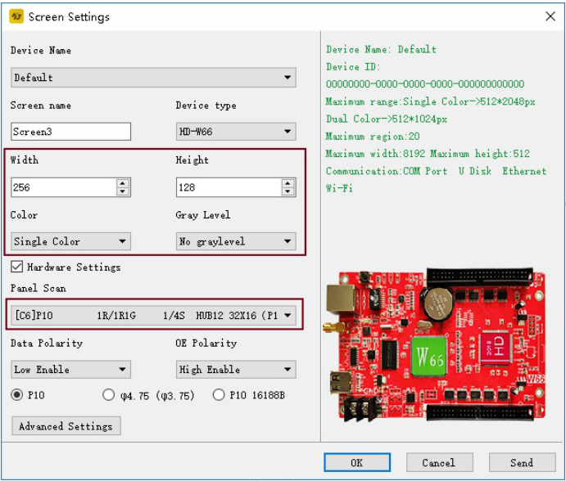
2. After adding content, text and other areas, click on the USB flash drive to export.

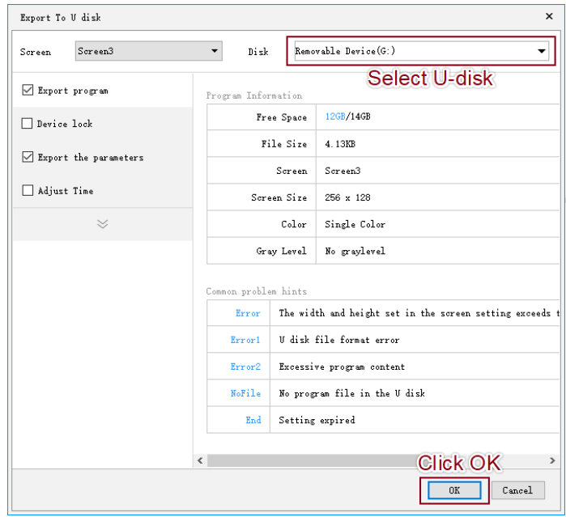
Note: If the time on the current display is not correct, you need to check the time, and then export it with a USB flash drive.

Appendix 2 Common settings during use

Appendix 2.1 How to upgrade the control card

The control card upgrade is mainly used to update product functions or handle major BUGs. Under normal circumstances, the update is not required. The specific upgrade method is as follows:

Click Settings → Firmware Update → Select the corresponding firmware version → Then click the update icon on the right as shown below:

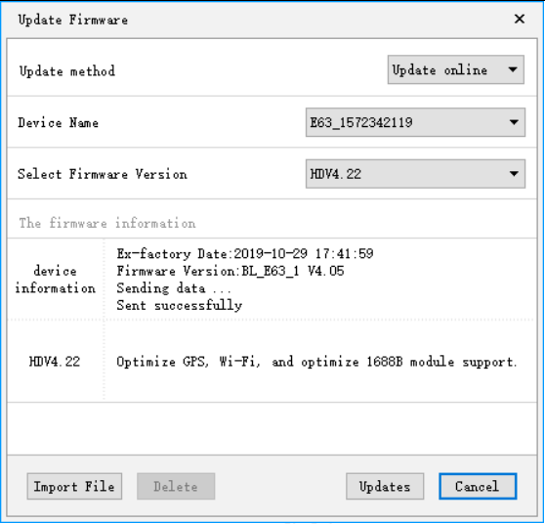

Click the interface update, select the corresponding firmware version, and the operation can be completed (the firmware upgrade can be updated through a U disk, a serial cable, a network cable, and Wi-Fi)

Appendix 2.2 How to restore control card to factory settings

To restore factory settings:
- Disconnect the power of the display first;
- Then press and hold the test button on the control card and do not release it;
- After the display is powered on, wait for about 10 seconds to release the test button.

Appendix 2.3 How the Control Card Tests the Display

Appendix 2.4 There are two methods for testing the display screen timing switch display (hardware and software)
Hardware test: After adjusting the parameters, press and hold the S1 button of the control card (in the case of power-on), let go after entering the test state, and then click multiple times to perform several other different test modes.
Software test: software settings> device management <display test> pop-up interface for testing, as shown in the figure:

Note: You can use the software to control the display test after the software finds the device.
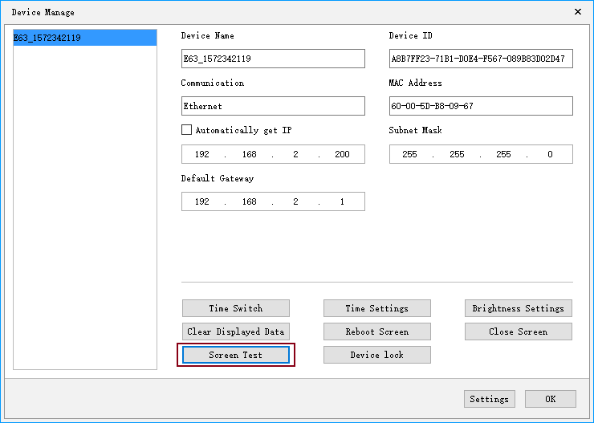
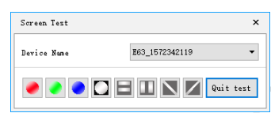

Appendix 2.4 Display timing switch

Timing on / off of display screen: Settings → Timing on / off → Enable → Set startup time and shutdown time;

Appendix 2.5 How to set the text to stand still

If the text is still, you need to select the special effect still display, as shown in the figure:
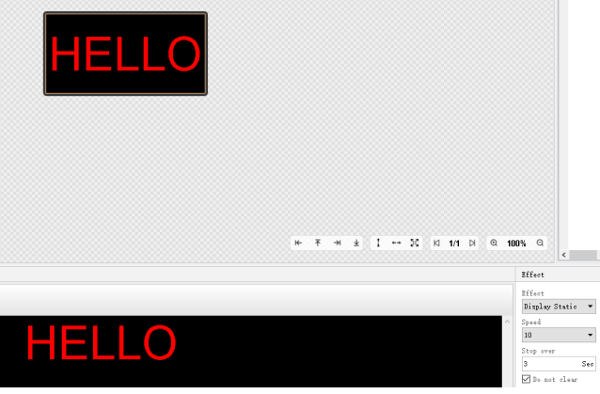

Appendix 2.6 Text moves continuously without interruption
Create a text area. The display method is to move to the left continuously. When you click End to End, the content on the screen will be displayed continuously to the left. If you do not select End to End, the space bar after the content will be displayed continuously
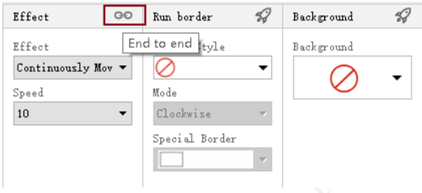

Appendix 2.7 Operating Instructions for Temperature, Temperature and Humidity, PM2.5

First, temperature and humidity operation instructions
- The wiring diagram is shown in the following figure. The red wire is connected to the right, that is, the box-shaped pin, the yellow wire is connected to the middle pin, and the black wire is connected to the third pin.
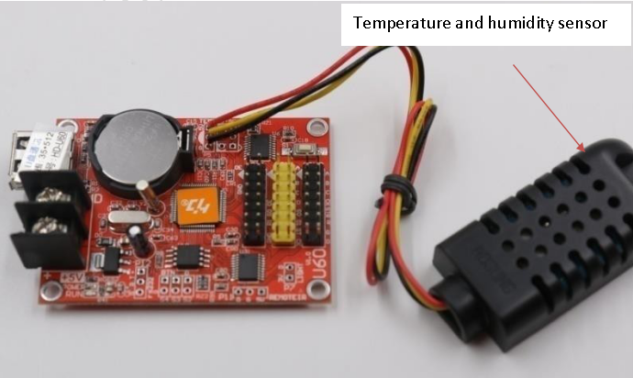

  - Use of temperature and humidity sensors The sensor model is: AM2301
Normal use voltage: 4.2-5.2V
Humidity measurement range: 0-99.9% RH
Temperature measurement range: -40--80 degrees Celsius Humidity measurement accuracy: ± 3% RH
Temperature measurement accuracy: ± 0.5 degrees Celsius

  - Software settings for temperature and humidity
    - Create a new temperature and humidity area, refer to the establishment of
5.8 temperature and humidity area.
    - Set the hardware settings for temperature and humidity. The default is temperature. You need to select temperature and humidity.
    - If the temperature and humidity are not very accurate, you can fine-tune by temperature and humidity correction.
    - Support background and border.
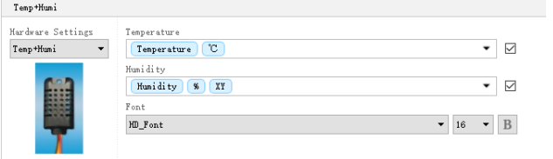
Second, the temperature operation instructions

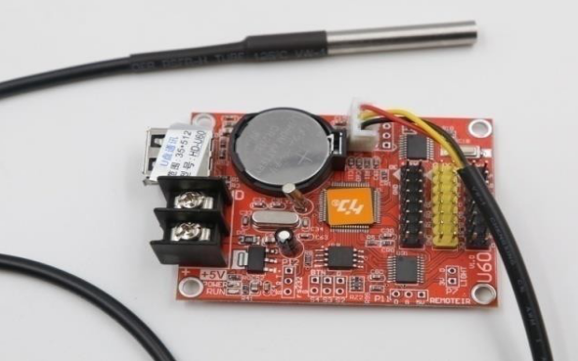
1. 1. Waterproof temperature sensor, the red wire is connected positively, that is, the box-shaped pin, the yellow wire is connected to the middle pin, and the black wire is connected to the third pin.

Model: DS18B20
Normal use voltage: 4.2-5.5V
Temperature measurement range: -40--80 degrees Celsius Temperature measurement accuracy: ± 1 degrees Celsius
2. Setting of temperature zone in software
- Create a new temperature and humidity area, refer to 5.8 to establish a temperature and humidity area;
- If the temperature is not very accurate, fine adjustment can be made through temperature correction.
- Support background and border.
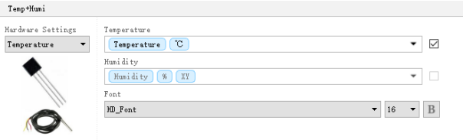

一、 PM2.5 operat Instructions
- Firmware version：V4.15
- Support PM2.5 module model（E62、E62P、E63、E64、E66、U63、U64、U60PLUS、U62PLUS、U60-75、S63、W60-75、W63、W64 W62-75 W66）
- wiring

Serial  number | Network cable color | Wiring position P12
1 | Brown, white brown | P12 Round hole
2 | Orange, white orange | 5V
3 | Green, white green | P12 Round hole in the  middle
4 | Blue, white blue | P12 Square hole

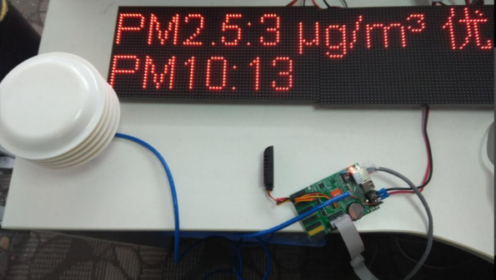

- Setting of temperature and humidity area on software
  - Create a new temperature and humidity area, refer to 5.8 to establish a temperature and humidity area;
  - Set the parameters of PM2.5.
  - If PM2.5 and PM10 are not very accurate, you can fine-tune by PM2.5 and PM10 calibration.
  - Support background and border.
