Document content | HD2016 LED Control Card Operation manual
Version | English V2.0
Page number range | 1-43

HD2016 LED Display Controller Operation Manual

CONTENTS

CONTROL CARD SELECTION TABLE 4
CHAPTER ONE: INTRODUCTION 5
  - : FUNCTION FEATURE 5
  - : OPERATING ENVIRONMENT 5
CHAPTER TWO: INSTALL AND UNINSTALL 6
2.1: INSTALL 6
CHAPTER THREE: TOOLS INSTRUCTIONS 6
3.1: THE SOFTWARE MAIN INTERFACE 6
    - : file menu 7
    - : setting menu 7
    - Operation menu 12
    - Tools 13
    - Language menu 13
    - Help menu 14
  - TOOLBAR 14
  - SIMULATING SCREEN 15
  - SCRREN ATTRIBUTE 15
  - REMOTE CONTROL USING 16
  - SMART SETTING METHOD 16
  - LED CROSS SIGN SETTING 19
CHAPTER 4 SETTING UP SCREEN AND PROGRAM FILE 21
  - SET UP NEW SCREEN FILE (THE FIRST LEVEL CONTENT) 21
  - SET UP NEW PROGRAM (ONE SCREEN CAN SET UP 1000 PROGRAMS ) 21
  - ADD HYPTERTEXT OF PHOTOS, GIFS ETC 24
  - ANIMATED CHARACTERS 25
  - EXCEL SHOWING 25
  - COUNT UP AND COUNT DOWN 26
  - DIGIT SHOWING 27
  - TEMPERATURE AND HUMIDITY (NEED WELD SENSOR) 28
  - PRAY SHOWING 28
  - WEATHER SHOWING 28
CHAPTER 6 COMMUNICATIONS SETTING 30
  - MAKING SERIAL PORT CABLE 30
  - COMMUNICATION SETTING (SERIAL PORT) 30
    - RS232 communication 30
    - RS485 communication 31
  - MAKING NETWORK CABLEL 32
1).MAKING NETWORK CABLE HAVE 2 WAYS: CROSS CABLE (CONTROL CARD CONNECTED WITH COMPUTER DIRECTLY)
AND PARALLEL CABLE (CONTROL CARD CONNECTED WITH ROUTER) 32
  - COMMUNICATIONS SETTING(INTERNET ACCESS) 32
    - LAN single card (HD-E63) communication 32
    - LAN multiple Network card (such as HD-E63 cards) 33
  - COMMUNICATION SETTING （WIFI WIRELESS CONTROLLER ） 34
    - If Only 1 WIFI Controllerr connected 34
    - Change Wi-Fi ssid and password ;More than 1 Wi-Ficards Connected 36
  - U-DISK CONTROLLER OPERATION 37
APPENDIX 2 THE NORMAL SETTING IN USING PERIOD 38
APPENDIX 2.1 CONTROLLER UPDATED FIRMWARE WAYS 38
APPENDIX 2.2 HOW TO RENEW TO FACTORY SETTING 39
APPENDIX 2.3 HOW TO TEST DISPLAY 39
APPENDIX 2.6 HOW TO SET TEXT STATIC AND NO MOVING 40
APPENDIX 2.7 TEXT CONTINUE MOVING AND NO STOP 40
APPENDIX 2.8 TEMPERATURE 、TEMPERATURE +HUMIDITY SENSOR 41

Chapter One: Introduction

: Function feature

The whole HD2016 control system are simple operation, strong function, easy to learn and use, support image-text(Excel、JGP、BMP、GIF、SWF、video、text、animation word etc.)/Text/animation word/Excel/timer（countdown /up/button countdown / up）/count/lunar calendar/Temperatureand humidity/Pray area etc., can support serials port(including 232 and 485)、Ethernet port、WIFI、U-disk etc. Multiple control communication, can meet the application of different situations.
Main advantages：
- Support Gray level;
- Support layer overlay, areas overlap;
- Add 3D Text, animation characters;
- Full support smart settings, support for most modules (U disk card using common settings);
- A variety of custom combinations of effects;
- Support area background;
- Add button timing up/down (cyclic time), button count up/down;
- Support Realtime Partition (secondary development);
- The higher brightness and faster speed left. Higher refresh rates;
- The new text rotation, supports 90°, 180°and 270°rotation;
- The increase in receivables function, parameter lock screen function;
- Support Temp, humidity, brightness, remote control and can choose to play 1-999 programs;
- Support direct connection, LAN, inter-network multi-connection, the device can be found;
- Support group management.
- Support prayer and the Weather forecast function

: operating environment

Operation system: Windows 2000/XP/Win7/Win8/Win10 etc.

Software support all languages

Chapter two: Install and uninstall

2.1: Install

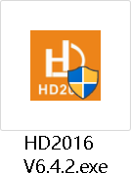
Download software HD2016 From website and then install (Note: if the operated system is Win7 or Vista, please put the installation path to non-system disk)

After HD2016 software finished installation ,in【start】→【program】can find “HD2016” program group, then click HD2016 to run it. As well, you can click shortcut of HD2016.exe on the desktop to access software.

Chapter three: TOOLS INSTRUCTIONS

3.1: The software main interface

Open ”HD2016” software main interface as below:
Group manage screens.
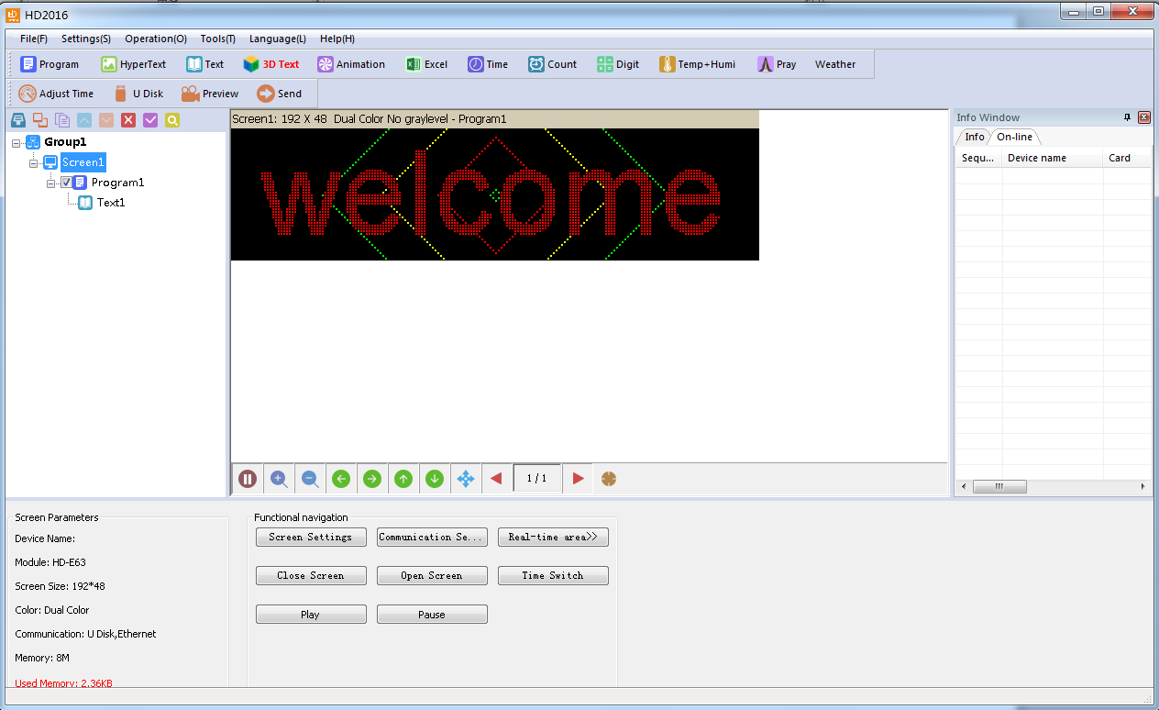Info window can show the command status if send successfully and online devices.
Menu bar
Tools bar
virtual screen
Program
and areas
Simulation tool (preview/pause preview, zoo
m/alignment/page up/down)
Screen parameter

.

.

: file menu

As below：
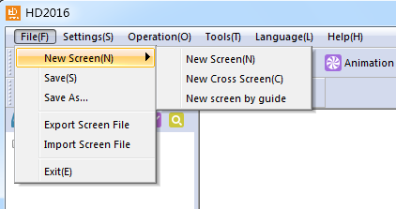
New screen (Ctrl+N): used to create a new screen(No screen counts limited), Can also be grouping manage(select group option in system setting).
Save (Ctrl+S): used to save current screen file.
Export screen file: export current screen file to user-defined path. Import screen file: load screen file to software directly.

: setting menu

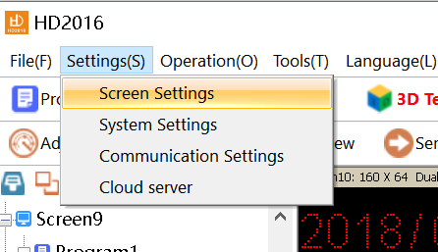
As below:
- Screen parameter settings: used to bind parameter of device and screen, as below:
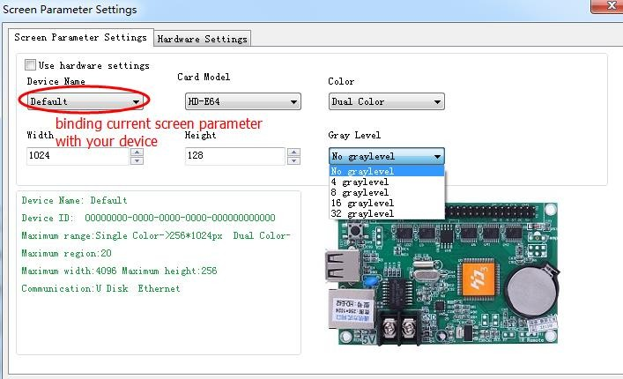
1).First step, if control card displays normally, it just need set screen’s width and height pixel, color and gray level,
- Second step, hardware setting, please choose default common smart setting for common

screen.( If Your Screen is P10 Red normal, no need this step.)
For example: P10 single color, just select below photo of A6 then it is ok. Note: For abnormal led module, select “Additional” –>”smart setting” .
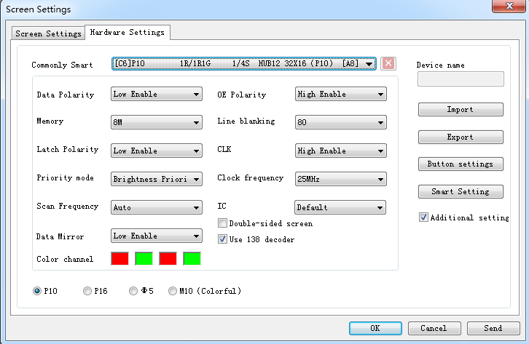
(For smart setting: it need find the device first , HD-U6x Serials controller can’t smart setting)
“Button setting” in hardware setting, used to set four buttons’ function, as below:
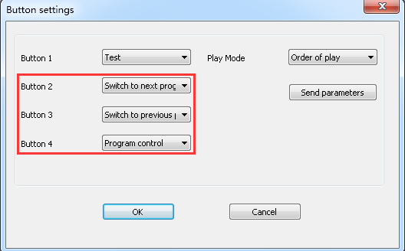
Note: button4 turn on screen display the second program,turn off screen display the first program.

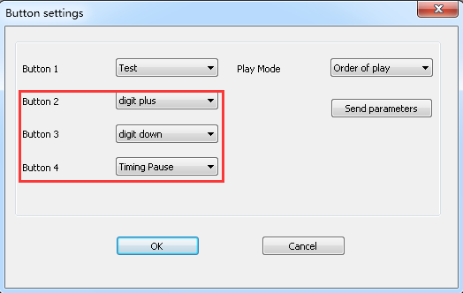
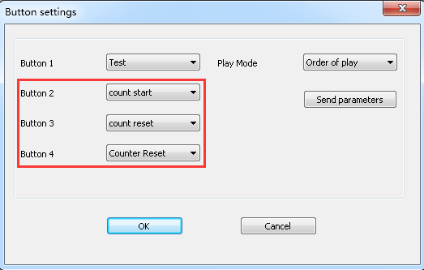
“Play Mode ”three kinds of
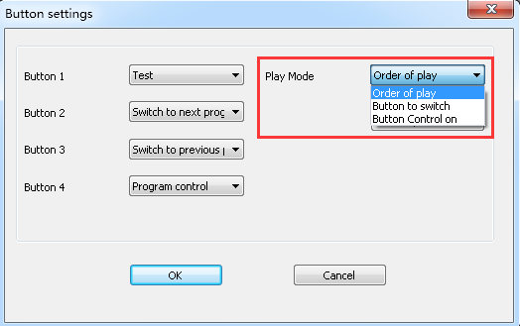
注:播放模式-按钮控制,在显示屏节目-播放时间-按钮控制选择对应的按钮
Note: Play Mode - Button settings, On ‘Program’ - ‘Play Time’ - ‘Button Control on’ Select Corresponding Button

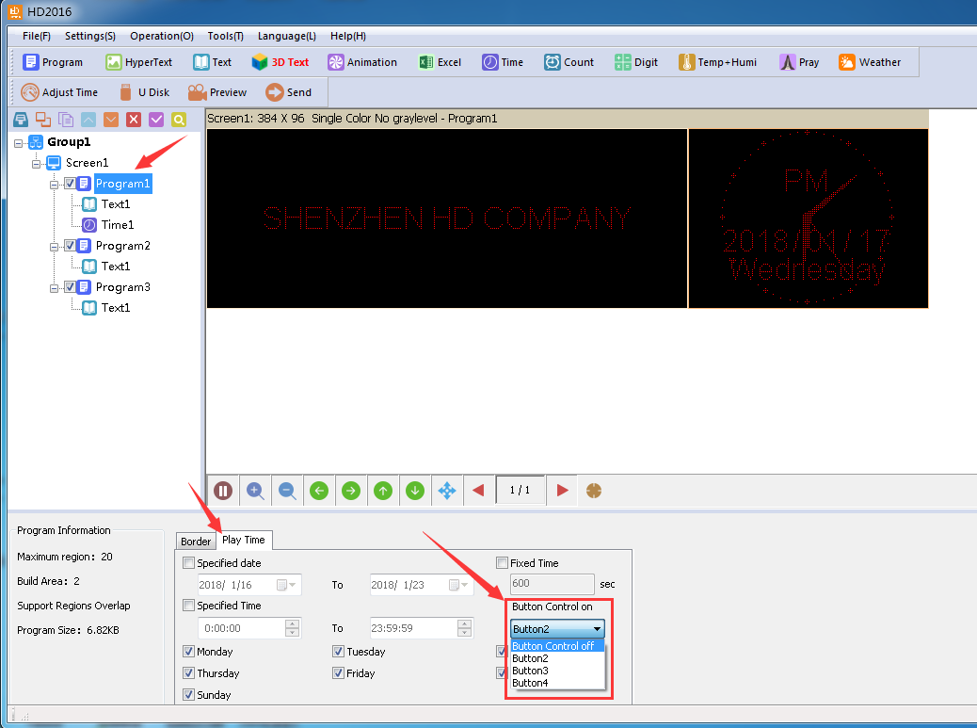
- Communication setting: used to connect multiple cards. 1).Ethernet:
①The defaulted way is connection 1PCS card .Meaning only one card connected with computer, no need any IP setting, just need normal LAN cable connection and find the device.
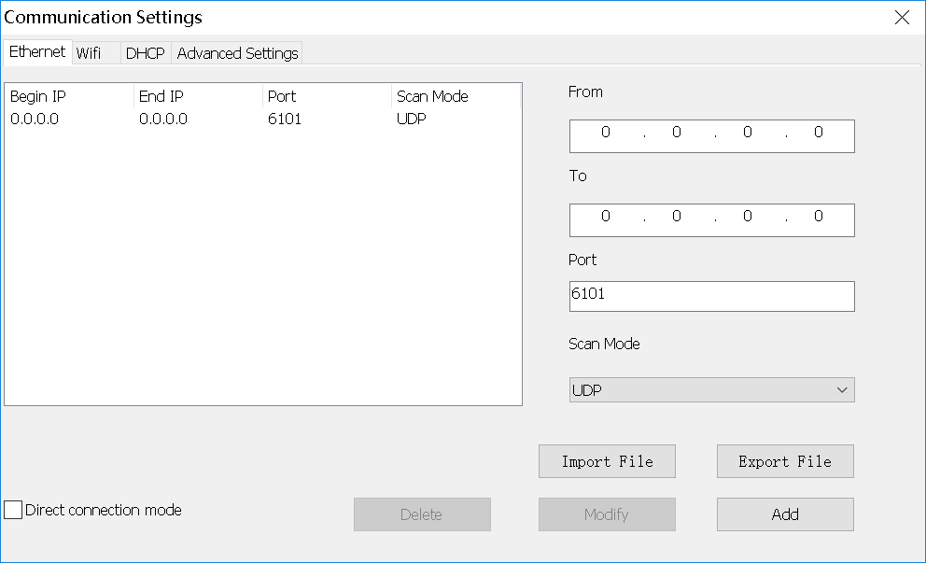
②.when not select “Direct connection mode”, it is suitable for condition when controller and main operated PC are not at the same network segment, it need add the IP address of controller network segment to the software. Operation as below. After added, then you can find the controller in 192.168.3.*

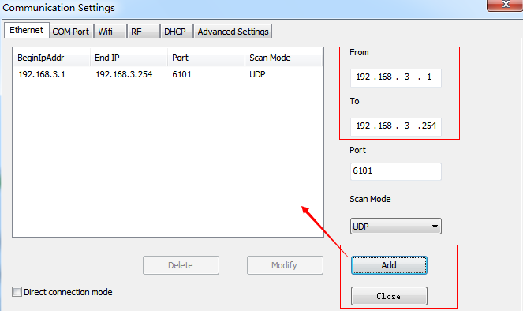
2).wifi: Used connect wifi signal of controller ,automatically default input password 88888888 ,no need manual input, as below shows：
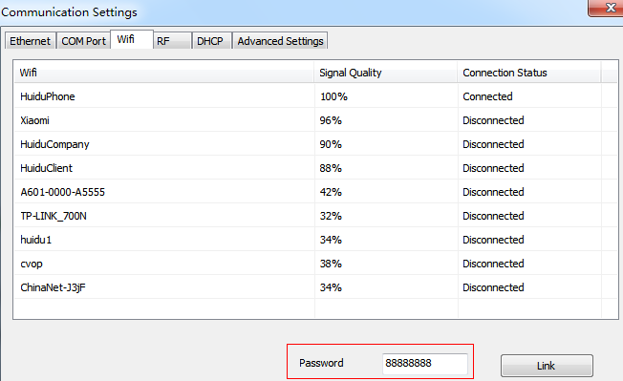
- DHCP: when multiple controllers connected to the Switch, user do not need set card IP address. Use DHCP, software will distribute IP address for controllers automatically, see picture as below: software distribute IP address
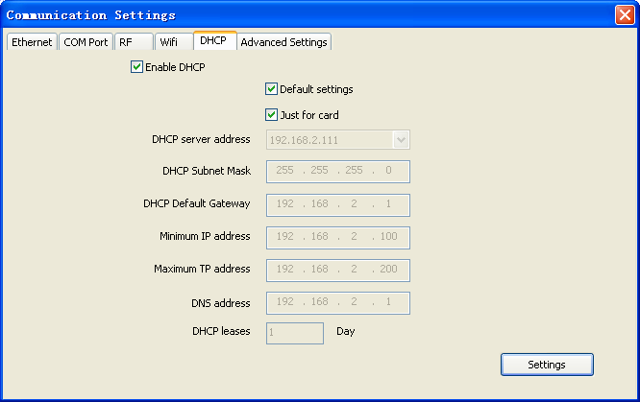
192.168.4.100-192.168.4.200 to controllers. Only use on the case of controller connected to Switch, no router.
- Advanced setting. Advanced setting interface is used to set if need find 4th generation card (After found 4th generation card, just upgrade firmware), Type one to

type four is LAN card connection way. The software Default setting is Type one.
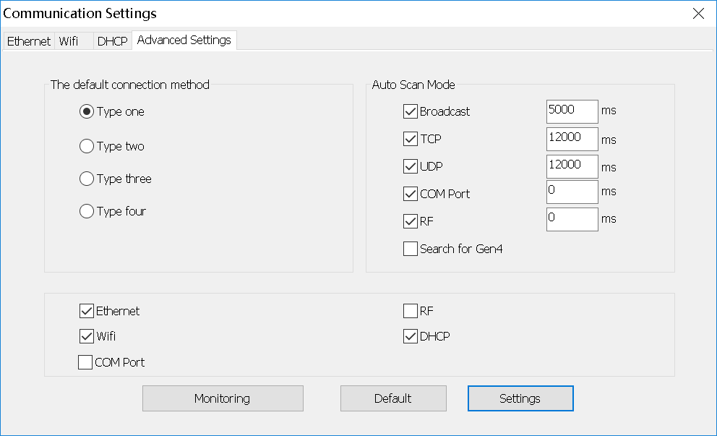
- System setting: setting system parameter (suggest not modified)
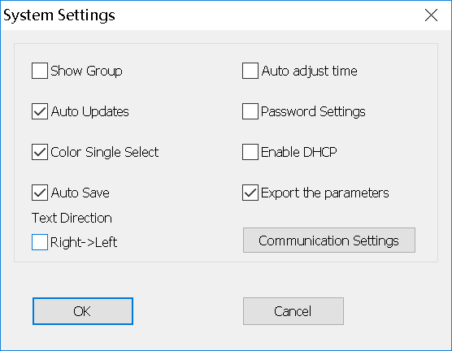
Add new function: lock screen, it can choose which parameter can’t modification.
Text direction[Right->Left]: for Arabic or Persian language, please check it.

Operation menu

1).Device manage：modify all the found device name, modify Ethernet card IP address, and manage device’s display data、timing setting、brightness setting、timer switch、 display screen testing、 switch、restart display screen.
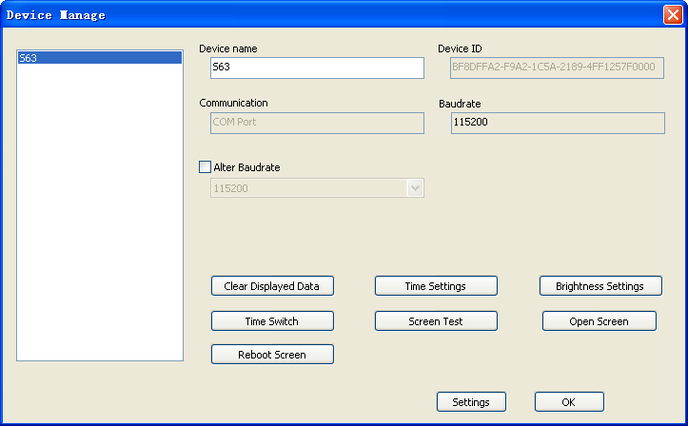.
- Multiple sending: Sending multiple led screen files. There have two modes:

multiple -screen mode and copy mode. All found device can be used ,including Ethernet port card、serial port card、Wifi card .
①Multiple-screen mode: In Setting-screen parameter setting-Device name, and must select device name, and each screen file binding a device.
②Copy mode: Selected the screen file that need send, and sending this screen file to all found devices.
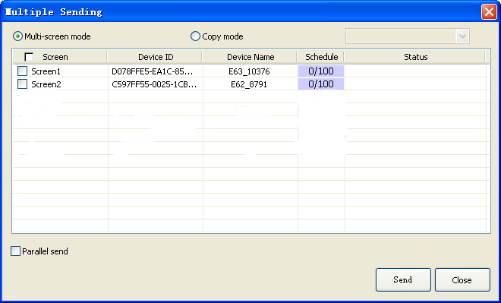

- Time settings: setting led control card time, can be system time, also can try past or future time.
- Brightness setting: Having 3 mode. custom, automatic adjustment and by time period regulation
5).Timer switch: Setting time with PC synchronous or setting time by different. 6).Boot Animation: Showing image when opening the display. Selected Enable, and select image (bmp、jpg、png ) after download file click “sending”, or export file to U-disk.
7).Update Firmware/ Wi-Fi Update: Used for updated firmware

Tools

Including Notepad、calculator、drawing、 network testing、 the local IP Settings, Animated characters background、 info window、 Program appearance.

Language menu:

Including 21 kinds operation interface language Arabic, Bulgarian 、 Chinese simplified、English、French、 German、Hindi、Iranian、 Japanese、 Korean、

Mongolian、 polish、 Portuguese、 romanian、 Russian、 Serbian、Spanish、 Thai、Chinese traditional、Turkish、Vietnamese and so on.

Help menu :

Checking HD2016 software version and updating new version software.

Toolbar

Including Program、global program、graphic、HyperText、Text、Animation Characters、Excel、Time、Count、Digit、temperature and humidity、Adjust time、U-disk、preview、Send and so on. 2 lines also can be adjusted to 1 line. As picture show:

Program：Add a new program
Global program: Add a led cross Pharmacy screen
HyperText: Add new image-text area. Add picture、GIF、Animated characters、SWF、 text、 video、Excel. when just add picture, multiple picture edit special effect together,support region background.
Text : text support rotate 90°、180°、270° support region background
Animated characters: Effects of Single effects and multiple effects. Support Image background and other style background.
In Additional setting, support artistic font of Hollow and Stroke, add new outline fonts, and show multiple effects , and multiple special effect overlay using.
Excel：Add Excel area, support zoom in and zoom out, background and boarder.
In Additional setting , it have Color inversion, Vertical screenshots and Horizontal
screenshots.
Time: digital clock and Dial clock together, dial add AM/PM display, support region background
Count：support 4 modes count down, count up, button count down, button count up.
Support circle timing, support region background.
Digit: count number from lowest to highest, or from highest to lowest. Support region background.
Pray: Used for showing Pray times everyday.
Temperature and humidity: temperature and humidity need different sensor, being used to show current temperature and humidity (It need add another weld sensor) The temperature sensor is DS18B20,
Adjust time: correct system time (adjust led control card time with PC synchronous)
U-disk: U-disk card special using. The current display file and time saved in U-disk (U-disk update program or updated firmware)
Preview: Preview current program or led screen overall preview. When selected Program, preview current program. And selected screen to overall preview, display showing effects same as preview screen.
Sending: Sending current led screen file.

Simulating screen

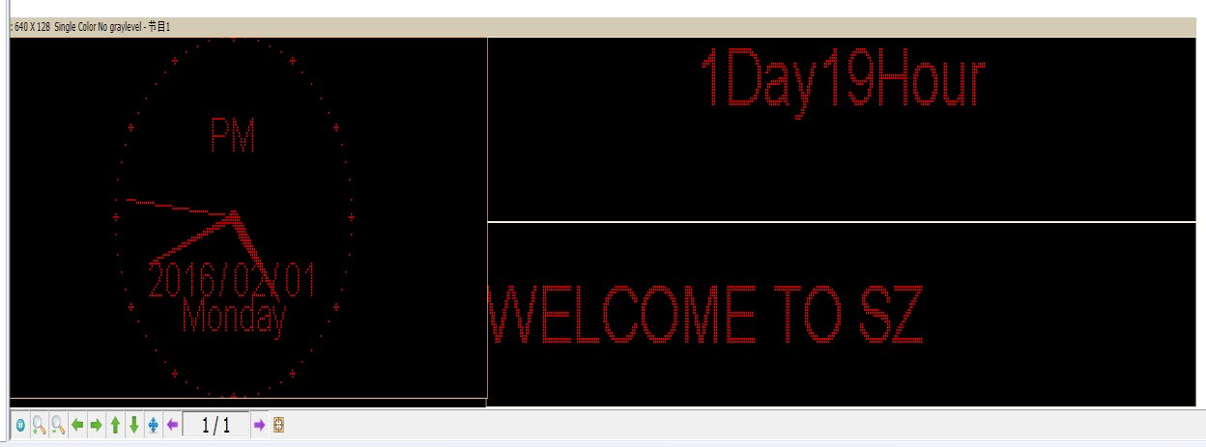

Notice: see the red place, there have tools for edit simulating screen. (Include tools: preview/pause preview, zoom in/ zoom out simulation window, current region right and left shift, region overall, display content paging, simulate display window top left corner display )

Scrren Attribute

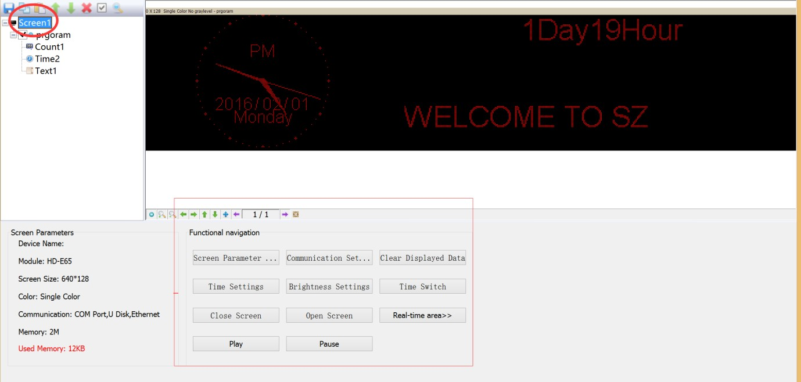
This tool can setting brightness/timer switch etc. Add new function of real time region, and appointed display real time picture area arbitrary size, but better for SDK.
Current screen parameters: According to screen setting changes
Navigation function: Including navigation function such as, screen parameter setting, communications setting、time setting、timer switch, display testing、turn on screen、turn off screen、real time region、play、pause and so on

Remote control using

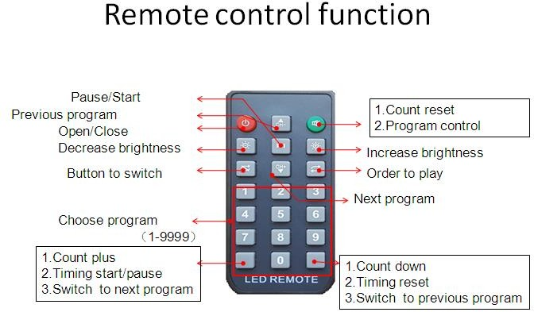
It need weld a infrared probe, remote control using as bellow:

Note: S2 start timing; S3 timing reset; S4 timing pause;

Smart setting method

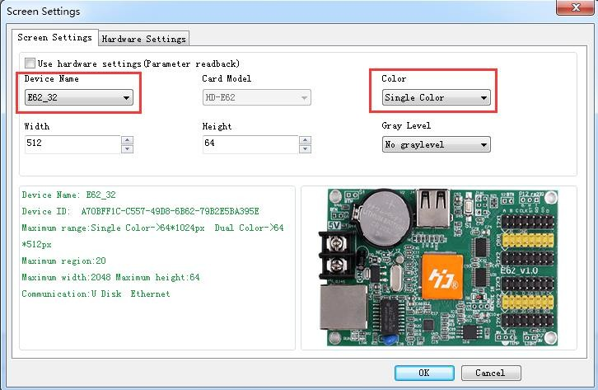
- , In Setting-screen parameter setting, choose device and color

- In Setting-screen parameter setting-hardware setting, if in commonly smart setting , it

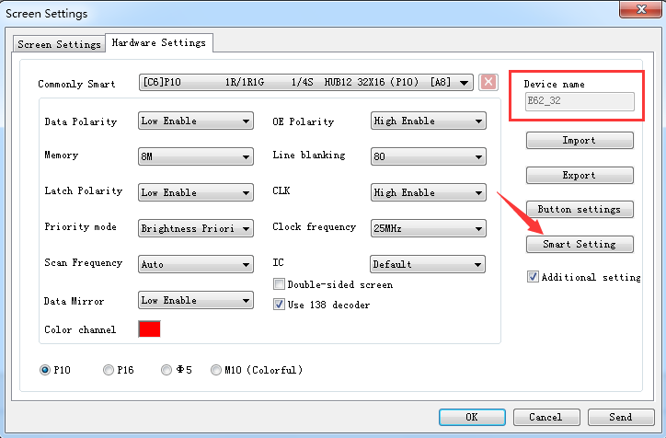
have the default screen parameter, then can direct choose, and click “sending” . As bellow picture show:
If you can’t find current setting file, then can refer smart setting. Note: If you know the module's plot, U disk can also be set smart.
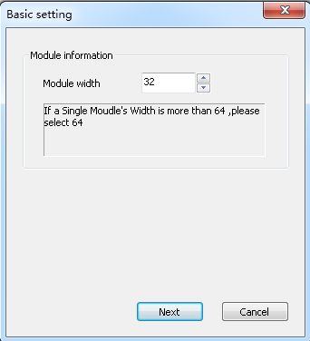
①setting 1PCS LED Module Pixel of Width. for example, P10 single color 32W*16 Pixel
②Choose LED module data polarity and OE polarity Its accord to LED module real showing.
No changeable is meaning no 138 decoder

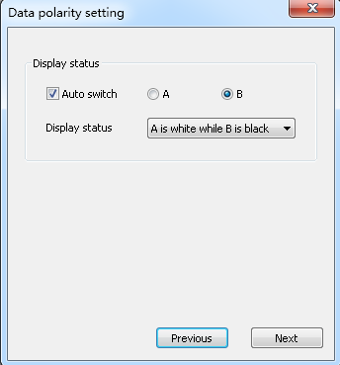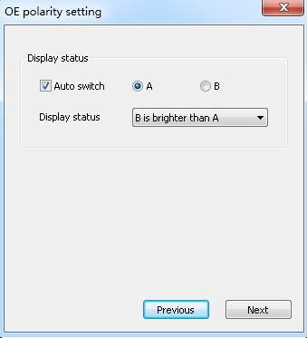
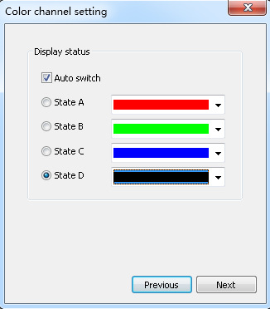
③Color channel according to screen actual situation to select. Single color for example P10 no need to choice , dual colors only have state A and state B.
④Confirmed Led module scan mode. As picture show, 32/2=16, can get to know the led module scan is 16 scan.

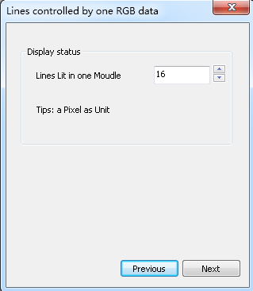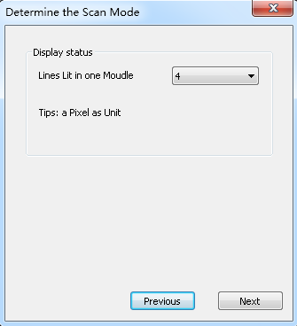

⑤ Alignment setting. The image same like 1PCS led module. Just see in the right corner of 1PCS module of the display.
Then in that Led module one Led light is bright and Tracking point, then accord to led module going on. Tracking wrong step can click “step back ” and tracking this point again. Or reset all point. After finished tracking point click “save” file.
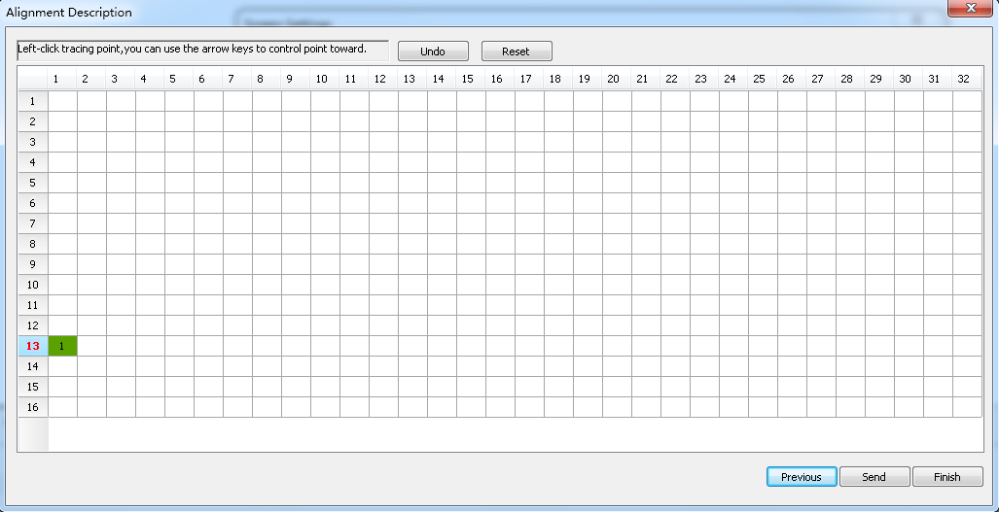
The default save way is the custom. Saved at program installed path C:\Users\Administrator\AppData\Roaming\HD2016\FPGAFile。

LED cross sign setting.

A new cross sign screen, as picture:

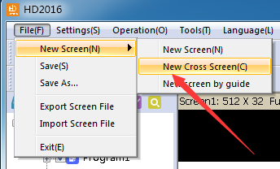

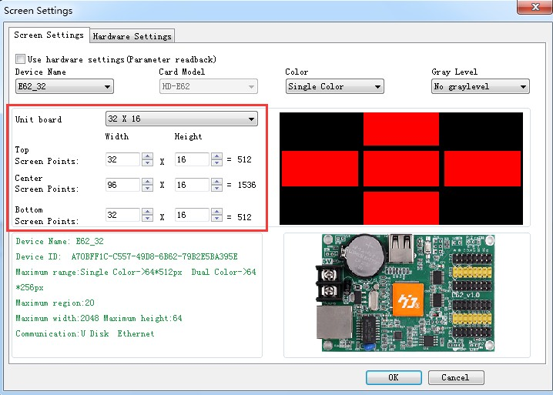
1).Cross sign screen parameter setting same with normal module setting, just reference above. cross sign screen size divided into 3 parts to setting, Top、middle、bottom.

2).Cross sign screen can establish Global program and normal program, global program separated the top、middle and bottom and showing in one area.
Establishing program can set up 3 areas to show program.

Chapter 4 Setting up screen and program file

Set up new Screen file (The first level content)

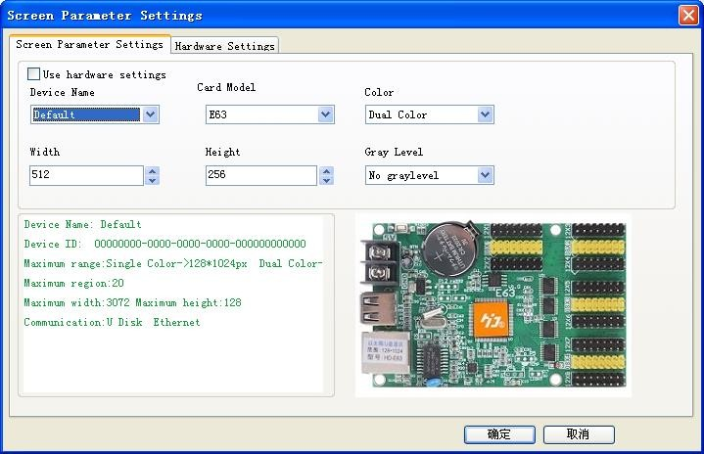
Click file--- New screen (password: 168), the screen file been set.

1).If Control card have correct parameter (Display working normal) Click “Using the hardware setting” and selected device here is HD-E63, then clicking “yes”, finishing establish a screen.
2). If Control card not have correct parameter (Display working abnormal). Do not select “Using the hardware setting”, selecting device and color, then setting width and gray level etc.
Then into Hardware setting, set screen Commonly smart. If Commonly smart setting do not have LED Module scan, please connect Ethernet cable or serial port cable or wifi to smart setting.

Set up new program (one screen can set up 1000 Programs )
Click shortcuts Program button (First need to click File-New screen) As picture:

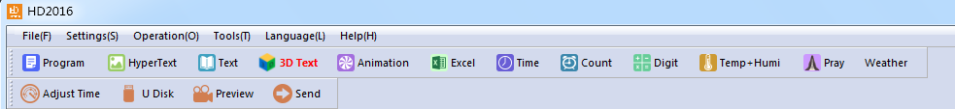

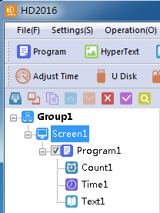
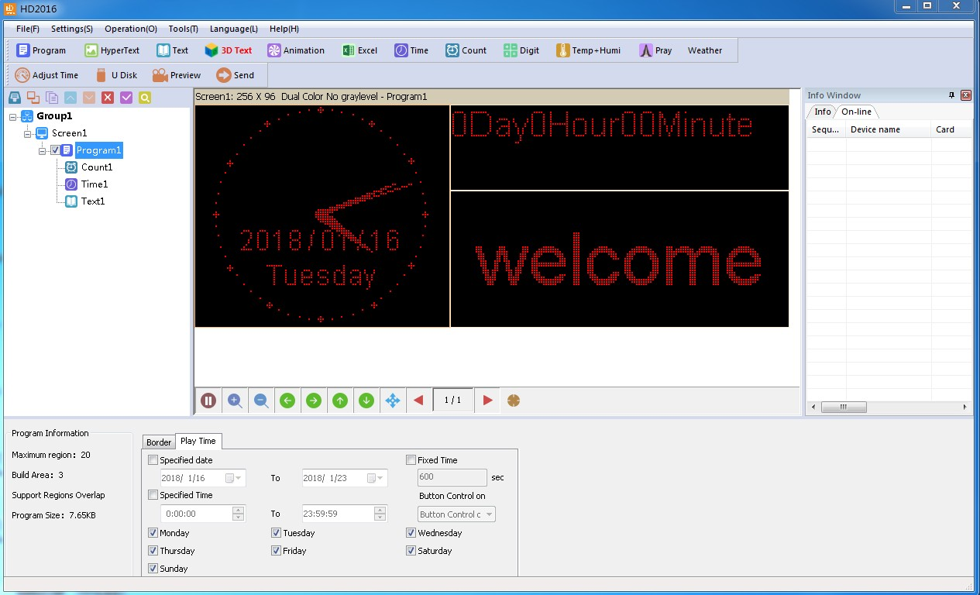
Or set up new Program as bellow picture set):

Note: 1000 Programs can set different attributes, these attributes includes: Specified date, time、these attributes includes: Specified date, time、Fixed time、Border.

Set up area (Each program can have 20 areas)
Select program, then click Hypertext、Text… and so on to build different type of areas, shown as below

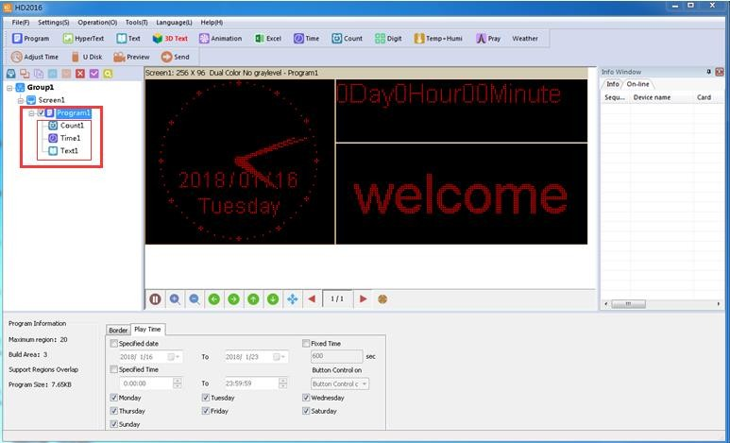

Program Editing Done
1).After finished 4.1 , 4.2 and 4.3 , the Screen File been set up. If need to add more programs, only need to repeat 4.2 and 4.3 steps; If use one software to control several screens, then need to create several Screen File and repeat 4.1,4.2, 4.3 and 4.4
2).After program done, it can be saved (default Saved Location: C:\Users\Administrator\AppData\Roaming\HD2016\ProjFile, or through File saved to other path)
On software screen, user can check program effects synchronous and setting, if not satisfied , click Send and showing in display.

Chapter 5 How to display different content

Displaying Text
If just text showing, user just add Text area to meet requirement. Text support left turn、 right turn、 rotation of 90°、180°、270°and Excel etc. add areas、add background 、 support special effects.
Procedure: reference 4.1 and 4.2 content, setting up screen program;
Click Text (Free setting coordinate、 length、 width )

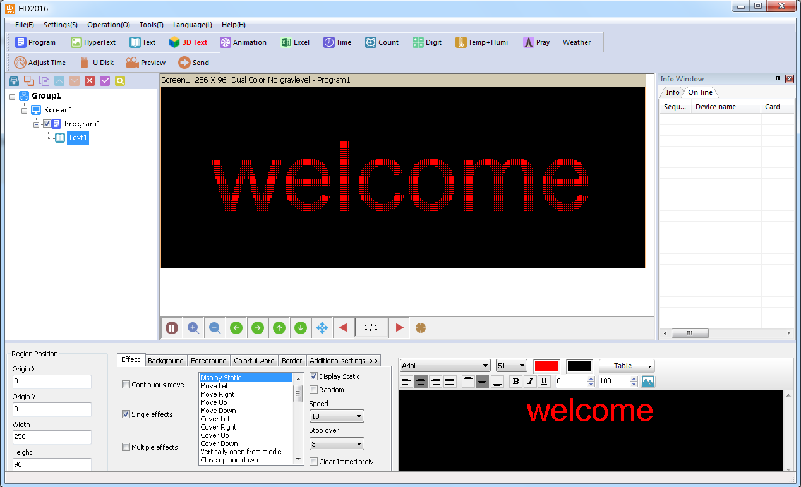
HD2016 software edit function is strong, even if modify single character. Editing right and left centered, up and down centered、word space、Line Spacing.

Add HypterText of Photos, Gifs etc.

If user show logo or picture on display (Format only support JPG、BMP、PNG、GIF ). The setting procedure as bellow.
Procedure: reference 4.1 and 4.2 content, Setting screen program;
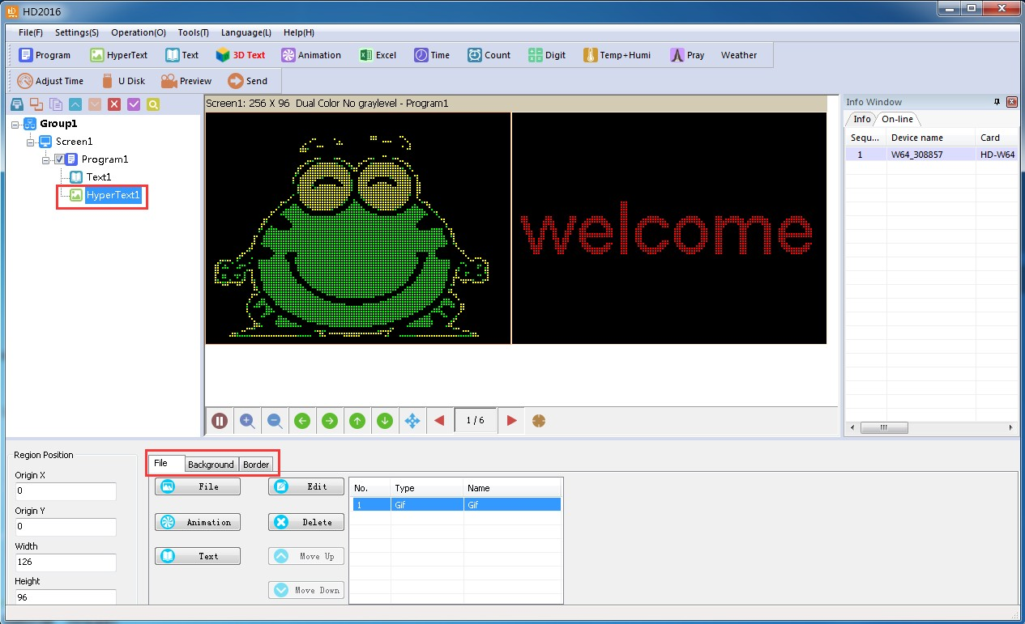
Click subtitle “HyperText”, you can set coordinate, length, width.
Picture can edit multiple picture, only picture can make it.

Supporting add new video、Excel、Animated characters, SWF,GIF, and image-text.

Animated characters

- Refer to 4.1 and 4.2 content, and set up Screen Program-animated character;
Or click subtitle Animated characters
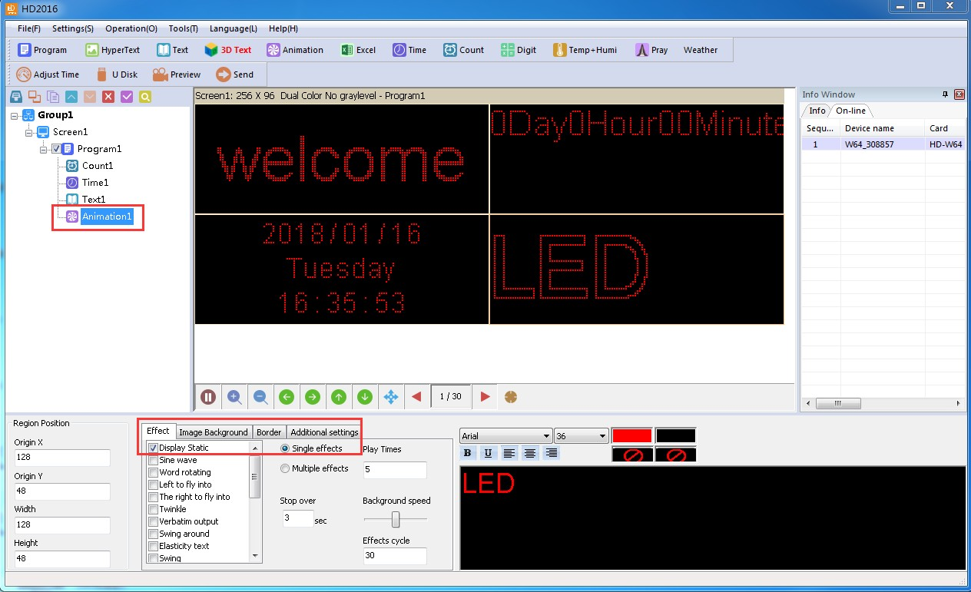
- Animated characters can set effect, image background, and also support area background overlapping showing. Also in Additional setting, it has Hollow and Stroke effects

Excel showing

In display, it can show Excel sheet.
Reference 4.1 and 4.2 content, and set up Screen Program;
Click subtitle choose Excel, appear animated characters area (Freely setting coordinate、length、width )
For Excel showing, it need install the full version of Microsoft, then Loading can be properly. It can be Horizontal screen-shots and Vertical screen-shots.

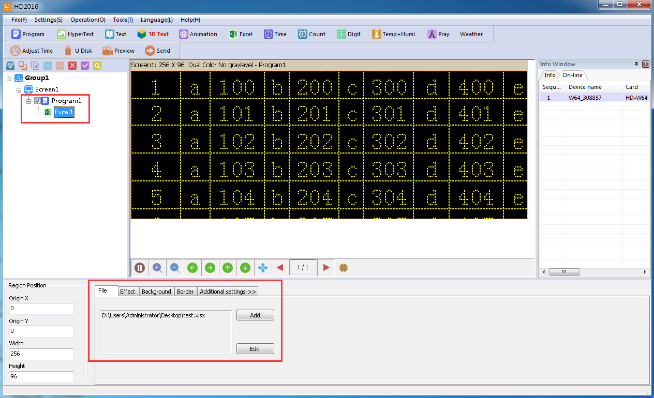
  - Time showing (Calendar time and dial plate)
Reference 4.1 and 4.2 content, and set up Screen Program click Time area
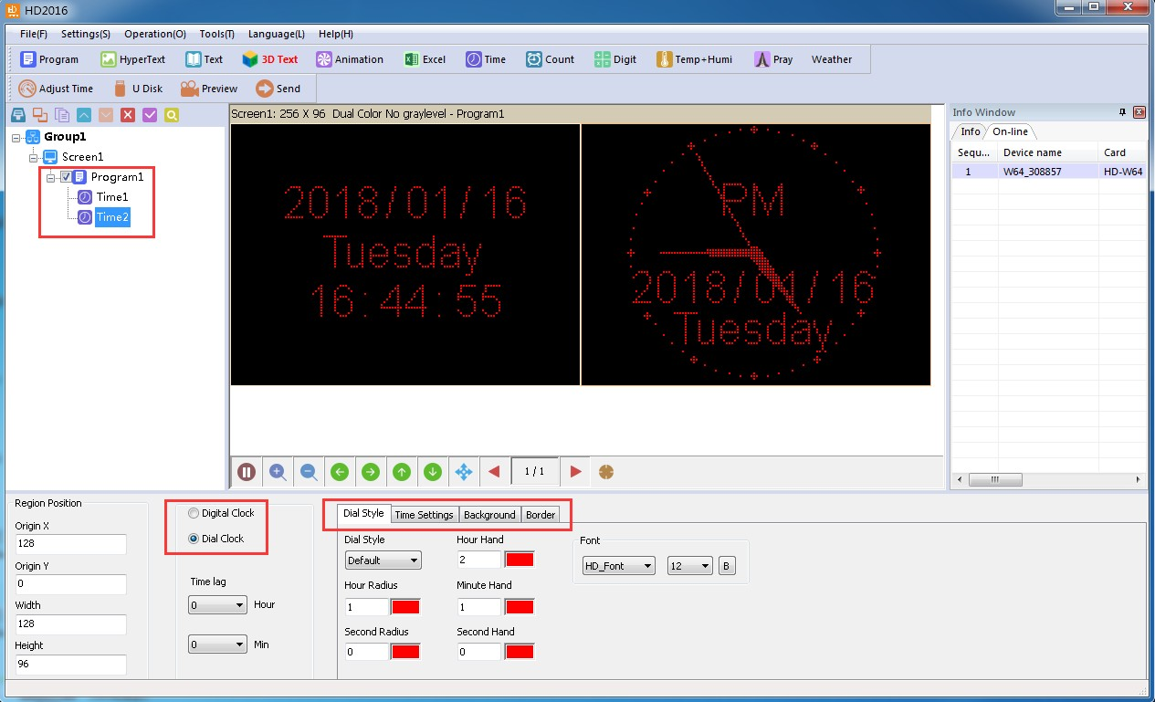
Or Click subtitle time, appear time region (Free setting coordinate、 length、 width ) it is easier setting, as picture:

Count up and count down

1). Showing count up and count down, or use button count up and count down. Refer to 4.1 and 4.2 content, Add Screen->Program-Count;
2).Click subtitle timing, appear Count area (Free setting coordinate、length、width )

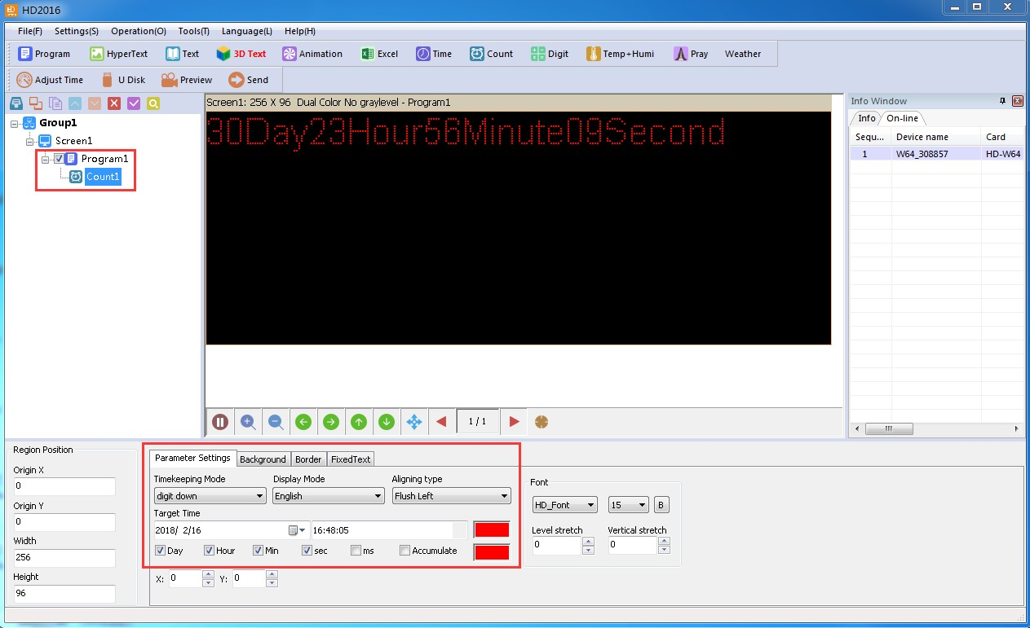
Support circle Count, that is meaning Countdown been finished, then automatic reset and Starting again.

Digit showing

Showing digit number, mainly used in parking place etc. Reference 4.1 and 4.2 content, Set up Screen Program-Digit.
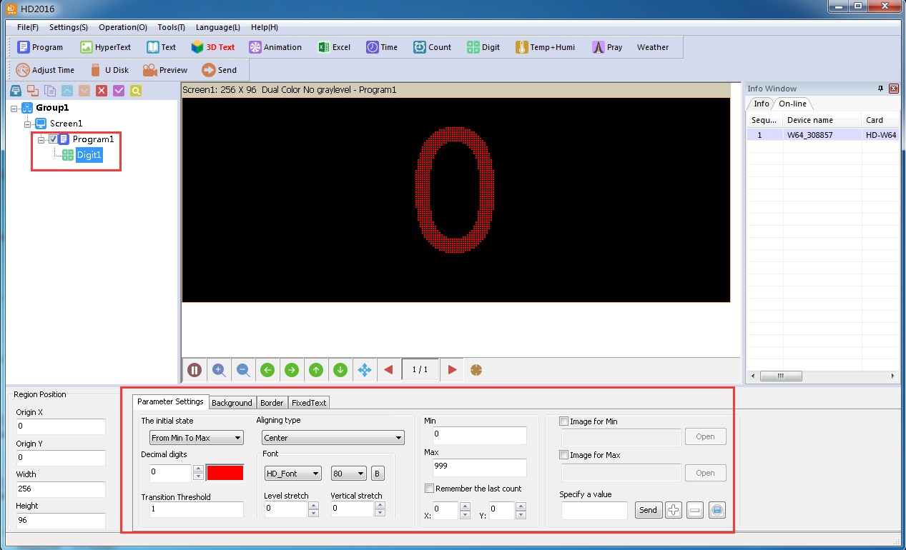
Clicking Digit, appeared Digit area as picture:
The initial state is from Max to Min, or from Min to Max. it can add the minimum and maximum values picture. The largest value can set to 9999999, decimal digits can set

3 numbers.

temperature and humidity (need weld sensor)

- LED display showing current environment temperature.
Refer to 4.1 and 4.2 content, set up Screen Program- Temp+ Humi;
- Click Temp+ Humi, temperature and humidity have different sensor. As picture:
- Set in P5 on controller, the appendix shows details setting ways.
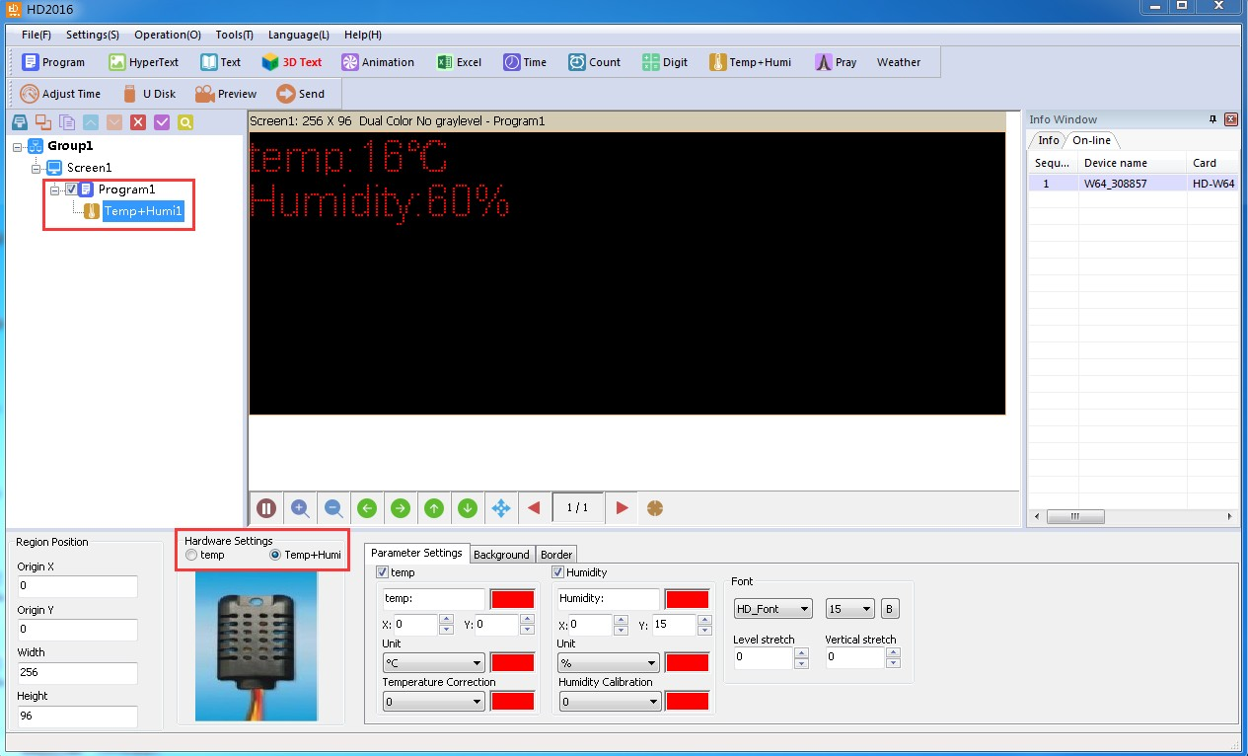

pray showing

Showing Pray, mainly used in parking place etc.
Reference 4.1 and 4.2 content, Set up Screen Program-Pray.
Clicking Pray, appeared Pray area as picture:

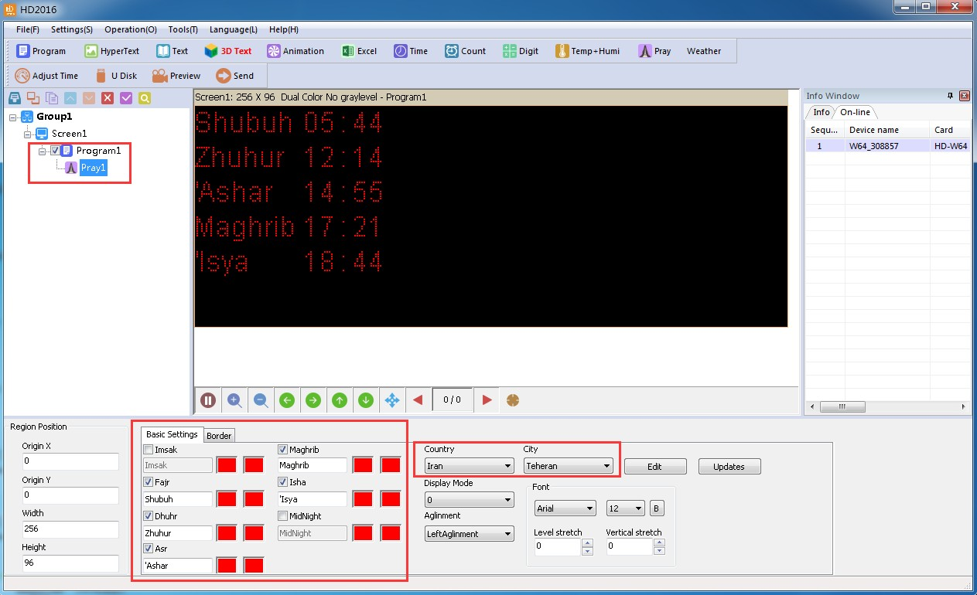
Temporarily support four countries, showing the two modes 0 and 1.

weather showing
Showing Weather, mainly used in parking place etc.
Reference 4.1 and 4.2 content, Set up Screen Program- Weather.
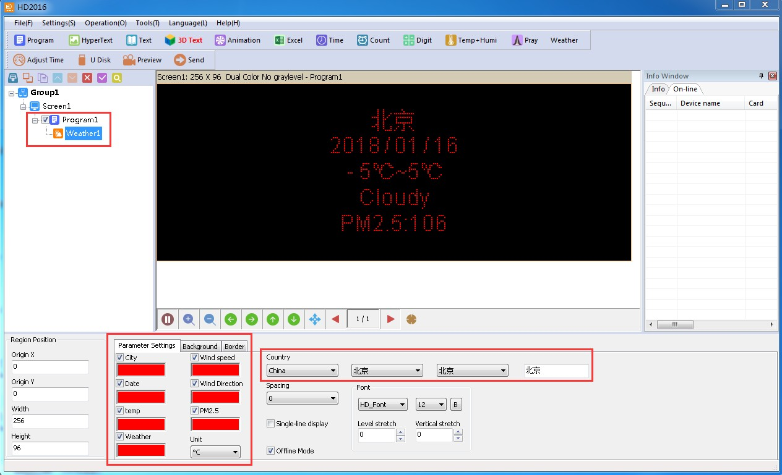
Clicking Pray, appeared Pray area as picture:

- The controller will obtain the weather data every hour (directly from the server);

- Currently, the online mode only supports the network port, and all the offline mode controllers support it (4.14).

Chapter 6 Communications setting

Making serial port cable

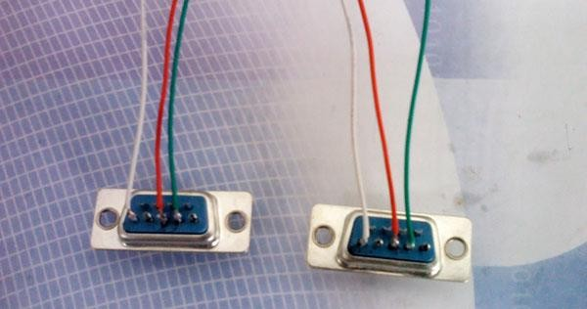
Our system use straightway RS232 line, finished line as follow:

Communication setting (serial port)

Serial port connection have two types: RS232 and RS485.

RS232 communication

1).After installed the driver successfully, HD2016 will found current device. Ours RS232 driver is HL340.
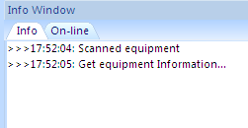
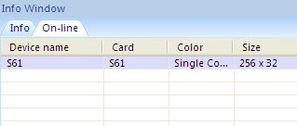
One computer can only connect one serial port card, after the software found device automatically, in File-screen parameter setting and choose current device name, then can send parameter and program. As picture show
2).If software can’t find device, please click , location as picture show:

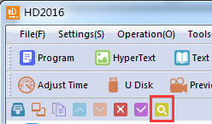

3).If user still not find device, please check cable problems.
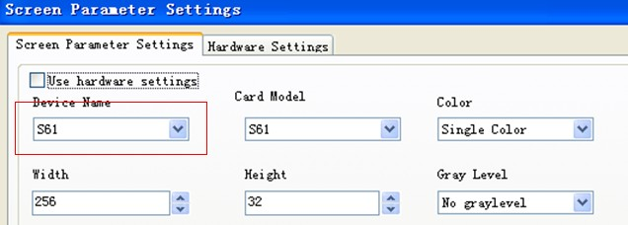
If current information window notice “selected screen not binding equipment ", please into setting “screen parameter setting”, select device name, as picture show:

RS485 communication

1) Solution: 485 communication serial port connected, and it need 485 converter. Connection method as follow: Converter Positive pole (+) connected with control card square hole, Converter Negative pole (-) connected with control card on 485 in middle hole.（one 485 controller only supports one control card）

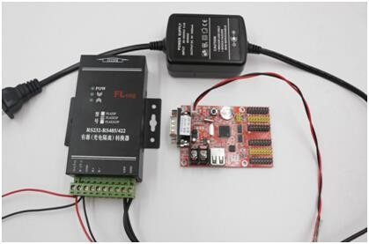

Making Network cablel

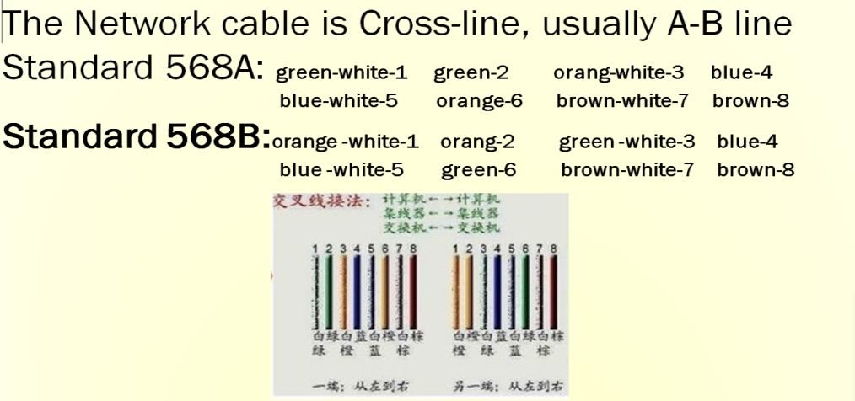
1).Making Network cable have 2 ways: cross cable (control card connected with computer directly) and parallel cable (control card connected with router)

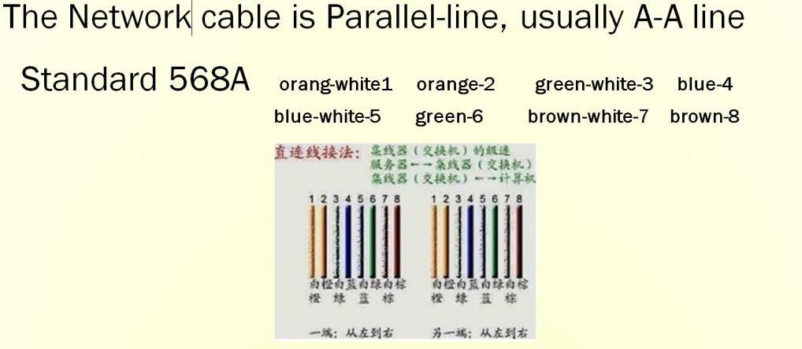

Communications setting(internet access)

LAN single card (HD-E63) communication

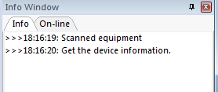
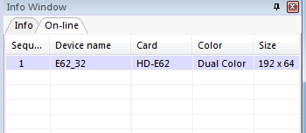
Method: No need any setting, stand-alone straightway connect control card, on information window will find device. As picture show:

Note: If current information window notice “selected screen not binding device”, please into setting-screen parameter setting, and selecting device name, as picture:

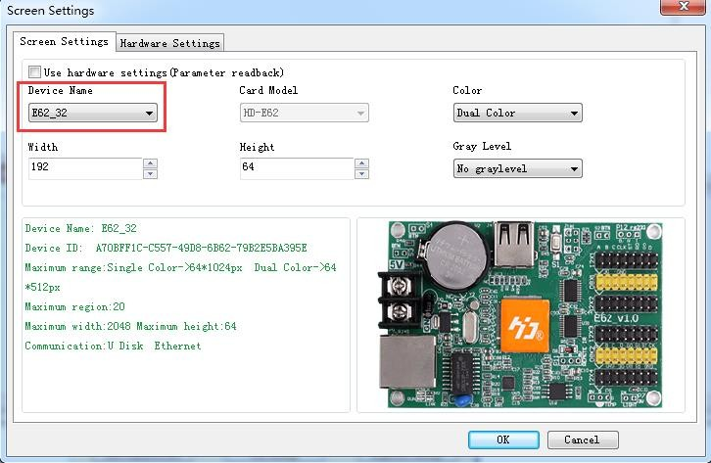

LAN multiple Network card (such as HD-E63 cards)

1). After all controllers connected, you can modify the control card IP same with current LAN Network segment.
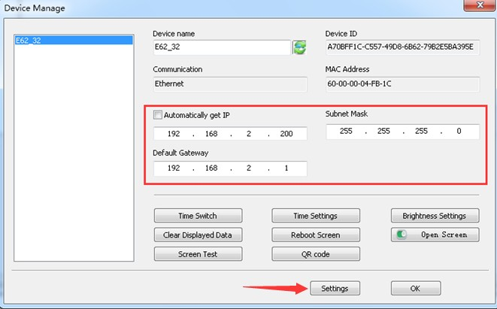
Click Operation-Device manage, revised the control card IP address and device name Note: after revised, and click settings

Communication setting （WIFI Wireless controller ）

If Only 1 WIFI Controllerr connected

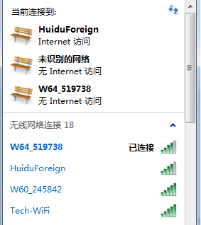
- If only 1PCS WIFI Card connected, first connected the WIFI signal of the controller as below (The WIFI signal come out automatically)
- The WIFI default password ““88888888”,in HD2016,no need written password Showing as below, Click “LINK”, and connect automatically by password 8888888, also password can change.
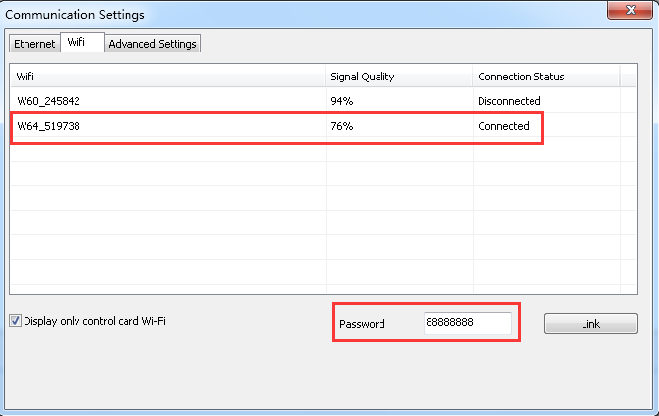
If current WIFI of SSID showing “{}”,for example {W64_26882}, then only check the WIFI Password in HD2016 software.
- After connected the WIFI, in software it can find the device. Showing as below: came out the device name information

- In setting-> screen parameter settings, selected the current device, and send.

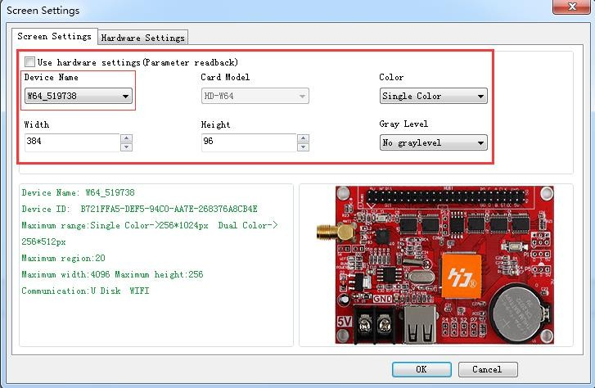
Note: If Current display work good, no need go to Hardware settings If Current display showing abnormal, click Setting- Hardware setting
(For common display, just click Setting-Hardware setting-Commonly smart;
For uncommon display, it can click Setting- Hardware setting-Additional settings
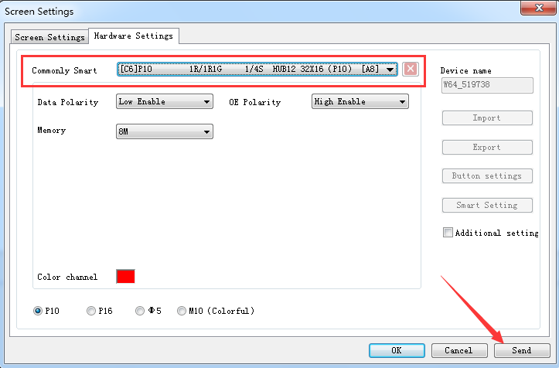
–Smart setting)

Change Wi-Fi ssid and password ;More than 1 Wi-Ficards Connected
Multi Wi-Fi cards connected, it need each card connected the Remote Router. Meaning it need a Router. The operation ways as below
1).The PC recognized the Wi-Fi signal automatically, and operation reference above One Wi-Fi card.
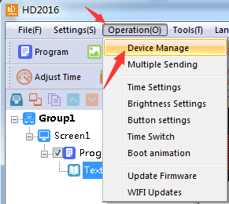
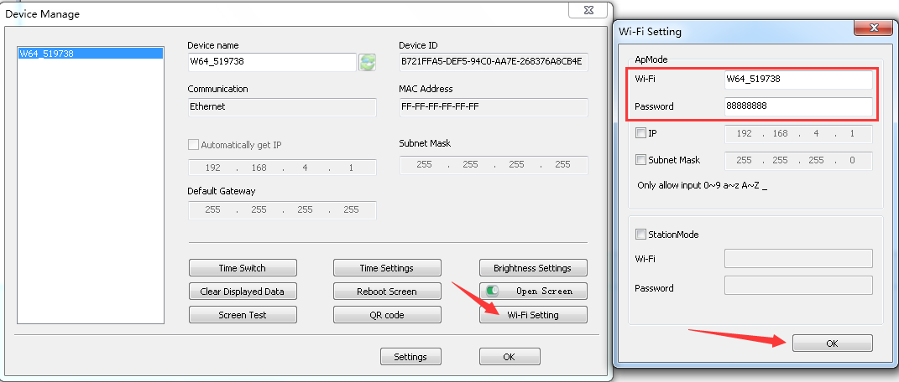
2).Change Wi-Fi ssid and password.

3).The Wi-Fi card connected the Remote Router, the ways as below
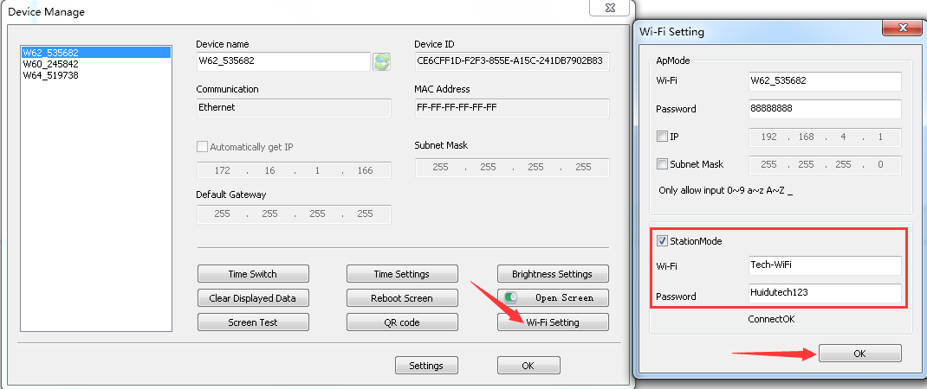

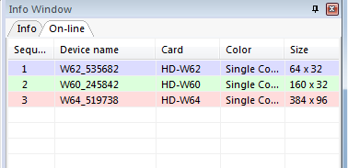
4).The PC connected the Wi-Fi signal, and open HD2016 Software, it can find All the Wi-Fi cards.

U-disk Controller operation

U-disk controller no need install lines, and is convenient.
Note: First time use U-disk Controller to Export program, it need select the “export the parameters”
For example P10 Single color module
- Open HD2016 software, click File-New screen -screen parameter settings .Setting the Width、Height、Color、Gray level etc.
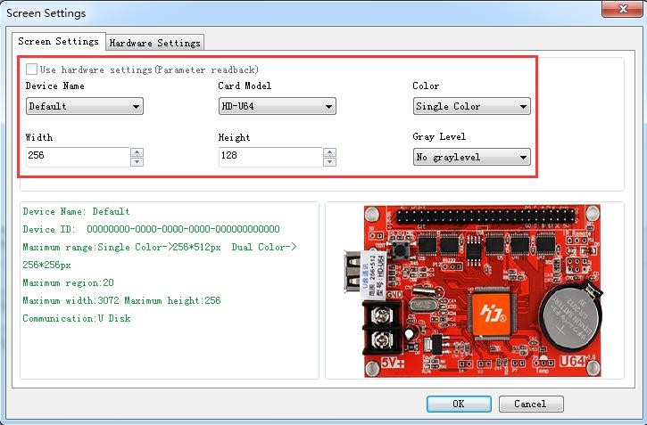
- Hardware setting parameter
Note: If current display showing normal, no need this step.

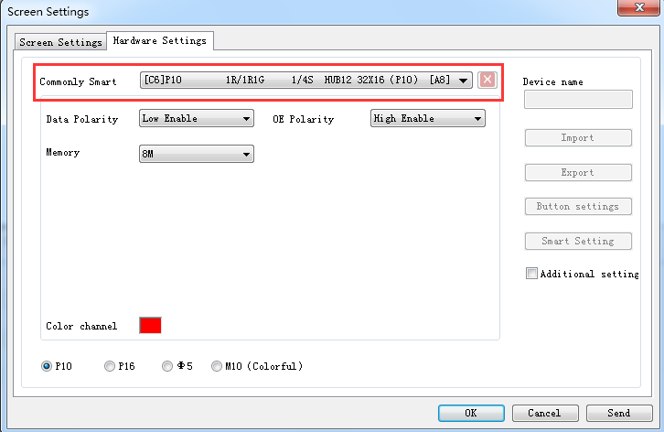
- Then add program of text、Hypertext、Animated character、Excel、Time etc. Click U-disk to export program.

Note: First time use U-disk Controller to Export program, it need select the “export the parameters”.
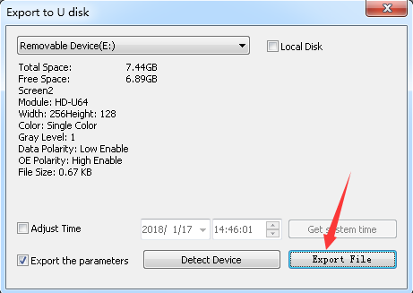
Next time for showing normal, no need select

Appendix 2 The normal setting in using period

Appendix 2.1 Controller updated firmware ways

Updated firmware mainly used when problem occur. The updated ways as below:

- Download firmware of .bin file (each controller have .bin file)
- Click Operation-update firmware (Password 168), select the .bin file.
- Updated firmware by RS232 or 485or LAN,
U-disk controller updated by U-disk (Putting the firmware to U-disk and insert to controller, like updated program)
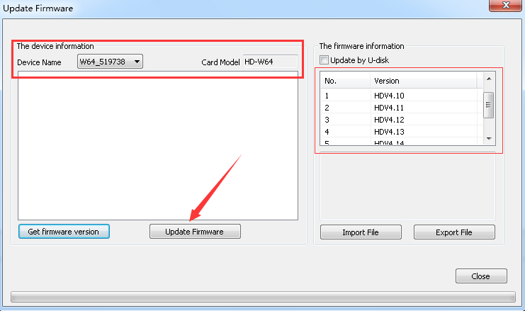
Note: In update period, the display can’t power off and can’t pull out the RS232 Line or LAN Lines

Appendix 2.2 How to renew to factory setting

There have 2 ways (hardware renew and software renew）
Hardware renew: power off the electronic- Press the TEST Button and at the same time power on the electronic, hold on 6 seconds and no loose —Then loose the button –The controller renew the factory setting.
Software renew: Operation-clear display data(Note: This step need communication well)

Appendix 2.3 How to test display

There have 2 ways （ hardware test and software test）
Hardware test: when adjust the display working normal-- press the TEST Button ( the electronic need power on) and hold on 6 seconds --when into testing status, then loose – Press 6 times and come out different 6 testing modes
Software test: Operation-Screen Test.

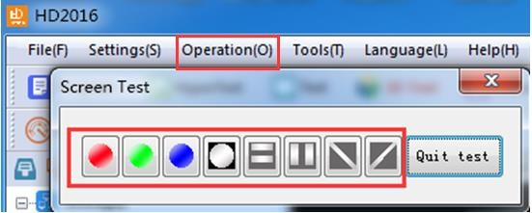

Appendix 2.6 How to set Text static and no moving

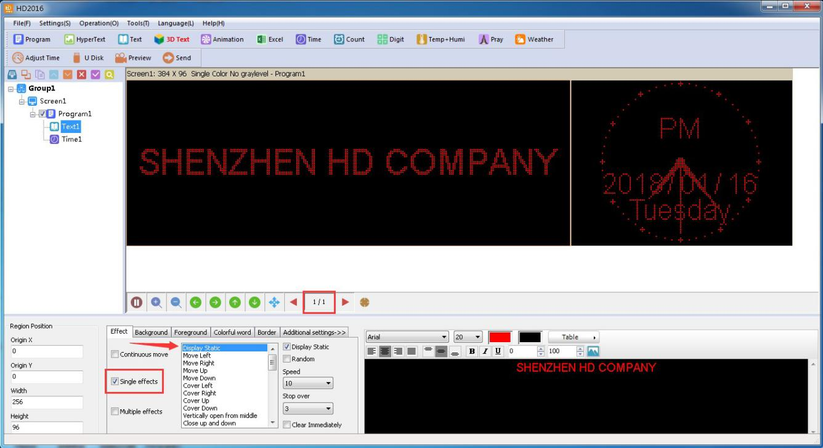
Ways: In Text-effect- select Display Static, the program page 1-1

Appendix 2.7 Text continue moving and no stop

In Program – Text - select Continuous move and End to end（Continuous move left or Continuous move right or Continuous move up）.
If not select End to end, the text showing continuous after SPACE Key.
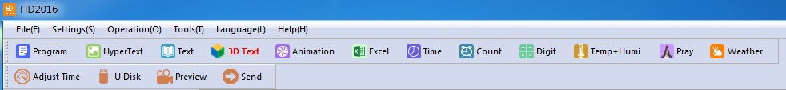

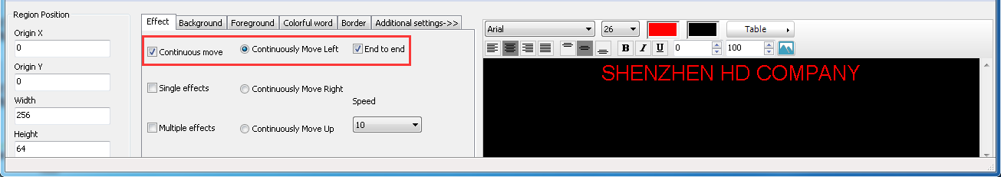

Appendix 2.8 Temperature 、 Temperature +Humidity sensor

- Temperature +Humidity sensor
Weld place in P5. Red line connected Positive (+) of Square pin, Yellow line connected Middle pin
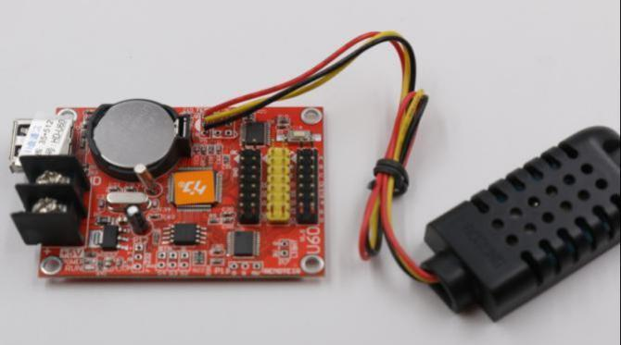Black line connected the Third pin
Sensor

The Temperature+ Humidity parameter Type：AM2301
Working voltage：4.2-5.2V Testing humidity range: 0-100%RH
Testing temperature range：-40—80℃ Testing humidity precision：±3%RH Testing temperature precision：±0.5℃

- Setting in software of Temperature +humidity
①In Program- Temp+Humi, reference 5.9 of area setting
②Setting the Temperature+ humidity parameter. It can set only show temperature or only humidity. One program only set up 1 area of Temp+Humi

③If Temperature and humidity not precisely , it can adjust by Correction
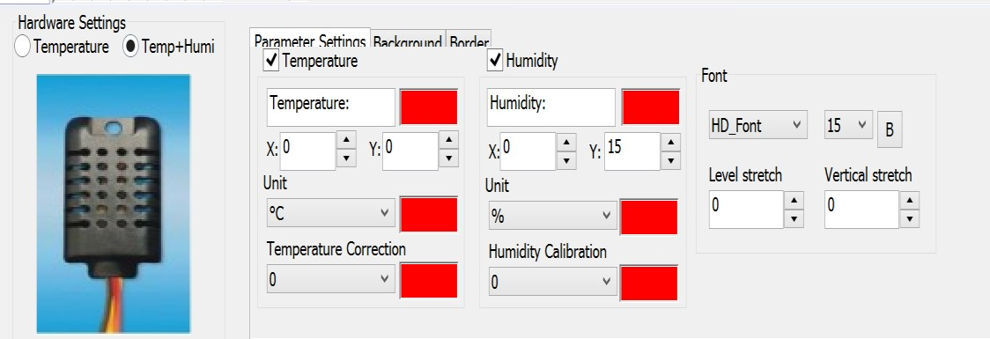
④Support background and border

2).Temperature sensor welding
①Non-temperature sensor welding
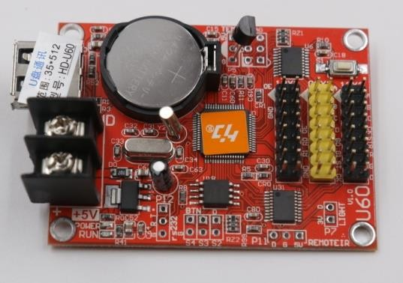
Weld place in P5, and the sensor Round side direction to Battery of Positive (The Square Hole is Positive）
Type：DS18B20
Working voltage：4.2-5.5V humidity range：-55--125℃ humidity precision：±1℃

②Waterproof sensor welding
Welding place in P5, the sensor red lines connected Positive (the square hole) The yellow lines connected in middle
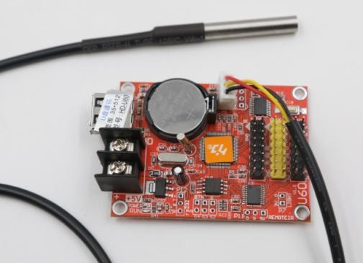
The black lines connected in third
Type：DS18B20
Working voltage：4.2-5.5V temperature range：-55--125℃ temperature precision：±1℃

③Setting Temperature in software
- In Program- Temi+Humi- Temperature
- Setting the temperature parameter: only one program setting 1 area of temperature 3.If Temperature showing not precisely, it can adjust by Correction
4.Support background and border

Thank you for supporting HD

